Week 7
Rights

Day 1

NAME:______________________

Day 1 Agenda

Topic | Activity
Warm-Up!
English Language Arts | - Read and reflect upon Maslow’s Hierarchy of Needs  - Read background information on the creation of the Universal Declaration of Human Rights  - Respond to questions about the readings and reflect on how human rights apply to them personally.
Science | - Read about Climate Change as a Human Right  - Answer questions about what you read  - Draw a picture and explain
Mindfulness Moment!
Math | - Rights-the Math of Independence thru the Civil War/Voting
Health | - Digital Rights: Privacy
Mindfulness Moment!
Civics/Social Studies | - The Bill of Rights

Warm-up Activity: Write a journal entry around the daily quote on identity.
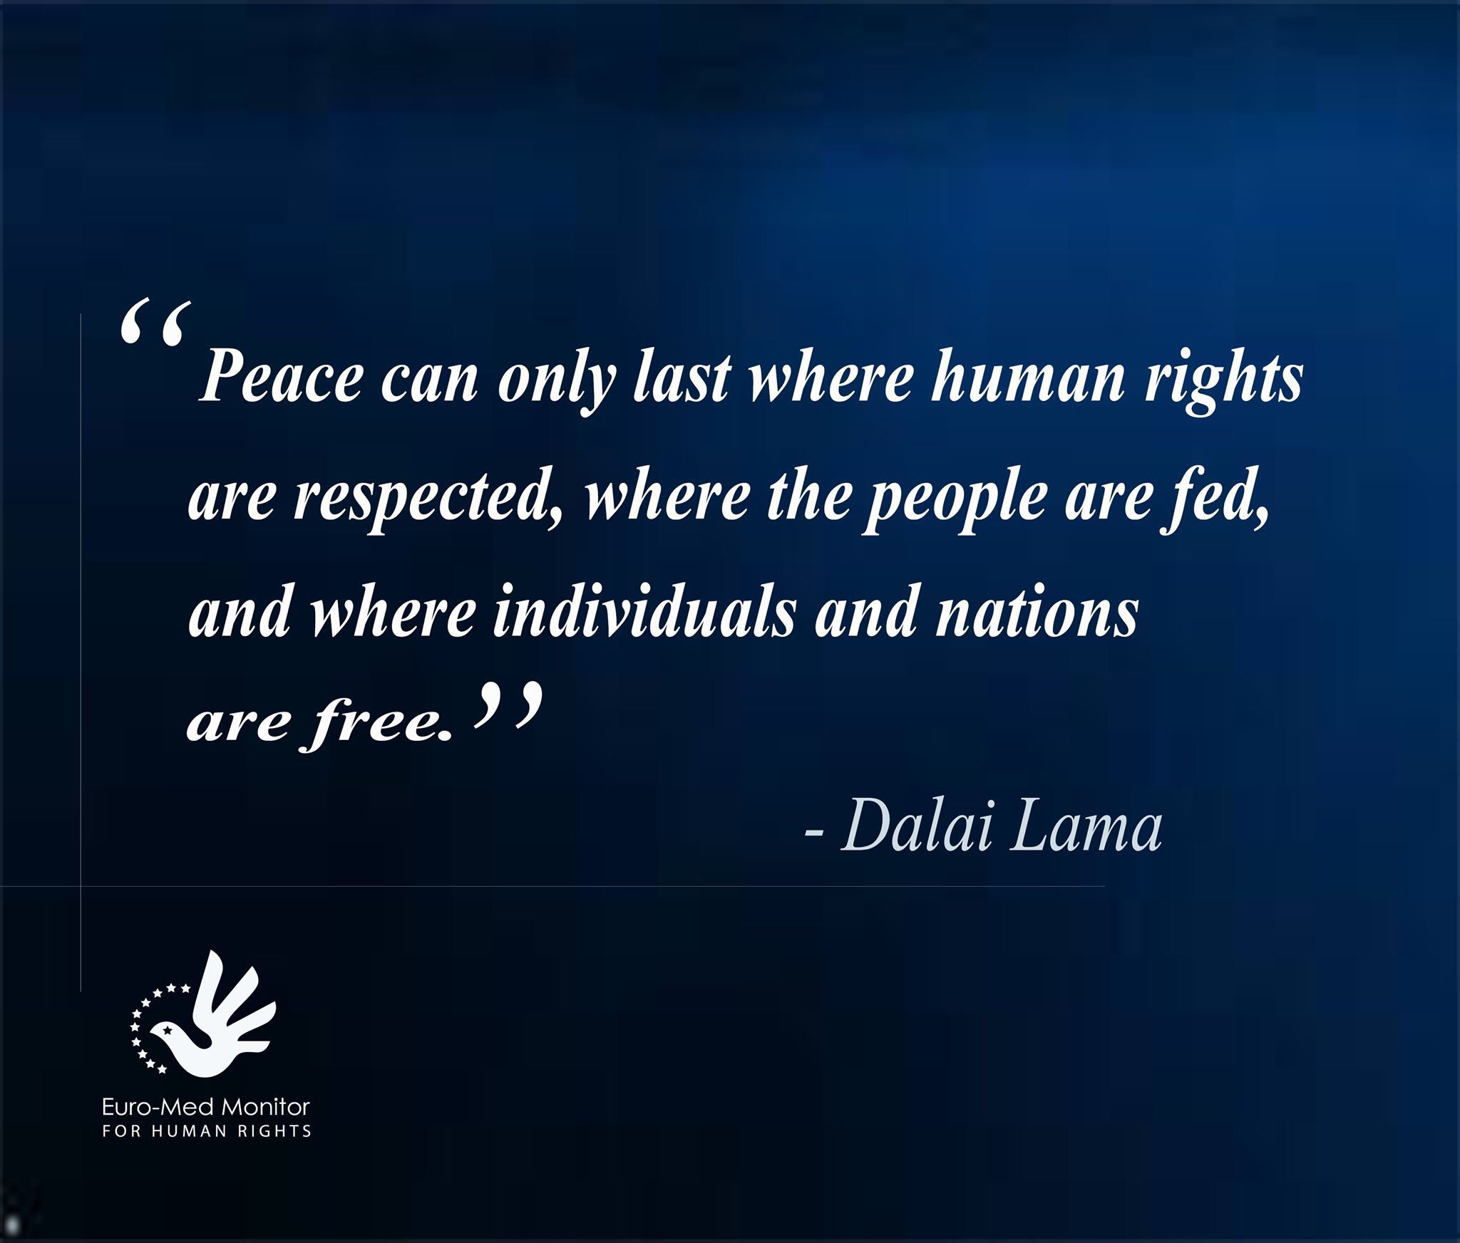

Day 1: Human Rights
English Language Arts

What is this lesson about? Over the next week, you will be reading, thinking, talking and writing about “rights”. When we think about rights, it is necessary to make a distinction between wants and needs. While many of us may want certain things, rights really address what you need to live life as a human being with dignity.

Step 1: Read, Think, Write
In 1943, American psychologist, Abraham Maslow, stated that healthy human beings have a certain number of needs, and that these needs are arranged in a hierarchy (an order) , with some needs being more basic than others). Maslow’s so-called ‘hierarchy of needs’ is often presented as a five-level pyramid. The bottom four levels of the are basic needs. A person does not feel anything if they are met, but becomes anxious if they are not. The fifth level of the pyramid is a ‘growth need’ because it enables a person to ‘self-actualize’ or reach his fullest potential as a human being. Once a person has met his basic needs, he can turn his attention to self-actualization. Only a small minority of people are able to self-actualize because self-actualization requires uncommon qualities such as honesty, independence, awareness, objectivity, creativity, and originality.

Look at the diagram below that outlines Maslow’s Hierarchy of Needs:

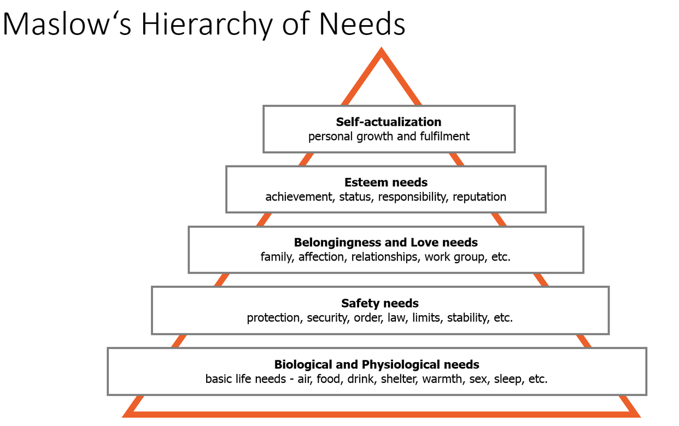

Write about Maslow’s Hierarchy of Needs.

Do you agree that people need to satisfy basic needs before they can think of other needs or wants? Look at the order--Maslow indicated that the most basic or important needs are on the bottom and the level of need is less the higher you go on the pyramid. Do you agree with this order? Why or why not? If these are considered “universal” needs, how do you think this connects with the idea of the rights that every human deserves? There is no right or wrong answer. Just write about what you think.

Step 2: Discuss with a partner or with the group
Share your writing with a partner and look for ideas you have in common.

Step 3: Read and Annotate the Informational Text Below

Before you read: Some vocabulary and references to understand:

United Nations: organization made up of 193 countries that aims to maintain international peace and security, develop friendly relations among nations and international cooperation. | genocide: the deliberate killing of a large group of people, especially those of a particular ethnic group or nation. | gypsies: a member of a traveling people traditionally living by trade and fortune telling. Gypsies speak Romany and are believed to have originated in South Asia.
refugees: a person who has been forced to leave their country in order to escape war, persecution, or natural disaster. | delegate: a person that represents others, in particular an elected representative sent to a conference. | mutual:held in common by two or more parties
taboo: banned on grounds of morality or taste | composite: made up of various parts or elements. | ponder: think about
persecution: oppression or mistreatment because of race or political or religious beliefs. | consciousness: the state of being awake and aware of one's surroundings. | legacy: something or consequence that has been handed down by those that came before
universal: affected by all people or things in the world |  | concentrated: intense

Less than three decades after the First World War, in which more than 18 million soldiers and civilians were killed, Europe was once again in a World War. World War II, which pitted Germany, Japan, and Italy against Great Britain, the United States, and the Soviet Union, was not only a global war, it was a total war in which each nation's entire human and material resources were called into service. About 70 million civilians and fighters were killed, making World War II the deadliest conflict in human history. Millions were left homeless, and millions more began an uncertain life as refugees.

Only when Germany was defeated in May 1945 did the world fully understand the cost of 6 years of warfare: mountains of corpses, entire cities demolished, nations traumatized by the use of violence against civilian populations. Only then did world leaders realize the human cost of 12 years of Nazi rule in Germany: the Holocaust-the genocidal murder of millions of Jews and gypsies and the persecution of homosexuals and other minorities, many of whom died in the last year of the war. In addition, the US firebombed the cities of Hiroshima and Nagasaki and destroyed 70 percent of all buildings and killed over 200,000 people These atomic bombs demonstrated that the world now possessed the tools of its own destruction. Eleanor Roosevelt, the wife of President Franklin Delano Roosevelt later reflected, "I think that if the atomic bomb did nothing more, it scared people to the point where they realized that either they must do something about preventing war or there is a chance that there might be a morning when we would not wake up."

The horrors of World War II reinforced the idea that the world needed to establish a global bill of human rights that would obligate "every state to recognize the equal right of every individual on its territory to life, liberty and property, religious freedom and the use of his own language." This idea was also one of the stated goals of the newly formed United Nations in 1945.

On joining the US delegation to the United Nations at the end of 1945, Eleanor Roosevelt described the enormous responsibility she and her fellow delegates faced: "The time has come... when we must recognize that our mutual devotion to our own land must never blind us to the good of all lands and of all peoples. In the end... we are "One World" and that which injures any one of us, injures all of us. Only by remembering this will we finally have a chance to build a lasting peace."

Her commitment to seeing beyond national interests drew her to the drafting of a Universal Declaration of Human Rights (UDHR). To protect its people and interests, every society develops written and unwritten codes spelling out the liberties, taboos, and obligations of its members. And as different societies and cultures encounter each other, they often seek to find common ground. Representatives from Asia, Europe, North and South America, and the Middle East (most of Africa was still ruled by colonial powers) argued not only about cultural issues but politics as well. After almost three years of negotiations that sometimes escalated into serious conflict, the Universal Declaration of Human Rights, which Eleanor Roosevelt described as a "composite" of international beliefs on the rights, freedoms, and dignity of human beings, became a reality. Thanks in part to Roosevelt's inspiring leadership, the General Assembly of the United Nations adopted the declaration on December 10, 1948.

But this was only a beginning. Roosevelt insisted that the document was designed to serve as the foundation for future human rights protections. And to serve this purpose, it needed to be brought to life, through educational programs, in the consciousness of citizens the world over.

Five years after the adoption of the Universal Declaration of Human Rights, Roosevelt again reminded her audiences that human rights are more than legal or political commitments. Such rights begin, she said, "in small places, close to home-so close and so small that they cannot be seen on any map of the world. Yet they are the world of the individual person: The neighborhood he lives in; the school or college he attends; the factory, farm, or office where he works. Such are the places where every man, woman, and child seeks equal justice, equal opportunity, equal dignity without discrimination. Unless these rights have meaning there, they have little meaning anywhere. Without concerted citizen action to uphold them close to home, we shall look in vain for progress in the larger world."

The Universal Declaration of Human Rights has inspired many individuals and policymakers around the world to work toward a better world. Today we ponder the legacy of this document Despite substantial movement toward equality and understanding, racism and its consequences continue to haunt communities and governments around the globe; wars targeting civilians continue to be waged; and the perpetrators of genocide, torture, and human rights violations often go unpunished.

Adapted from: https://www.facinghistory.org/universal-declaration-human-rights/introduction-universal-declaration-human-rights

Step 4: Answer the following questions.

- Why did the actions committed by the Nazis cause other nations to think of creating an international document about Human Rights?

- The United States’ bombing of Hiroshima and Nagasaki effectively ended WWII. Why do you think that the author says that these bombings scared everyone, including the U.S.?

- Eleanor Roosevelt stated that “we are “One World” and that which injures any one of us, injures all of us.” What did she mean by this?

4. Why was it important to have representatives from different cultures and countries to create a universal document like the Universal Declaration of Human Rights (UDHR) ?

5. Why did Eleanor Roosevelt feel that it was important to create educational programs about the UDHR?

6. Explain what Eleanor Roosevelt meant about the importance of Human Rights being honored in “small places” first, not just on the international level?

Step 5: Write
List three rights that you believe are most important and ALL humans deserve. Explain your choices. Why are these three the most important to you? How can NOT having these right affect others?

Student Feedback:
Circle the emojis that best represents how this activity made you feel. | 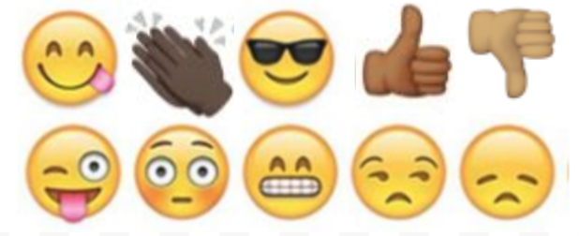  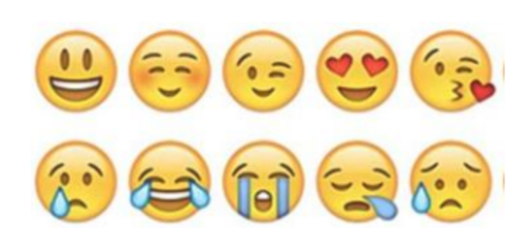

Day 1: Climate Change as a Human Right
Science

What is this lesson about?: Today you will read through the Climate Change is a Human Rights Issue passage. You will answer a few questions about what you read. You will draw a picture and write a response.

Step 1: Read through the Climate Change is a Human Rights Issue passage

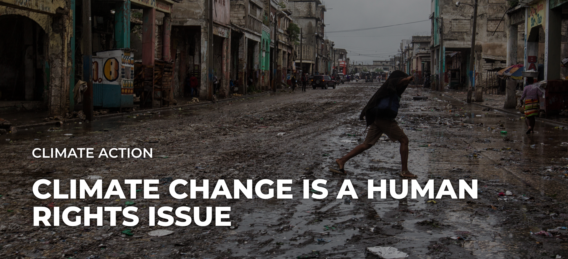
earthday.org (2019)
As the planet heats up, bringing with it more drought, famine and extreme weather events, people will be left without access to basic human needs. Millions of people will suffer and die because of climate change, and as political leaders drag their feet to act on humanity’s biggest threat ever, those numbers will only increase.

Climate change isn’t simply a political or economic issue. It’s a human rights issue, perhaps the biggest one in human history. If we continue spewing greenhouse gases into the atmosphere, we not only destroy ecosystems and drive species to extinction, we indirectly violate human rights.

Extreme weather events are more prevalent in a warming world, leading to death, destruction of property and crops and limited access to food, water, shelter, healthcare and education, as the United Nations Environment Programme outlined in its 2015 climate change and human rights report.

“We need to understand that environmental collapse generally, as well as climate change specifically, is completely a cross-cutting issue,” said Amnesty International Secretary-General Kumi Naidoo, on a October briefing call with Earth Day Network.

As world leaders enter the second week of the United Nations’ COP25 in Madrid, they must understand what’s at stake for humanity and the human rights threats if we continue to delay climate action. Many options lie ahead of us, but the most effective ones are those that reduce greenhouse gas emissions as fast as possible.

That said, humanity’s best-case scenario is to immediately transition into clean-energy economies, fair and equitable systems that don’t exploit lower classes but instead empower and enrich communities.

The worst-case scenario? Civilization, as we know it, collapses.

No matter the outcome, people will suffer. All that carbon dioxide in the air isn’t going away any time soon, even if we miraculously stopped spewing the stuff into the air tomorrow. The impacts from the greenhouse gasses currently in the atmosphere will be felt for decades.

“Today, climate change … constitutes a mass death penalty facing all the people on this planet,” said Naidoo.

Any amount of suffering that can be averted by curbing greenhouse gases, therefore, is something we should strive for. Every hundredth of a degree increase matters.

A panel of human rights experts attempted to make this point and accelerate climate action last year at the United Nations’ COP24 in Poland. They released a joint statement urging countries to achieve an emissions target of 1.5 degrees Celsius above pre-industrial levels, as well as “to commit to urgently increase their ambition, given the grave nature of the climate crisis and the pressing need for scaled-up mitigation efforts.”
Today, climate change … constitutes a mass death penalty facing all the people on this planet. Kumi Naidoo, Amnesty International Secretary-General
As climate change intensifies, people will be forced to adjust, investing billions of dollars in infrastructure or migration. Those who have more money can afford to move out of harms’ way. And those historically neglected or marginalized in society will only be further disadvantaged and threatened in a warming world.

Climate change doesn’t treat everyone equally. Low income communities, people of color and women will all be disproportionately affected as global temperatures rise. The inequality of climate impacts could be a continued hindrance to the progress of climate action.

As Naidoo said, “Sadly, there probably would have been more urgency if the people that were dying first in the largest numbers were people in the most powerful countries.”
Women and children are 14 times more likely to die in climate change disasters, according to the U.N. Women make up most of the world’s poor, and women tend to rely more heavily on natural resources for their livelihoods and societal gender roles.

When Hurricane Maria hit Puerto Rico, for example, women worked overtime to prep houses before the hurricane hit and rebuilt houses after they were demolished. The additional domestic work — with fewer resources — can make it difficult for women to recover financially.
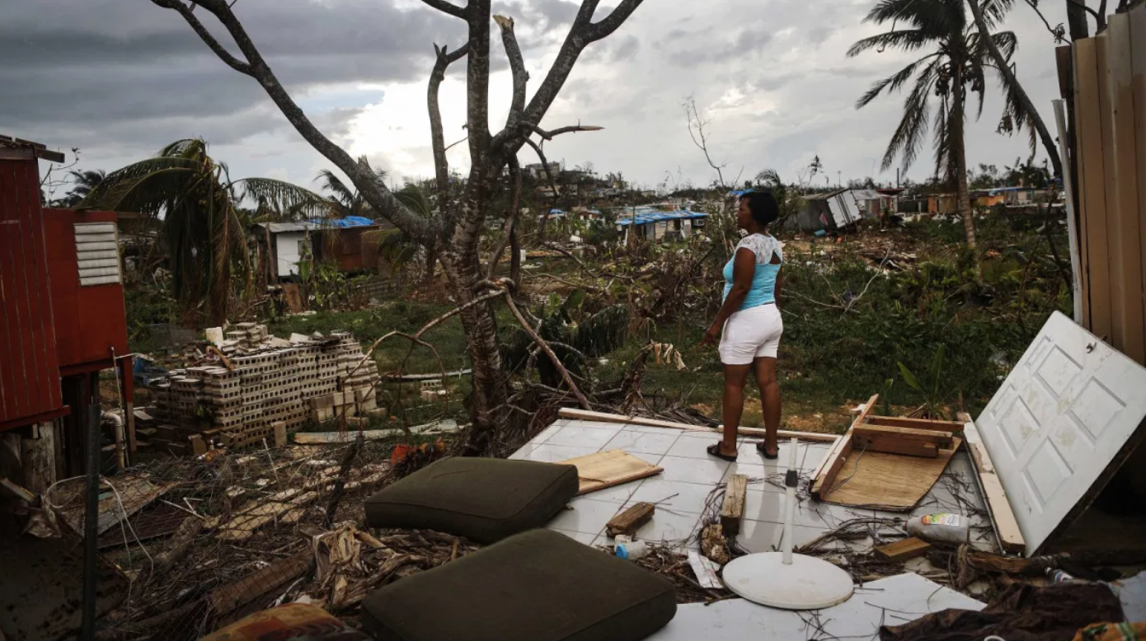
But women and girls may also be a powerful, untapped climate solution: Research organization Project Drawdown lists educating girls as the sixth-most most impactful solution to reducing total atmospheric CO2.
In cities, it’s another story. Air pollution and the heat island effect disproportionately hurt people of color. A 2017 report by the NAACP and the Clean Air Task Force found that black Americans breathe air that’s nearly 40 percent more polluted than white Americans. People of color are also at least 75 percent more likely than other Americans to live in communities that border oil and natural gas refineries.

To level the playing field, we must recognize the double-edged sword of climate change, which both violates human rights and disproportionately affects communities that are already most vulnerable.

“We need to fundamentally change our system on collaboration and equitable development in all parts of the world,” said youth climate activist Jerome Foster II, in an interview this year with Earth Day Network. “Not seeing other countries as a handout, but as responsible to make sure that the entire world is fair and equal.”

One way to work toward a more just, equitable society is for countries to meet their commitments under the Paris Agreement and contribute to the Green Climate Fund, established to limit greenhouse gas emissions in developing countries and help vulnerable societies adapt to climate change.

Recent climate strikes — coordinated by organizations like Fridays for Future, Extinction Rebellion and Sunrise Movement — should make us more optimistic for the future, but they are only a start. Climate change is a global problem that needs global solutions. Everyone, world and youth leaders alike, must be on board to make meaningful change. The future of humanity is on the line.

As climate activist and indigenous hip-hop artist Xiuhtezcatl Martinez told Earth Day Network in September, “For us this is about our survival. This is not just about our future, our future generation. This is about the lives that are being lost today and the people that are being displaced today.”

Step 2: Answer the following questions

According to the article you just read:

- What is the most effective way to delay climate action?

________________________________________________________________________________________________________

- What communities are most vulnerable to climate change? Why?

________________________________________________________________________________________________________________________________________________________________________________________________________________

- What suggestions do you have to help our environment and world?
________________________________________________________________________________________________________________________________________________________________________________________________________________

Step 3: Draw a picture and describe

Draw a picture of your community or world that is not negatively impacted by climate change.

What do you notice about your picture and the pictures in this article?

________________________________________________________________________________________________________
____________________________________________________________________________________________________________________________________________________________________________________________________________________________________________________________________
________________________________________________________________________________________________________________________________________________________________________________________________________________

Student Feedback:

Circle the emojis that best represents how this activity made you feel.

Mindfulness Moment!

Breathing Exercise
To do it:
- Relax your neck and shoulders.
- Keeping your mouth closed, inhale slowly through your nose for 2 counts.
- Pucker or purse your lips as though you were going to whistle.
- Exhale slowly by blowing air through your pursed lips for a count of 4.

Day 1: The Math of Voting: Independence thru the Civil War
Math

What is this lesson about?: In this lesson we will focus primarily on the math of voting during Independence and early years of the United States.

Warm Up Problem-
If Manny gets 20 out of 25 correct on a math test, what grade does that come out to? What percent of the problems did he get correct?

Randy saved $40 in March. In April he saved $50. He saved $10 more in April. But by what percentage did his savings go up by?

Activity #1: Voting and population around 1776

At the time of the American Revolution in 1776, voting was restricted to while male landowners of Protestant faith. Historians estimate that at the time of the Revolutionary War between 10-15% of the population was eligible to vote in the various colonies. Use the chart below to answer questions.

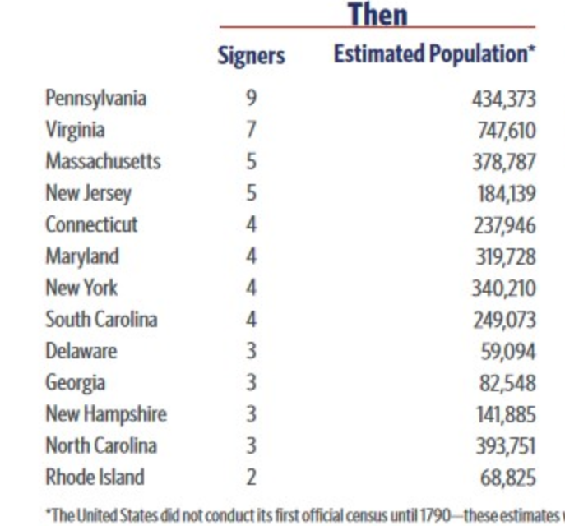

All total, it is estimated that just over 2,500,000 people were living in the US in 1776. Assuming that 10% of them were eligible to vote, how many people was that?

If that 10% figure held across the colonies, how many people would have been eligible to vote in Georgia in colonial elections, about the time of independence?

How would that have compared to Massachusetts?

Activity #2: Women voters in New Jersey

In 1787, with the passage of the US Constitution and Bill of Rights, voting standards were left to each state in the union. All states except New Jersey continued to restrict voting to white male Protestant landowners, which allowed women of all races who owned property to vote as well.

The brief history of how women were granted the right to vote in New Jersey specifically is not widely known. But there are records of white women voting. To date, there is no record of African American women voting in this time period.

Based on 18 New Jersey poll lists from between 1797 and 1807, nine (9) included women’s names.
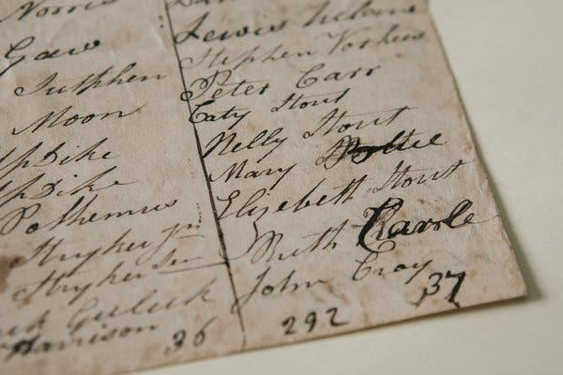

But overall, researchers found that only about 7.7 percent of total votes recorded were cast by women in New Jersey.

- Assume there were approximately 200,000 people living in New Jersey in 1780.
  - If 10% of them voted, how many would that be?

  - And if only 8% of that number were women, about how many women voted, all total in New Jersey?

In the late 1790s, womens’ right to vote began to unravel in New Jersey, amid charges of voter fraud, which coincided with the rise of contested elections and sometimes vicious party politics. More than one election brought complaints of men rounding up carriage-loads of eligible women and bringing them to the polls, to help push their candidate over the top. In 1802, a candidate claimed that he lost a legislative race by a single vote only because a married woman and an enslaved woman had illegally cast ballots.

Finally, in 1806, came a bitterly fought election in Essex County, New Jersey, to decide where a new courthouse would be built. Nearly 14,000 votes were cast — more than the number of eligible voters. The finger was pointed at fraudulent voting by women (and African-Americans, for which there is no record of any voting). So, in 1807, the law was changed to explicitly limit the vote to white men, while also loosening the property requirement. Use the table below to answer a few questions about the voting results from the 1806 election in Essex County.

Eligible Voters, approx # (1800) | 13620
Votes Cast | 14400
Women Voters | 2160
Male Voters | 12240

How many more votes were cast than persons registered?

Approximately, what percentage of the voters were women?

Why do you think so many more men than women voted?

Why do you think, would women and African Americans be blamed for voter fraud?

Activity #3: The Three-Fifths Compromise

The most controversial of all compromises between the North and South, proposed in 1783 as a part of working toward a constitution, was the Three-Fifths Compromise, an agreement to count three-fifths of a state's slaves in apportioning representatives, presidential electors and direct taxes.

This meant that although slaves were NOT allowed to vote, they counted (at a 3/5s rate) when determining the number of representatives each state got to send to the US House of Representatives.

Estimated Population 1780
State | Population | Black | Pct. Black | White | Pct. White
North
New York | 210,701 | 21,054 | 10 | 189,647 | 90
New Jersey | 139,627 | 10,460 | 8 | 129,167 | 93
Pennsylvania | 327,805 | 7,855 | 2 | 319,950 | 98
Connecticut | 206,701 | 5,885 | 3 | 200,816 | 97
Rhode Island | 52,946 | 2,671 | 5 | 50,275 | 95
New Hampshire | 87,802 | 541 | 1 | 87,261 | 99
Massachusetts | 268,627 | 4,822 | 2 | 263,805 | 98
Total | 1,294,209
South
Virginia | 538,004 | 220,582 | 41 | 317,422 | 59
South Carolina | 180,000 | 97,000 | 54 | 83,000 | 46
Maryland | 245,474 | 80,515 | 33 | 164,959 | 67
North Carolina | 270,138 | 91,000 | 34 | 179,138 | 66
Georgia | 56,071 | 20,831 | 37 | 35,240 | 63
Delaware | 45,385 | 2,996 | 7 | 42,389 | 93
Total | 1,335,072

Based on this estimated population chart, above, for 1780, answer the following questions.
What southern state had more African American slaves than whites in 1780?

- All total, about how many African American slaves lived in the 6 southern states in 1780?

- About how many whites lived in those same 6 southern states at that time?

Based on the three-fifths compromise, slaves in the southern states would ‘count’ when it came to deciding on Representatives to Congress even though they could not vote locally.

- Compare the white and black population of South Carolina to Connecticut.

Connecticut: Black Population ______________ White Population _____________

South Carolina: Black Population ___________ White Population_____________

- Compare the overall population of those same states in 1780.

- Which state would have more representatives in Congress.

- Does this seem fair?
  - To residents of Connecticut?

  - To white representatives of South Carolina?

  - To African Americans from South Carolina who ‘counted as ⅗ of human, but could not vote?

Activity #4: Expanding voting rights--to nearly all white men

By 1828, all of the states in the union had amended their state constitutions to remove the limits on any religious groups from voting. And by 1828, it is estimated that nearly 35% of US citizens were eligible to vote, up from 10-15% in 1776.

By 1856, just prior to the Civil War, all states (North Carolina being the last) had amended their constitutions, removing the property-holding requirement.

African Americans and women could still not vote, but all white men over 21 could. The map below shows the percentage of the population in the southern states in 1860, just before the start of the Civil War. Use the map to answer the questions below.

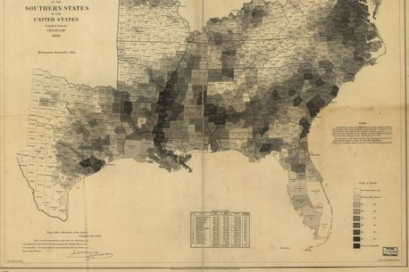
It is hard to see the details of this map, which is an original. But the dark shaded areas represent areas where up to 90% of the population was held as slaves. All together, there were almost 4 million slaves just before the start of the civil war.

- List 2-3 geographic areas where the population was 90% or more slaves?

- Remember back to last week when we studied how the prison population gave voting power to areas with prisoners who could not vote. How does slavery and the 3/5ths rule do the same thing concerning voting rights to those not imprisoned and not enslaved?

Student Feedback:
Circle the emojis that best represents how this activity made you feel.

Day 1: Digital Rights- Privacy
Digital Health

What is this lesson about?: Today you will learn about your digital rights. We will focus on digital privacy and identify your rights. Exploring your rights through the lens of what parents post on social media.

Step 1: What are digital rights?

Digital Rights and Responsibilities:
Every digital citizen is granted rights while in the digital world. These include, but are not limited to: privacy, freedom of speech, the right to internet access, freedom of assembly online, and the right to develop their internet infrastructure.
Answer the question below:
Which of the digital rights explained above are most important to you? Why?

Step 2: Read the article on your digital rights

Alison Santighian flicks her finger over her smartphone screen, and her Facebook profile scrolls past in a blur. She is looking for a particular photo from a few days ago, a picture her 9-year-old son, Arsen, didn't want her to take.

"Found it!" she says, as Arsen, sitting on the family's patio at their Bethesda, Maryland, home, peers over her shoulder. "He looked very handsome that day," Alison explains, and Arsen rolls his eyes. He was dressed in a dapper white suit for a piano performance, and when Alison asked him to pose for a picture that she could share with her Facebook followers, Arsen said he'd rather not.

In the end, they landed on a compromise, and Arsen did strike a pose, by slumping in his seat with a piano music book tented over his face, his expression hidden.
There have been more negotiations like this lately, as the Santighian kids - Arsen and his 11-year-old sister, Elsa - have begun asking questions and expressing opinions when their parents decide to share a photo or personal anecdote on social media. Such conversations have become a nearly ubiquitous rite of passage among families where children of a certain generation - the true digital natives, many of whom may have debuted on Facebook before exiting the womb - are now old enough to have their own ideas about what they want their online presence to look like, and who has the right to define it.

At first, the choice belongs to parents alone since an infant can't object to a soft-filtered selfie with mama; or a toddler won't know if their tantrum becomes a topic of online commiseration. But when, exactly, does it start to change? Is there a turning point somewhere between first steps and first school dance, a clear moment when one's offspring becomes an independent being whose experiences belong to them, too, and not just to a proud (or confounded, or frustrated) parent who just wants to boast (or inquire, or vent)?

The stakes of this particular familial conflict are poised to increase as more members of Gen Z - a generational cohort that the Pew Research Center defines as those age 22 and younger - come of age. Children might first be concerned about what their friends think of a parent's posts or pictures - but later, new concerns are added to the mix: If you made a joke that your dad shared on Twitter, will a college-admissions officer think it's funny? If a potential employer Googles your name, would they find pictures of you and your sister in bathing suits at the beach?

Alison and her husband, Pete, think the line of authority begins to blur a bit as kids become teens and inch closer to legal adulthood. For now, when Elsa and Arsen object to a photo or a social media post, they are encouraged to explain why, and Pete and Alison take those points seriously.

But ultimately - in this household, at least - the parents make the final decisions, and they don't have to ask permission.

"We do post things that they don't know about," Alison says. "Cute pictures of them sleeping, for example."

"Oh, I know about that," Elsa corrects her. "It's kind of creepy, if you think about it." She smiles and shrugs. "But I'm fine with it."
"Why is it creepy, Elsa?" Pete asks.
"Because you're in your sleep," Elsa says.
"We look at you all the time when you're asleep!" Alison says.
"That's looking," Arsen interjects, "not posting."

Alison and Pete consider this for a moment. Alison laughs and starts nodding.
"You know," Pete says, "that's a good argument."

When Stacey Steinberg began the research that would make her a leading expert on "sharenting," she felt sure that - as a lawyer who had prosecuted child abuse cases - she'd wind up concluding that parents really shouldn't post anything about their children online.
"But what I really found in my research, and in my own life - because I'm a mom who shared on social media - is that there are so many benefits that come from sharing our stories," she says. "If we were to silence our voices as parents, I think our families would miss out on opportunities to connect, and society would miss out as well."

Parents offer a myriad of reasons for wanting to share their experiences on social media: There's a sense of community there, a source of solidarity and support amid the triumphs and pitfalls of parenting. It's a way to keep far-flung relatives in the loop. It's a journal, a photo album, a memory box where the magical and mundane moments of fleeting childhood can be revisited again and again with the tap of a finger.

To whom do those memories belong?

"When kids are really little, their story is so connected and embedded with a parent's story," Steinberg says. "Then it gets more complicated as they get older, as they have their own digital identity, and they have more of an interest in controlling what that identity looks like."
Viji Sathy, a photographer and educator in Chapel Hill, North Carolina, sensed this shift in the past year, as her 10- and 12-year-old boys began responding to her camera with a certain wariness.

"They started asking, 'Are you going to post that?' " she says, "and once I got that from them a couple of times, I started asking them, 'Is it okay if I share this?' "

Usually, it is. But sometimes - like when the boys have impromptu jam sessions together on saxophone and piano - they ask her to refrain from recording them. (A video feels more personal and invasive than a photo, they say.)

Sathy has been sharing her family's story through images and video since her boys were infants, "so it's hard for me to surrender that control, because this is something for me, too," she says. "But we talk about the importance of consent in general, and this is another example of how we respect consent and model it for our kids."

That was the precise word used by the actress Gwyneth Paltrow's teen daughter, Apple Martin, who sparked a fervent debate about online privacy when she issued a pointed, public callout to her mom after Paltrow shared a photo of the pair on a ski trip in March.

"Mom we have discussed this," Martin wrote in a comment on Paltrow's Instagram post. "You may not post anything without my consent." (Paltrow posted in response, "You can't even see your face!" )

A torrent of judgment swiftly followed, with thousands of commenters weighing in: Martin was being unreasonable. Paltrow was being irresponsible. Martin had a right to her privacy. Paltrow had a right to her parental pride.

Most kids don't have Hollywood A-lister parents with 6 million Instagram followers. But many of Martin's Gen-Z peers share a desire to curate their own online image, says Jason Dorsey, president of the Center for Generational Kinetics, a global Gen Z and millennial research and consulting firm. The company conducted a survey of thousands of members of Gen Z across the United States, Europe and Australia last year, and found that they are especially savvy about digital privacy on social media.

"These are kids who have always been on social media through their parents, and for a long time, some kids might think that's cool: 'How many likes did we get?' It's almost like a game," Dorsey says. "But what happens is those same kids then become tweens and teens and have not only more awareness about the positives and negatives of social media, but they have all the normal questioning of identity and body image, and now they're very aware of the message that they're sending to the world."

And kids - even young kids - want more control over that message.
"I think that everything that's a picture of me, I have the right to veto," says Sathy's 10 year-old son, who asked not to be named to protect his privacy. "I mean, it's me, isn't it? I should get to control what is shared about me."

In general, Steinberg says she thinks parents should defer to their kids. But there will always be exceptions, she adds. Say, for instance, that a child doesn't like how he looks in a group photo at a family wedding; that picture might be shared anyway.

"What I've learned over time is that this isn't a black and white issue, this is a complicated issue," she says. "They might be the first generation of kids who are growing up with a digital footprint, but we're also the first generation of parents trying to navigate these new seas in our parenting repertoire. Every family needs to talk about it, but I don't think every family needs to come up with the same answer."

For Paltrow, the answer was to leave the disputed Instagram post in place - but to make sure that her daughter's 15th birthday photo was "Apple-approved." (Paltrow included an image of a text exchange to prove she'd obtained Martin's consent.)

Stacey Ferguson, co-founder of the popular Blogalicious online community and conference and a mom of three in Maryland, says she also favors kid-approved photos when she posts to her public Instagram account, where she has nearly 5,000 followers.

But she made a rare choice to overrule her oldest daughter's wishes during a recent spring break trip, when Ferguson posted a picture of her 14-year-old "and she had a meltdown," Ferguson says. "She said, 'You have to take it down, it's awful!' "

Ferguson didn't take the photo down. "I don't want to embarrass her, but she truly looked fine, and I wanted her to know: Even though, in your teenage mind, you think you look bad, you look great," she says. "I didn't want to reinforce that self-consciousness, that concern about 'What are people going to think, how do I look?' And she got over it quickly - she said, 'Fine, Mom,' and moved on."

For Doug French, a single father of two in Ann Arbor, Michigan, who began blogging about fatherhood in 2003 and co-founded the Dad 2.0 Summit, an annual conference about dads, marketing and media, the answer has been to let his 14- and 17-year-old sons have the final say over what he shares.

"I like to post quotes of Robert's on Facebook, because I want to chronicle them; he's funny," French says of his older son. "But anytime he says something that I want to quote, I run it past him first. And there have been a couple he didn't want me to post."
And that should be enough, Robert says.

"In this age, you have to watch your image, and that extends to what your parents post about you, and it's not fair for your parents to be defining your image for you," Robert says. "So when a kid objects, a parent should listen, and yield."

Step 3: Answer these questions about the article above.

- Do you think parents can just post pictures of their kids without getting their permission first?

- How old do you have to be to give permission for your own content?

- What age do you think you crafted your own digital identity? Why?

Step 4: Design a rule book for parents. This should include all the rules about the privacy of their own kids.

Mindfulness Moment!

Draw Your Breath
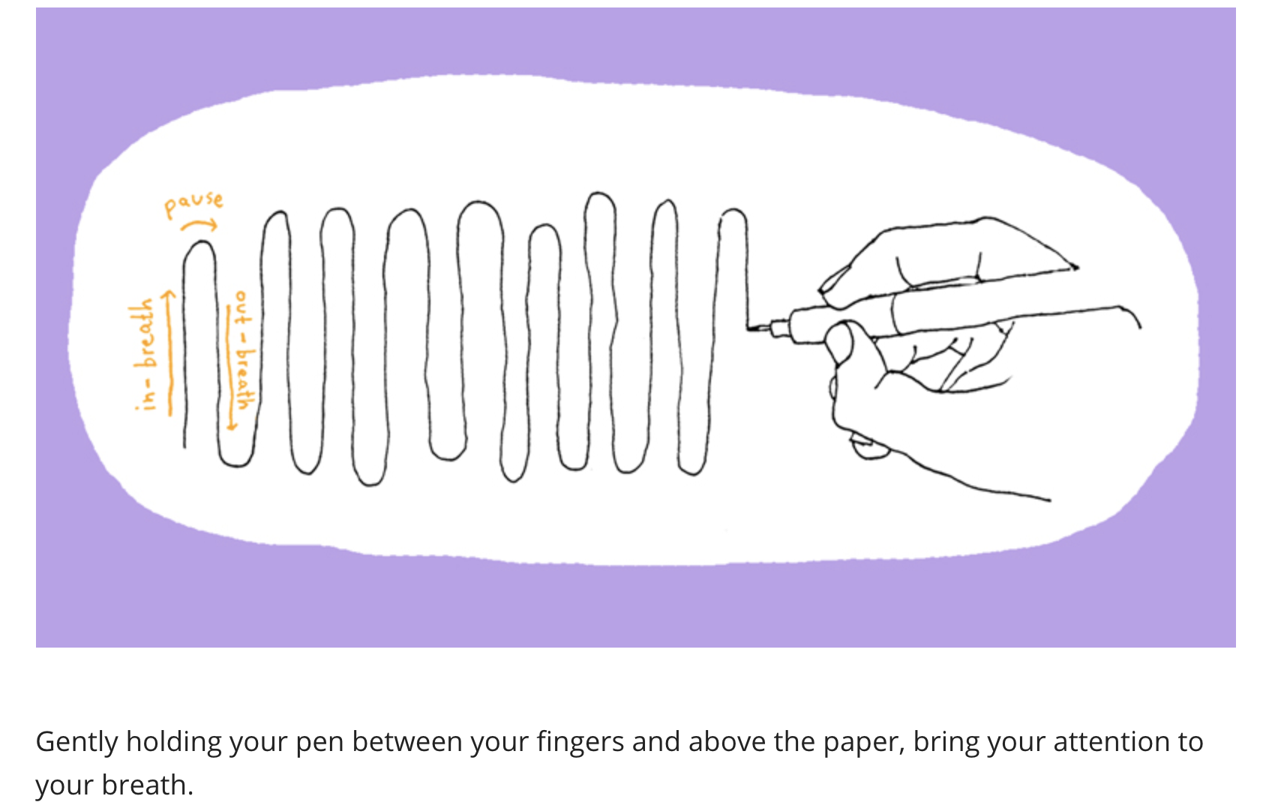

Day 1: The Bill of Rights
Social Studies

What is this lesson about?: Today you will get an introduction to the Bill of Rights in the U.S. Constitution and learn about the rights it protects.

Step 1: Warm-Up

After the Declaration of Independence in 1776, the Founding Fathers began working on state and federal constitutions. Although a bill of rights was not considered to be important at first, supporters realized it was crucial for ratification. Due largely to James Madison, the Bill of Rights officially became part of the Constitution in December 1791. The Bill of Rights consists of the first 10 amendments to the U.S. Constitution.

Can you name any of the rights or freedoms in the Bill of Rights?

Step 2: Read the Article

Give the people what they want: A bill of rights
By Virginia Calkins, Cobbleston Magazine
On a bitterly cold night in January 1789, James Madison suffered a frostbitten nose. It happened while he was campaigning in his Virginia district for the House of Representatives of the First Congress of the United States. Madison and his opponent, James Monroe, had stood outside a church to publicly debate the issues of the campaign. By the time Madison had finished his long ride home afterward, his nose was frozen.
No one expected Madison to win the election. The voters wanted amendments to the Constitution guaranteeing individual rights, and Madison's enemies had spread rumors that he opposed them. At first, Madison had doubted that such amendments were important. But now he supported them, in part because Thomas Jefferson had praised them in his letters from Paris, where he was serving as U.S. ambassador. Madison also realized that it was what the voters wanted. To make his position clear, Madison was traveling throughout his district, promising the people the amendments they wanted.
Madison won by a comfortable majority and in the spring of 1789, began his congressional duties in New York. By the time he arrived there, he had prepared a list of amendments to the Constitution. Most came from the Virginia Declaration of Rights, but some were from other states' bills of rights. All had been taken from 150 or more amendments proposed by the states as they ratified the Constitution.
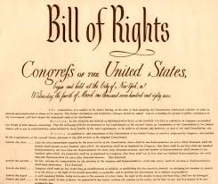
It was more than a month, though, before Madison had the opportunity to read his proposal for a bill of rights to the House of Representatives. He recommended that the points be worked into the main body of the Constitution. After a committee reviewed them, the amendments were put before the House for consideration.
Many of the amendments dealt with personal liberties that had been trampled by the British when the states were still colonies. Concepts such as freedom of religion, freedom of speech, freedom of the press, freedom to assemble in protest and freedom to petition the government for redress (correction) of grievances (wrongs) were very important to American citizens.
Madison also proposed that the Constitution protect the right to keep and bear arms, so that states could form their own militias and citizens could protect themselves, since at the time there were no professional police forces. Congress added a provision prohibiting any army or militia from forcing citizens to house soldiers. During the Revolution, many colonists had suffered the invasion of British soldiers into the privacy of their homes.
The House readily agreed to the clauses Madison had written guaranteeing due process of law; prohibiting self-incrimination and double jeopardy; forbidding cruel and unusual punishment or unreasonable searches and seizures; and the rights to a speedy trial and trial by jury.
Congress now considered the amendment Madison believed to be most important: "No State shall infringe the equal rights of conscience, nor the freedom of speech, or of the press, nor the right of trial by jury in criminal cases." He felt that states, too, should have to protect these basic rights.
Many people had objected to the idea of writing a bill of rights because they felt that listing certain rights this way would imply that others did not exist. So, Madison composed an amendment stating that the inclusion of certain rights in the Constitution "shall not be construed to deny or disparage other rights retained by the people." A final amendment reserved to the states any powers not delegated to the federal government by the Constitution. Madison himself would have preferred that the bill of rights also limit the ability of states to infringe on protected liberties, but Congress preferred to address only federal power. Not until 1868, with the passage of the 14th Amendment, would the states be responsible for the protection of the rights of their citizens.
Twice during the House debates, Roger Sherman of Connecticut rose to suggest that these amendments be numbered and added to the end of the Constitution instead of to articles within the text, as Madison had proposed. The second time Sherman spoke, the other House members agreed. As a result, the amendments were preserved together as a strong statement of individual rights.
As representatives approved each element, they reworked Madison's proposals into 17 amendments and sent them to the Senate for its approval. The Senate reworked them further, dropping one (requiring state guarantees) and combining those concerning freedom of religion, speech, press, assembly and petition into one.
On September 25, 1789, Congress sent these 12 amendments to the president, who forwarded them to the states for ratification. Only the final 10 received the necessary ratification by nine states. The original first and second amendments — dealing with how representation in Congress would be determined and with congressional salaries — were not ratified.
New Jersey was the first state to act, recording its favorable vote on November 20, 1789. On December 15, 1791, Virginia became the last state to ratify the document, and the 10 amendments we now know as the Bill of Rights officially became part of the Constitution. And with Virginia's approval, Madison helped give the American people what they had wanted. The Bill of Rights are natural human rights all people are born with, and that nobody should have to live without. The Bill of Rights was written to protect individuals from government infringing on those rights.

Step 3: Answer questions

What is the Bill of Rights?

Step 4: Matching rights with amendments
Read and review the Bill of Rights on the next page. Then use what you learned to match the amendment with the correct summary.

- 1st Amendment _______
- 2nd Amendment _______
- 3rd Amendment _______
- 4th Amendment _______
- 5th Amendment _______
- 6th Amendment _______
- 7th Amendment _______
- 8th Amendment _______
- 9th Amendment _______
- 10th Amendment _______

- No quartering of soldiers.
- Right of trial by jury in civil cases.
- Right to keep and bear arms in order to maintain a well-regulated militia.
- Other rights of the people.
- Rights of accused persons, e.g., right to a speedy and public trial.
- Freedom from unreasonable searches and seizures.
- Freedom of religion, speech, press, assembly, and petition.
- Right to due process of law, freedom from self-incrimination, double jeopardy.
- Freedom from excessive bail, cruel and unusual punishments.
- Powers reserved to the states

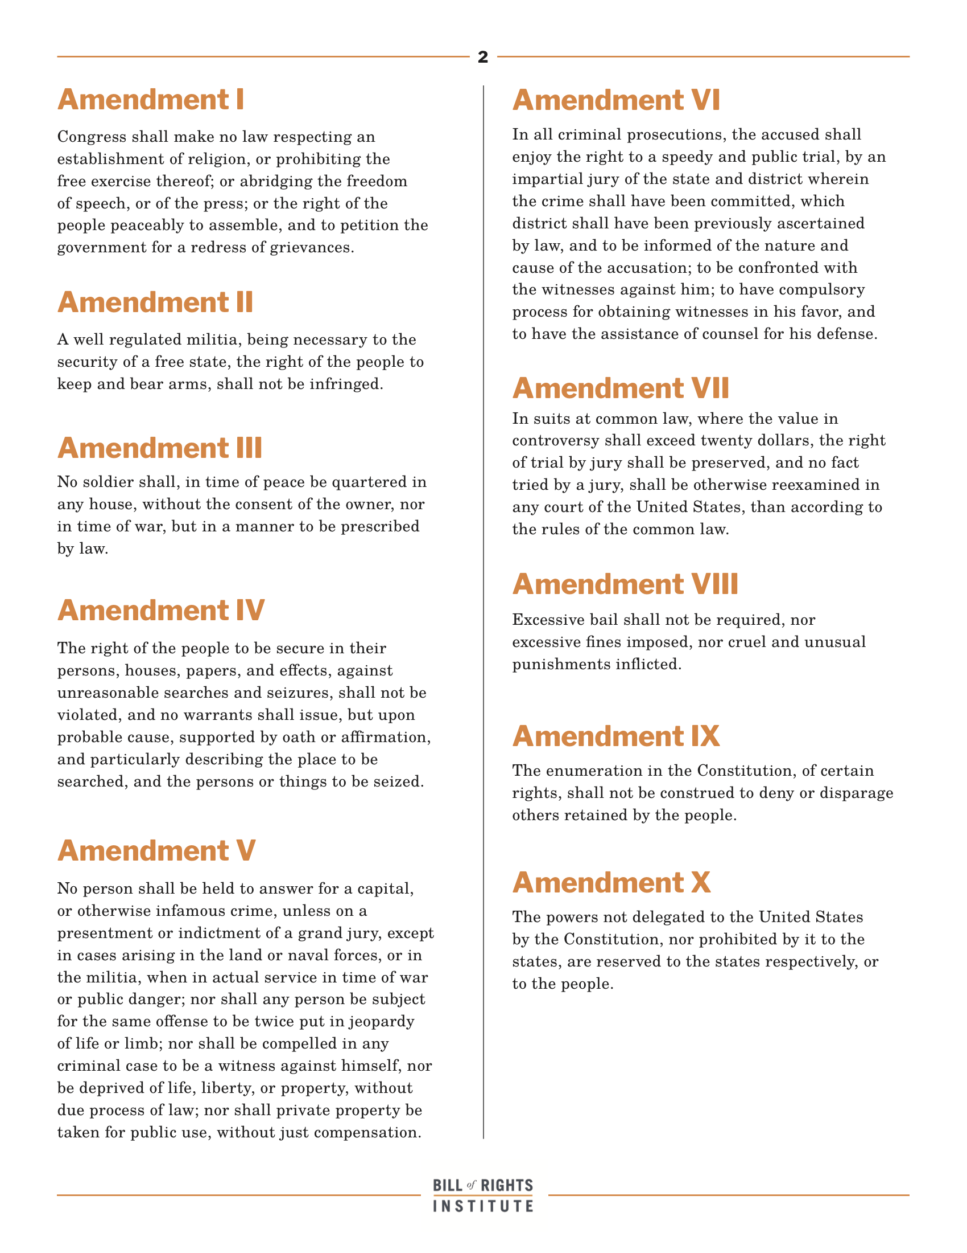

Step 5: The Bill of Rights Practice

Consider the scenarios below and identify 1) which right is being violated? and 2) which amendment offers protection against such a violation?
*if possible, work with a partner for this activity

1. Congress wants to find ways to cut costs because of the soaring budget deficit. Congress passes a law to require American citizens to house US soldiers in their homes during peacetime.  What right is being violated?  What amendment offers protection against such a violation? | 4. Carolyn is arrested for shoplifting a candy bar from a grocery store. At trial, she is found guilty. The judge decides that the right punishment is to cut off Carolyn’s hands so she will not be able to shoplift again.  What right is being violated?  What amendment offers protection against such a violation?
2. Concerned about rising crime, lawmakers for the District of Columbia ban all handguns in the city, and require that shot-guns be kept unloaded and/or disassembled.  What right is being violated?  What amendment offers protection against such a violation? | 5. Elizabeth is twelve years old. Her parents are very religious, but she is not. Once a week, Elizabeth’s parents make her come with them to their place of worship. Elizabeth always says she does not want to go, but her parents make her come with them anyway  What right is being violated?  What amendment offers protection against such a violation?
3. Gennie, a college student, is arrested for stealing a classmate’s designer sweater and selling it on eBay. When Gennie appears before the judge, she asks for a lawyer to help defend her. The judge tells Gennie that if she is smart enough to be in college, she knows enough to defend herself, so she won’t be getting a lawyer.  What right is being violated?  What amendment offers protection against such a violation? | 6. John, a fourteen-year-old public school student, wears a shirt to school that says “Be happy, not gay” to express his belief that homosexuality is wrong. His dean tells him he must change his shirt or be suspended from school. John refuses, and is suspended for a week.  What right is being violated?  What amendment offers protection against such a violation?

Step 6: Create a graphic organizer
Use the below graphic organizer to describe each amendment in the bill of rights and draw an image/doodle to help you remember what the amendment is about!
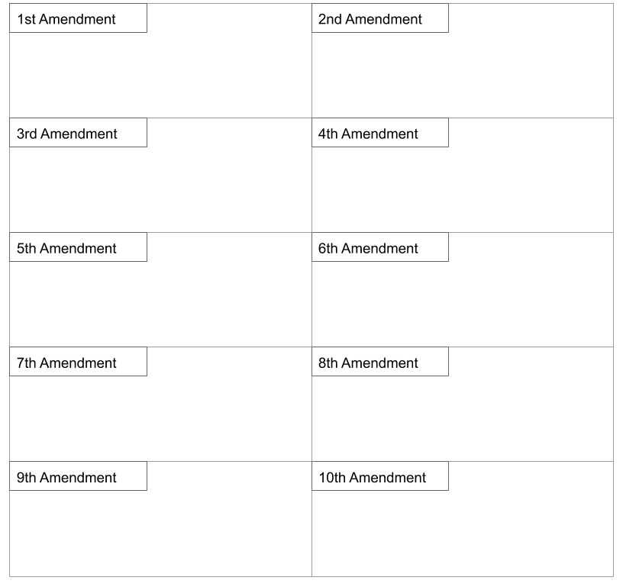
Student Feedback:
Circle the emojis that best represents how this activity made you feel.

