Week 6
Change

Day 2

NAME:______________________

Day 2 Agenda

Topic | Activity
Warm-Up!
English Language Arts | - Read the article, The Evolutionary Advantage of the Teenage Brain  - Respond to questions about the article  - Analyze an informational document  - Create their own informational sheet directed at an audience of their peers.
Science | - Read about Recycling  - Answer questions about what you read  - Draw a picture and explain
Mindfulness Moment!
Math | - Change and the Environment, Day 1: Pollution, race and wealth
Health | - P.E.
Mindfulness Moment!
Civics/Social Studies | - Changing explanations of the Salem Witch Trials  - Read and respond to the text

Warm-up Activity: Write a journal entry around the daily quote on identity.

Day 2: How is our brain changing?
English Language Arts

What is this lesson about?: Today you will continue to think about the theme of “change”. You will learn about how the teen brain works and changes as you mature and you will also read and discuss some ways that we can deal with changes in a positive way.

Before you read: Review key vocabulary

delusion: belief or impression that is firmly kept despite being contradicted by what is generally accepted as reality | neuroscience: sciences, that deal with the structure or function of the nervous system and brain. | evolutionary: gradual development of living organisms from one form to another.
arbitrary: based on random choice | adaptive: changeable | refine: to improve (something) by making small changes
impulsive: acting or done without thinking beforehand. | Misguided: wrongly informed, foolish | immortality:ability to live forever
neural: related to the nervous system. | analogy: comparison between two things for the purpose of explaining

Step 1: Read the following text.

The evolutionary advantage of the teenage brain
By Andy Murdock, UC Newsroom, Thursday, November 30, 2017

Teens. OMG. What on earth is going on inside their brains to make them act so, well, like crazy teenagers?
The mood swings, the fiery emotions, the delusions of immortality, all the things that make a teenager a teenager might just seem like a phase we all have to put up with. However, research increasingly shows that the behaviors of teenagers aren’t just there to annoy parents, they serve a real evolutionary purpose.
Changing minds
What is a teenager? Our standard definition is arbitrary: If your age ends in “-teen,” you’re a teenager. The brain, however, follows a different set of rules.

“From a neuroscience perspective, we know that the brain keeps growing and developing,” said Adriana Galván, associate professor of psychology at UCLA and director of the UCLA Developmental Neuroscience Lab. “Current literature suggests that it's around age 25 or so when the brain finishes the period of adolescence.”
It’s not that the brain stops changing — every time we learn something new, our brain changes — but by around 25, our brain has finished its long process of structural development. For teens, not only is the brain still very much in development, but different regions of the brain are changing at different rates, with important consequences.
“What that means is the regions in these different parts of the brain keep refining themselves,” said Galván. “In particular, there's greater activation in emotion centers deep in the brain, and there's also continued development of the prefrontal cortex, which is found right above the eyes.”
The prefrontal cortex is what allows us to think about the future, to understand consequences, and generally make better decisions. Not surprisingly, the prefrontal cortex of teens still has a lot of work to do to grow into adulthood.
One way to think about it is that brain has two sides, an impulsive side, and a cautious side, that balance one another.
Before we reach adulthood, the impulsive side of the brain is charging ahead, while the cautious side of the brain is still playing catchup. The result is a teenager.
“The analogy is that these two are kind of going head-to-head. And then eventually, as individuals become adults, the prefrontal cortex will win out, and have more influence over behavior than the impulsive part of the brain,” said Galván.
The game of risk
The delayed development of the prefrontal cortex might not be a simple side-effect of human development. Teen behaviors that grownups often dismiss as mere annoyances are actually adaptive traits that help teens learn and succeed, Galván and others have found.
Teenage behaviors aren’t unique to humans: adolescent chimpanzees, for example, begin courtship behaviors, play less, and increase their grooming of other, among other changes.
While some teens can appear chimp-like at times, humans have their own unique set of adolescent behaviors, including increased risk-taking and the onset of powerful emotions that weren’t present in childhood.
“Risky behavior, regardless of what the risk is, taps into the very same neural regions that process reward,” explained Galván. “So when you experience a risk in a positive way, the brain activation is the same as if you experienced a reward.”
Galván’s research has found that not only are teens more sensitive to rewards than adults, this makes them better learners.
“Compared to adults, adolescents have more [reward center] activation when they're learning a new task, and this greater activation helps them learn from the environment in a more adaptive and efficient way than the adults,” said Galván. “It's kind of a surprising result.”
High emotions may also benefit teens in ways that even the teens themselves likely don’t appreciate.
“There is probably an evolutionary reason for why teenagers are more emotional. One reason is that emotions help us connect with other people,” said Galván. “Emotions also serve as an important learning tool. When you feel a particular emotion, you're more likely to remember the event.”
If something negative happens, the emotions you experience will help you steer clear of those events in the future. Positive emotions will reinforce a behavior, making you more likely to repeat it.
If Galván could bust one myth about teenagers, it’s that teenagers should be quieted down until adulthood.
“The idea that the adolescent years don't serve a purpose other than annoying parents or hanging out with friends, is, I think, misguided,” said Galván. “All of the experiences that happen during adolescence are important for the individual's growth.”
The evolutionary advantage of the teenage brain https://www.universityofcalifornia.edu/news/evolutionary-advantage-teenage-brain via @UofCalifornia
Step 2: Answer the questions below:

- What does the pre-frontal cortex part of the brain control? How does the fact that it is not fully developed until someone is in their 20’s affect teen behavior?

- Teens tend to increase their “risky” behavior during adolescence. What does the article note as the positive side of this risky behavior?

- How does being more sensitive or emotional during adolescence help teens become better learners?

- What additional benefit do teens experience because they are more emotional?

Step 3: Read the informational fact sheet
Now that you have a background on how the teen brain is changing and adapting during adolescence, you are going to read an informational sheet that presents information in a clear and concise way that uses graphics or pictures to help readers understand. As you read, underline or star 3-4 facts that you find interesting.

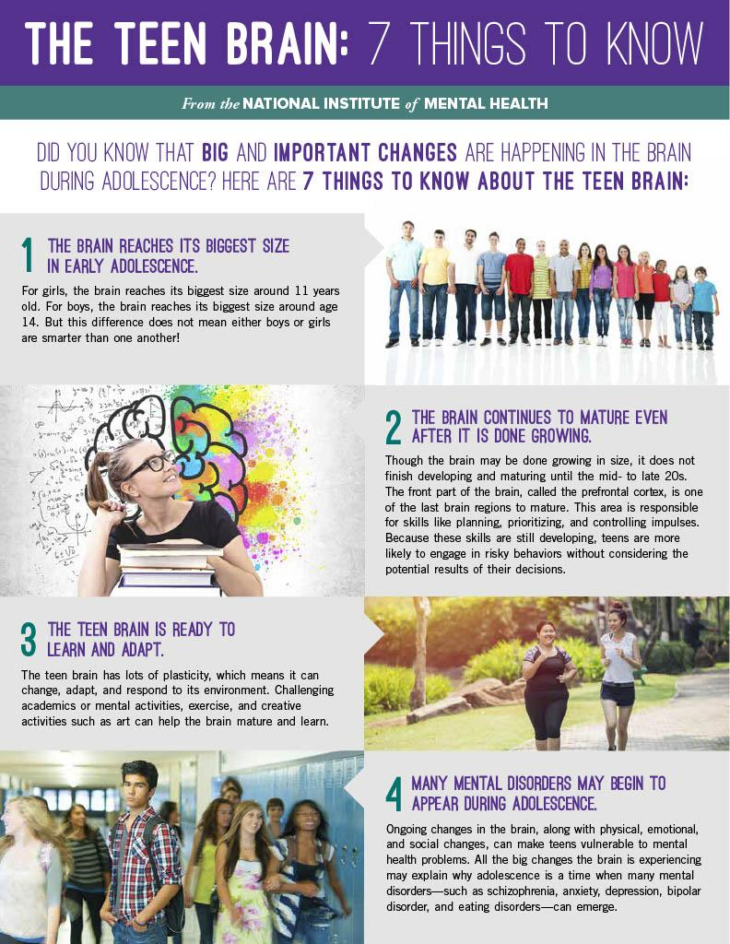
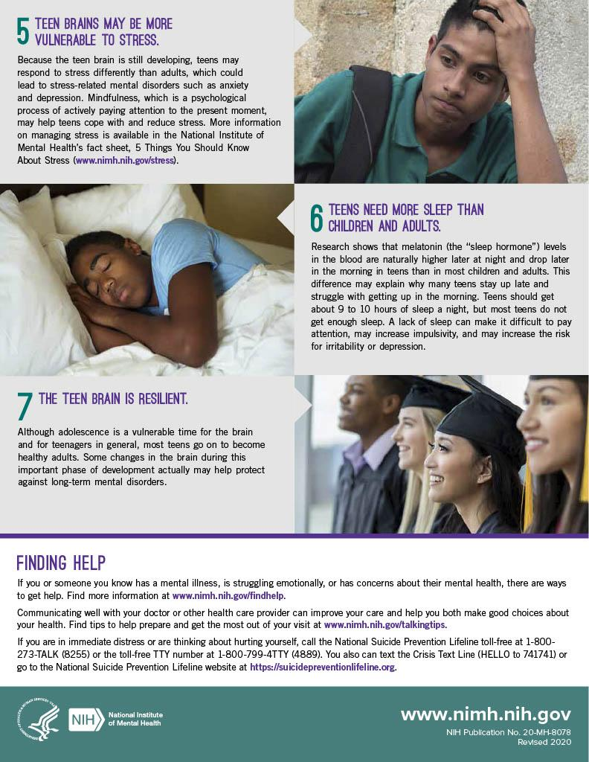

Step 4: Create your own Informational Sheet
Create an informational sheet/flyer to inform teens about their brains and give advice to teens on how to promote healthy brian development. Use information from the article and the poster but make sure to paraphrase (put into your own words) what you have learned. Use the template with the background provided but make sure to include at least 4 facts about the teen brain and at least 3 pieces of advice for teens on what they can do to support healthy brain development and change.

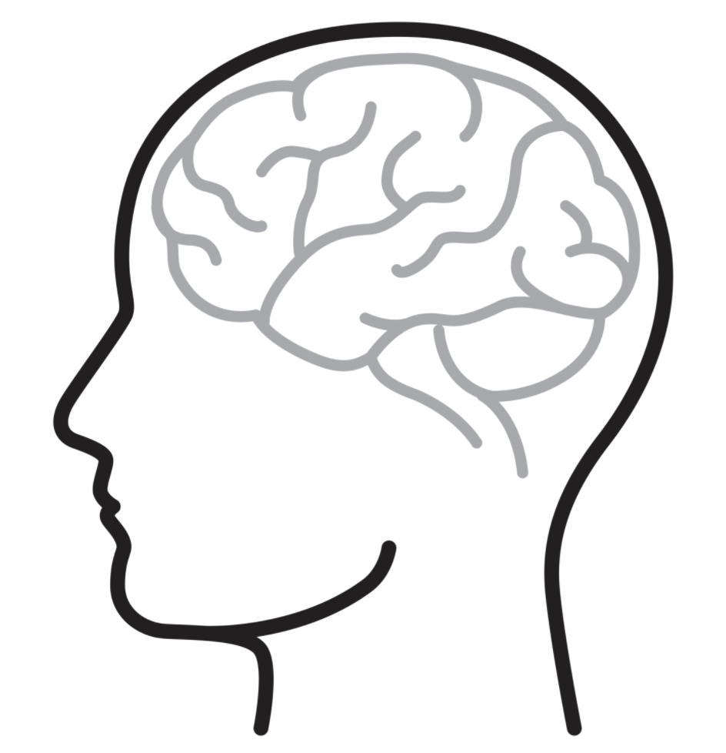

Step 5: Share out with a partner.
What do your posters have in common? What wording or graphic did your partner use to specifically address the teen audience?
Student Feedback:

Circle the emojis that best represents how this activity made you feel.

Day 2: Recycling
Science

What is this lesson about?: Today you will read through the Recycling passage. You will answer a few questions about what you read. You will complete a Recycling activity.

Step 1: Read through the Recycling passage

Recycling
(Technological Solutions)
What is recycling?
Recycling is a way to take trash and turn it into new products. There are a number of different recycling processes that allow materials to be used more than once.

What can be recycled?
All sorts of materials can be recycled. Some of the most common processes in use today involve recycling plastic, glass, metals, paper, electronics, and textiles. Typical used items made of these materials include soda cans, plastic milk cartons, newspapers, old computers, and cardboard boxes.

Recycling bins for different types of materials

How does recycling work?
Recycling is actually a complicated process and is different for each type of material.

Aluminum cans - Aluminum cans were one of the first items to be heavily recycled. The process isn't quite as complicated as it is for some other materials. The cans are first shredded and then melted. From there, the aluminum can be used to make new cans and other aluminum items.

Plastic bottles - There are a lot of types of plastics and each type is made from a different combination of chemicals. As a result, plastic bottles are first sorted into their various chemical types. Then they are cleaned to get rid of any leftover food or other waste. Next, the bottles are crushed or shredded into fine plastic chips. Then the chips can be melted down to create new plastic or turned into a fiber used for making carpets or clothing.

Paper - Paper starts its recycling process by being mixed with water and other chemicals to break it down. It then gets shredded and heated up. This process eventually turns the paper into a pulp or slurry. The pulp gets strained in order to remove any glues or plastics. After that, it gets cleaned and bleached to remove any left over inks or dyes. Now the pulp is ready to be made into new paper.

Computers and Batteries - Computers and batteries are usually recycled in order to remove harmful chemicals as well as to recover, or salvage, some valuable materials such as gold from electronics boards.

The Recycling Loop
The recycling symbol, or loop, has three arrows. Each arrow represents a different step in the recycling process. These steps are:
- Collecting recyclable materials, like aluminum cans and plastic bottles.
- Processing the old materials and making new items.
- Buying items made from recycled materials

Benefits of Recycling
There are a number of benefits from recycling. These include:
- Landfills - Recycling materials means less trash and saves space in dumps and landfills.
- Resources - When we use materials again, this means we can take fewer resources from the Earth.
- Pollution - In general, recycling materials can produce less pollution helping to keep our environment clean.
What can you do?
Be sure to recycle everything you can in your house and school. There is almost always a "recycle" trash can around. Be sure to drop your used aluminum cans and plastic bottles there. At home, be sure to put paper items like the newspaper, cereal boxes, and homework pages into the recycle bin.

Fun Facts About Recycling
- Plastics are usually marked with an identification code that shows a recycling symbol and a number from 1 to 7. This indicates the type of chemicals, or polymer, used in making the plastic.
- Used paper can be recycled around seven times. After this the fibers get too short and are filtered out by the recycling process.
- Some waste material is turned into electricity energy by burning it in modern incinerators.
- Glass is one of the best recycling materials. Clear glass can be recycled over and over again.
- In 2009, the United States recycled around 1/3 of all its waste. Around 7 million tons of metals were recycled.
Step 2: Answer the following questions

- Which of the following is sometimes recycled into fibers for carpets or clothing?
  - Aluminum cans
  - Plastic bottles
  - Paper

- Which of the following materials is converted into a pulp or slurry during the recycling process?
  - Aluminum cans
  - Plastic bottles
  - Paper

- Gold is sometimes recovered from recycling which of the following materials?
  - Computers
  - Aluminum cans
  - Plastic bottles

- How many arrows are there in the typical recycling loop?
  - 3
  - 4
  - 5

- What do the arrows of the recycling loop represent?
  - The main materials that can be recycled
  - A different step in the recycling process
  - A different method of recycling materials

- Around what percentage of trash in the United States is recycled?
  - 33%
  - 27%
  - 10%

- Recycling can be a very complicated process and is different depending on the type of material.
  - TRUE
  - FALSE

Step 3: Draw an image/picture

Imagine if there was no recycling. Draw a picture of what your community would look like. What would you do to help your community understand the importance of recycling?

Explain what you would do to help your community understand the importance of recycling?

____________________________________________________________________________________________________________________________________________________________
____________________________________________________________________________________________________________________________________________________________
________________________________________________________________________________________________________________________________________________________________________________________________________________________________________________________________________________________________________________________

Student Feedback:

Circle the emojis that best represents how this activity made you feel.

Mindfulness Moment!
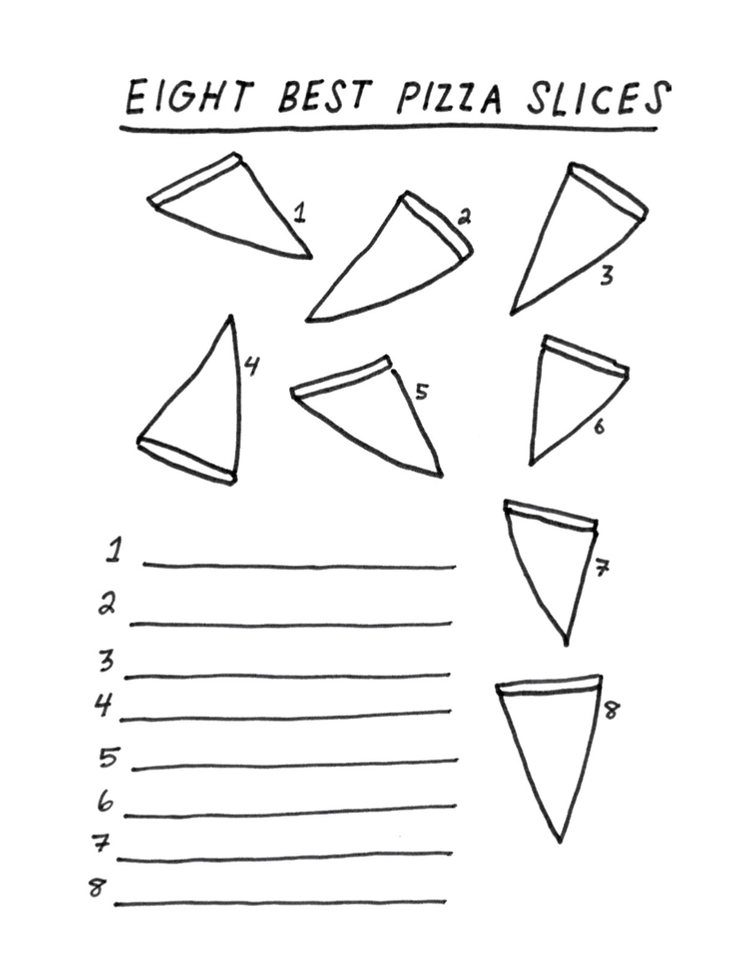

Day 2: Change/Pollution & COVID-19
Math

What is this lesson about?: Today we are going to focus on how the COVID-19 outbreak has influenced and is influenced by pollution. It has created significant changes to the pollution we see and feel and are influenced by.

Today’s Warm-Up Problem
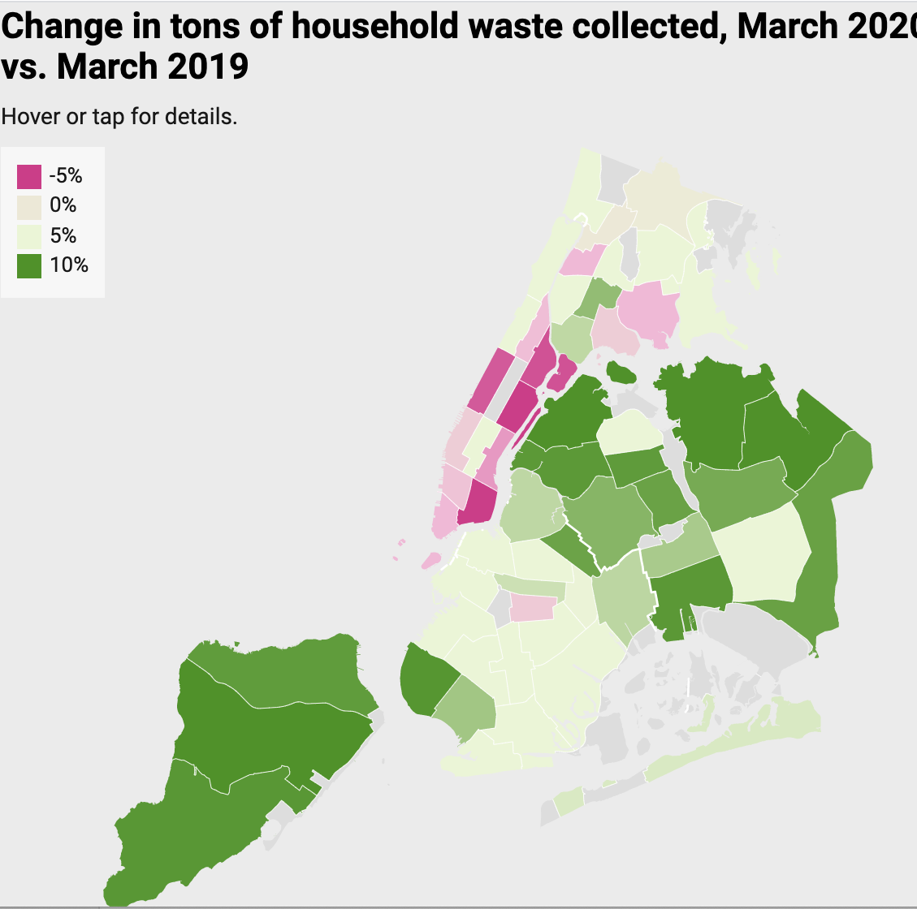
The above map shows the amount of trash collected in March of 2019 vs March of 2020 in New York City.
- Why, do you think, one part of the city would be seeing trash collections going down, while other parts are seeing it go up?

- In general, do you think trash collection from homes is going up or down between March 2019 and March 2020?

- If you were told that the areas in light pink/red--where residential trash collections have gone down are the wealthiest part of the city, what might you think this chart shows?

Note: Researchers have concluded that the reason for the decline is that many of the wealthy residents in Manhattan have left the city and gone to 2nd homes...to get away from New York during Covid-19….

Discuss/Consider: Does this raise any questions or concerns for you?

Activity 1: Carbon Monoxide in NYC

The photos below, show the carbon Monoxide levels in New York City, in March of 2019 and then again in March of 2020. The darker (purple if in color) reveal higher levels of carbon monoxide in the atmosphere.

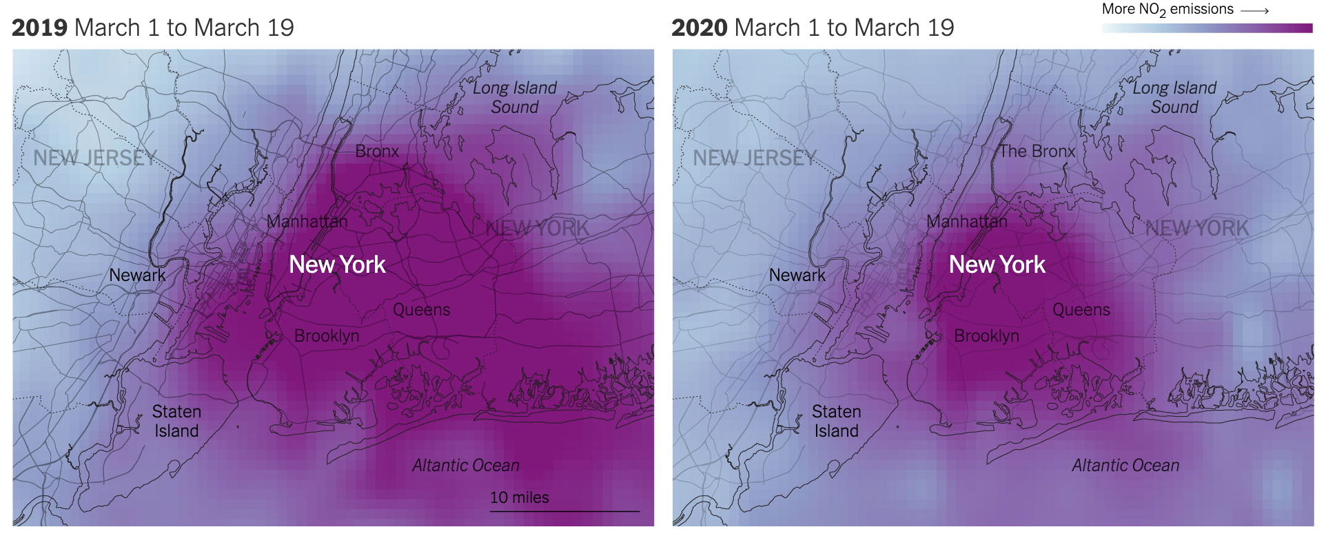
Although this is an image of just one gas--carbon monoxide -- measures of air pollution yield similar results.

- List 1-2 reasons why you think air pollution might be down this March and April compared to last March and April.

- The chart below shows average miles that families in Washington, DC drive in their cars over two time periods, as well as the cost of commuting to work by someone who uses public transportation
 | March 2019 | March 2020
Average Miles Driven Per Week | 110 | 20
Average cost for a gallon of gasoline | $3.50 | $2.25
Monthly subway/metro cost | $140 | $5

How many fewer miles is the family driving in 2020 than 2019 each week?

Assuming that their car gets 20 miles to the gallon, approximately how much money did they spend on gas each week in March, 2019?

How about in March 2020?

The person who used to commute on the metro to and from work is now working from home. How much is she saving each week subway/metro costs?

Many car insurance companies are offering rebates or reducing their car insurance rates this spring.

- Why would they be doing that?

A recent study in California indicated that the number of car accidents per day in March 2020 was ½ what it was in March 2019 in California. In addition, the number of accidents resulting in injury was also cut in ½.

- In March 2019, there were on average 980 accidents and 390 injuries per day related to auto accidents.

- How many auto accidents and how many auto injuries were there per day in March 2020?

Activity 2: Traffic in Los Angeles

The chart below shows the average speed along a major interstate in Los Angeles. It compares the speeds on Wednesday, March 18, 2020 compared to the average speeds on Wednesdays earlier in the year.
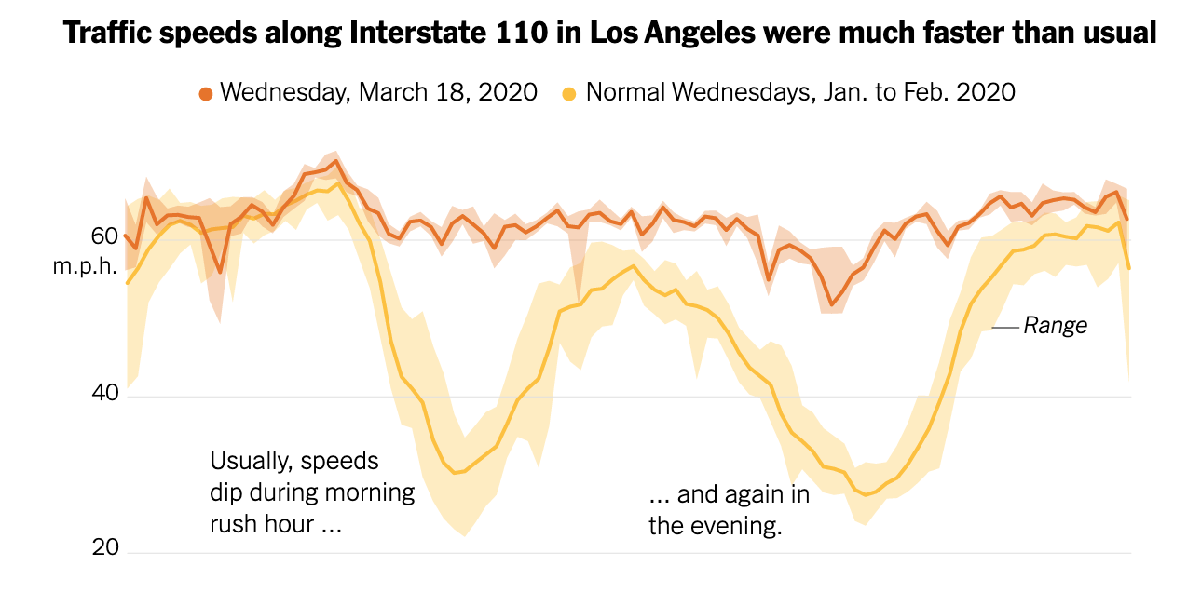
3am 9am 5pm 10pm

Based on this chart-
- Back in January 2020,
  - What was the average speed on the highway at approximately 9am?
  - How about at 5am?
  - What happens to the average speed between about 3pm and 7pm?
  - And if you were driving late at night or early in the morning, what is the average speed on the highway?
  - What is the difference between the average speed at 3am and 9am (approximately?)
- On Wednesday, March 18, 2020,
  - What was the average speed on the highway at approximately 9am?
  - How about at 5am?
  - What happens to the average speed between about 3pm and 7pm?
  - And if you were driving late at night or early in the morning, what is the average speed on the highway?
  - What is the difference between the average speed at 3am and 9am (approximately?)

Why is there such a wide swing of speeds on the highway early in the year and such a narrow swing (almost a straight line) in March?

What do you think this pattern will look like in October, 2020?

Step 3: Gallon of Gasoline

This chart shows the average cost of a gallon of gasoline in 4 states, comparing prices on April 20, 2020 compared to April 20, 2019.
 | Price for 1 Gallon of Oil
 | April 2019 | April 2020 | Price Decrease | % Decrease
California | $4.50 | $2.80
Texas | $2.50 | $1.55
Florida | $3.45 | $1.80
New York | $3.90 | $2.20

Complete the last two columns of the above chart. Use the reminder below if you need help completing the last column.

Rember: Percentage change =($\frac{Amount of change}{Original amount}$-)→ then convert the decimal to a %

In what state did the price of gasoline fall the most?
In what state did the price fall by the greatest percentage?
The price fell by the same amount in California and New York. Why is the percentage decrease different?

Predict what you think the average price of 1 gallon of gasoline is in your home state:
What do you think that price will be in October 2020?

Step 4: Thought Questions
Based on the information you have read about traffic, driving habits, price of gas, and pollution…..
- Why has the price of gasoline gone down so much during the COVID-19 time?

- What are 1 - 2 good things that are happening right now when it comes to keeping people and our environment healthy?

- Assuming that by the fall many people are going to head back to work..and start taking trips...will these benefits stay with us or go away?

- What might we do to make some of the ‘benefits’ stay with us after this pandemic subsides?

Student Feedback:

Circle the emojis that best represents how this activity made you feel.

‘

Day 2: PE
Health

What is this lesson about?: In today’s lesson, you will work on your PE BINGO card.

Step 1: Try to complete the PE BINGO card.

Mindfulness Moment!
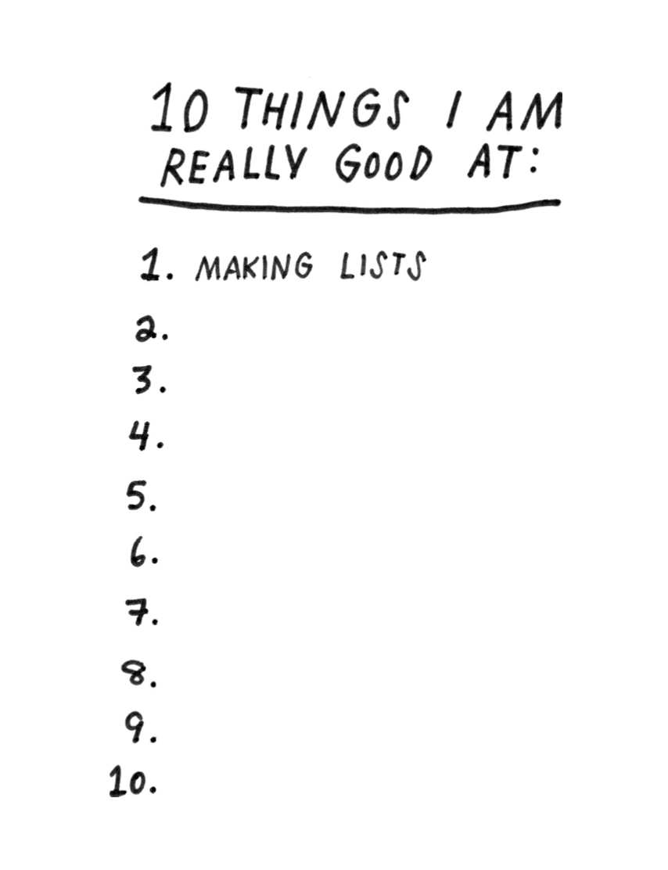

Day 2: Changing Explanations of the Salem Witch Trials
Social Studies

What is this lesson about?: In today’s lesson you will explore how our understanding of what happened during the Salem witch trials has evolved or changed throughout time.

Warm-up: free-write

Take 5 minutes to read the quote below and reflect on it. Write what you think it means?
"History is like a story in a way; it depends on who is telling it." – Dorothy Salisbury

Step 1: Read about the Salem Witch Trials

Were witches burned at the stake during the Salem Witch Trials?
By Evan Andrews for History.com

In January 1692, a group of young girls in Salem Village, Massachusetts became consumed by disturbing “fits” accompanied by seizures, violent contortions and blood curdling screams. A doctor diagnosed the children as being victims of black magic, and over the next several months, allegations of witchcraft spread like a virus through the small Puritan settlement. Twenty people were eventually executed as witches, but contrary to popular belief, none of the condemned was burned at the stake. In accordance with the law at the time, 19 of the victims of the Salem Witch Trials were instead taken to the infamous Gallows Hill to die by hanging. The elderly Giles Corey, meanwhile, was pressed to death with heavy stones after he refused to enter an innocent or guilty plea. Still more accused sorcerers died in jail while awaiting trial.

The myth of burnings at the stake in Salem is most likely inspired by European witch trials, where execution by fire was a disturbingly common practice. Medieval law codes stated that evil witchcraft should be punished by fire, and church leaders and local governments oversaw the burning of witches across parts of modern day Germany, Italy, Scotland, France and Scandinavia. Historians have since estimated that the witch-hunt hysteria that peaked between the 15th and 18th centuries saw some 50,000 people executed as witches in Europe. Many of these victims were hanged or beheaded first, but their bodies were typically incinerated afterwards to protect against postmortem sorcery. Other condemned witches were still alive when they faced the flames, and were left to endure an excruciating death by burning and inhalation of toxic fumes.

Step 2: Reflect and answer questions

Were ‘witches’ burned at the stake as punishment in Salem? If not, how were they punished?

Why do you think people have the misconception that burnings at the stake happened in Salem?

Step 3: Read about Explanations for the Salem Witch Trials

6 Logical Explanations For The Hysteria That Caused The Salem Witch Trials
By All That's Interesting
Published November 12, 2017; Updated October 15, 2019
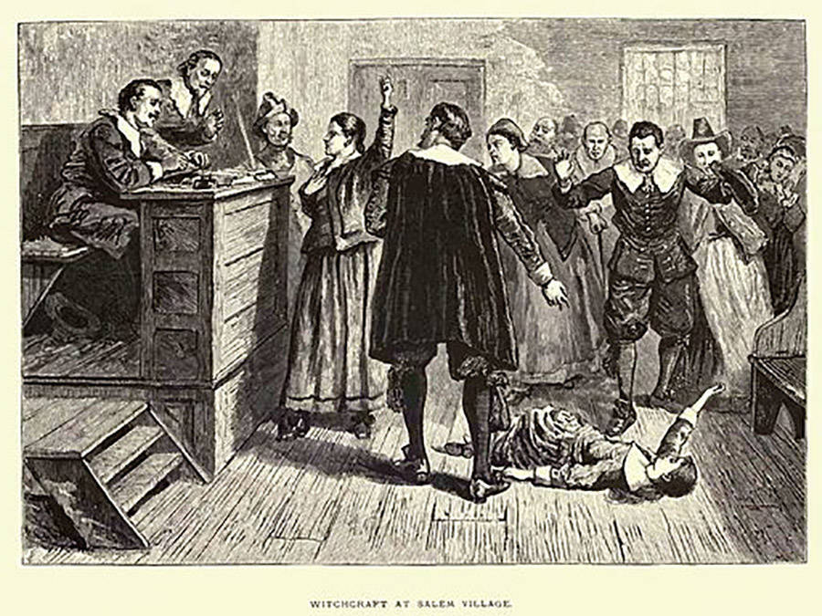
In 1692, "witchcraft" swept through the settlement of Salem, Massachusetts, leading to mass hysteria and several executions. Now, several theories hope to find what really caused the Salem Witch Trials.

In 1692, the settlement of Salem, Massachusetts came under threat almost overnight. The cause? Accusations of witchcraft flying back and forth between the citizens of this quiet Puritan settlement. Known as the Salem Witch Trials, the causes for this notorious episode of moral panic in the early colonial era has been hotly debated for the past three hundred plus years.

Within the span of a year, 20 people had been executed and hundreds arrested after being accused of witchcraft, but almost as suddenly as the trials began, they stopped; Salem came to its senses, and life carried on.

Since then, the events of the Salem witch trials have fascinated and perplexed scholars like few other episodes in American history.

What caused this quiet Puritan town to descend into total paranoia and persecution? The following theories might offer a more rational explanation than the supernatural.

Salem Witch Trials: Impact Of The Native American Wars
A number of new theories have suggested that the Native American Wars which raged during the 17th century close to Salem may have contributed to the witch hysteria that took hold in 1692.

King Philip’s War was raging in the colonies at the time, and the front lines were only about 70 miles away from Salem. Most people in the region had been impacted in one way or another, and many in Salem were refugees from parts of the region being torn apart by the war.

What’s more, raids from the native tribes in the area left many citizens of Massachusetts in a near constant state of fear over future attacks, creating an atmosphere of intense anxiety in which a violent death could come at any time and entirely without warning.
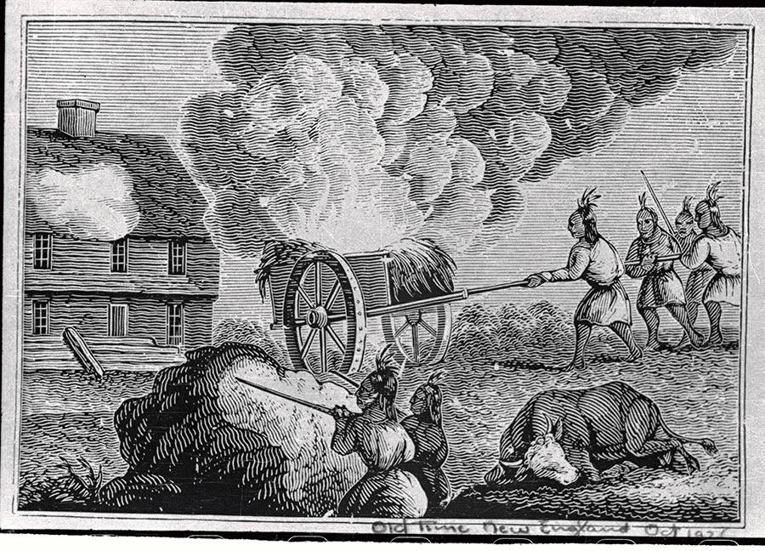
Several of the “afflicted” girls whose “bewitchment” kicked off the Salem Witch Trials had witnessed these raids first hand. It has been suggested that post-traumatic stress from witnessing these terrifying attacks and the culture of fear generated by the continued threat may have played a large role in generating the subsequent mass hysteria.

Historian Mary Beth Norton suggests the Native American Wars may have impacted the trials in another way.

She contends that the accusation and execution of ex-minister George Burroughs, who led a number of small, failed campaigns against the Native Americans, for witchcraft is indicative of the town officials attempting to shift “blame for their own inadequate defense of the frontier” to supernatural causes.

They wanted to believe that it had to be the devil that was threatening them, in other words, not their own inherent weakness. If safety is just one more witch-hanging away — in the minds of the public at least — it would be a powerful incentive to try to root out the culprit who was bringing this threat of death into their community.

Teen Angst And Patriarchal Oppression
When examining who exactly was accused of witchcraft, there are a number of demographic discrepancies which point to the possibility of that timeless, social antagonism: teenage angst, overbearing parents being insufferable killjoys, and historical patriarchy.

In his book Entertaining Satan: Witchcraft and the culture of Early New England, John Putnam theorizes that the witch trials were essentially a teenage rebellion against the authority of their elderly parents, as most of the accusers were teenagers and most of the accused adults.

Feminist historians have interpreted the trials as just another means of the patriarchy to persecute women who acted in ways contrary to the accepted social norms of the time. In the Salem Witch trials, as was historically the case with many similar prosecutions in Europe, women were the primary targets of accusation – particularly women who did not follow the social norms of the time, or were considered outcasts.

While the exact cause of the Salem Witch Trials remains contested, there is no doubt that underlying social forces of sexual oppression, individual repression, and Patriarchal reinforcement were a factor in the ensuing hysteria.
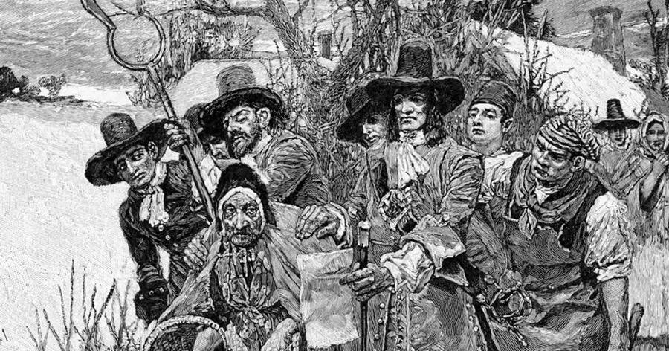
The Cold Weather Theory
One theory proposed in 2004 by Harvard graduate Emily Oster suggests that there is a more simplistic answer to what caused the Salem witch trials: the weather.

Her theory points out that there exists a strong correlation between outbreaks of witch persecution and periods of cold weather in Europe between the 13th and 17th century.

“The most active period of the witchcraft trials (mainly in Europe) coincides with a period of lower-than-average temperature known to climatologists as the ‘little ice age,'” Oster wrote in her Harvard thesis. “The colder temperatures increased the frequency of crop failure, and colder seas prevented cod and other fish from migrating as far north, eliminating this vital food source for some northern areas of Europe.”

The year 1692 falls right in the middle of a nearly 50-year-long cold spell that afflicted the world from 1680 to 1730, giving some weight to the theory.

She theorizes that the connection stems from the fact that witches were believed to be able to control the weather and destroy crops. When the people suffered from poor harvests due to poor weather, some concluded that it must be the work of witches who needed to be identified and dealt with.

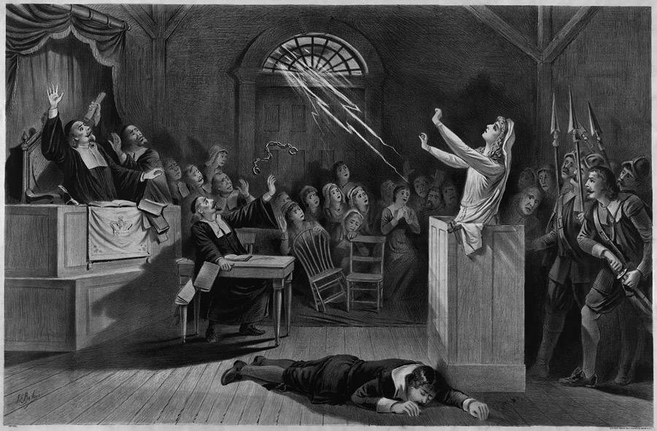
Mass Hysteria
Mass Hysteria is the “rapid spread of conversion disorder, a condition involving the appearance of bodily complaints for which there is no organic basis. In such episodes, psychological distress is converted or channeled into physical symptoms.”

Many scholars have argued that this is exactly what the girls who were first “bewitched” were actually experiencing.

Many scholars believe that mass hysteria was a primary cause of the Salem Witch Trials. The stress of living in such a rigid and religious society on the dangerous wilderness frontier led these girls to convert this stress into physical symptoms in which no natural explanation could be found.

Similar cases of hysteria have been reported throughout history. The mass hysteria experienced by the girls may then, in turn, have triggered a collective delusion among the villagers that Satan and witches were in their midst, thus providing a foundation for the witch hunt.

Boredom And Guilt
The story of the witch trials begins in February of 1692 when Betty Parris, age nine, and her cousin Abigail Williams, age eleven, began to exhibit strange behavior.

They began to hide under furniture, scream, and bark like dogs. Samuel Parris, the father of Betty Parris and a well-known minister, called for a physician to look at the girls who subsequently found nothing physically wrong with them. It was then concluded that they had been bewitched.

However, a modern theory suggests that the girls began to act strangely after they became frightened by a fortune-telling game.

In Salem at the time, children were restricted from almost all forms of play and leisure. They were expected to spend most of their time doing chores and studying the bible. This lack of stimulation naturally seeded to boredom.

This boredom may help to explain why Betty Parris and Abigail Williams became so interested in the fortune-telling and magical stories which a slave named Tituba introduced them to. As one of their only outlets for activity they naturally became drawn to these superstitions.

It is believed that their involvement with these forbidden supernatural activities and a combination of the guilt and fear they felt from participating in them, as well as a frightening omen they saw, may have been the cause of their strange behavior.

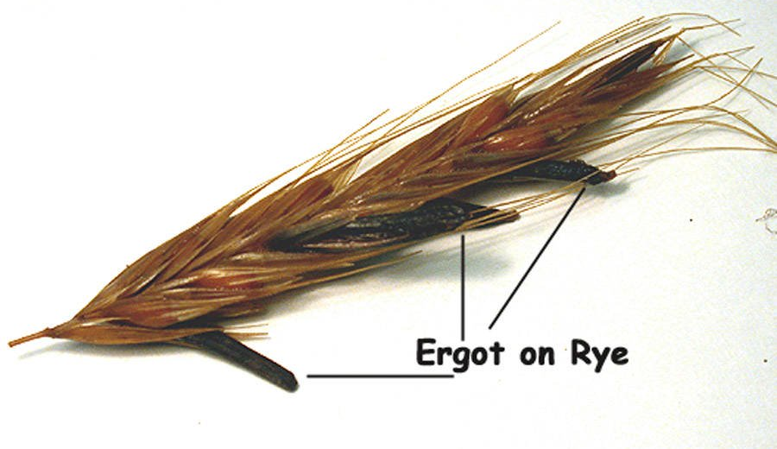
What Caused The Salem Witch Trials? Ergot Poisoning
One of the most interesting theories which has emerged about the cause of the Salem witch trials was first introduced in 1976 by Linnda Caporeal. She theorizes that the cause of the bizarre physical afflictions first witnessed in the “bewitched” girls could be the result of ergot poisoning.

Ergot is a fungus which in the right conditions can grow on grains. The fungus (which LSD is a derivative of) has been known to cause convulsions, hallucinations, and pinching sensations.

These are the very afflictions suffered by the girls as described by first-hand accounts and interestingly enough the weather conditions in Salem Village in the winter of 1691 were just right for ergot to grow.

Other studies on Ergot poisoning have also found that, like most drugs, children and females are the most susceptible. Is it possible that the afflicted were suffering from ergot poisoning? This question is still debated by scholars, but the theory is considered one of the more plausible explanations.

Step 3:

The author explains two way the Native American wars may have caused the hysteria of the Salem witch trials:
1) post-traumatic stress disorder, and
2) that after failed attempts to fight off the Native Americans, the townspeople needed to blame their failure on something and decided to place blame on the supernatural (witchcraft) rather than their own weakness or inability.
What explanation seems stronger to you and why?

In the section on teen angst and patriarchal oppression, the author explains how some historians believe teenage angst and societal rules that favor men played a role in causing the witch trials. What are some pieces of evidence or factors used to support this argument by historians?

In the section headed ‘boredom and guilt” the author explains that the witch trials started with two young girls “began to hide under furniture, scream, and bark like dogs.” In your opinion, based on your life experiences, do these seem like frightening or very odd behaviors for young girls? Why or why not?

In 1692, the girls’ behavior was determined to be very alarming. Based on your answer above would you say that interpretations of this type of behavior has changed over time?

Why do you think so many theories for explaining the Salem witch trials have been developed by historians? How can you explain why there are so many different theories?

What do you think is the best theory? Why?

*With a partner, share your answers to the above questions. For the last question, discuss how your personal experiences may have contributed to why you chose different theories or why you chose the same theory.

Student Feedback:
Circle the emojis that best represents how this activity made you feel.

