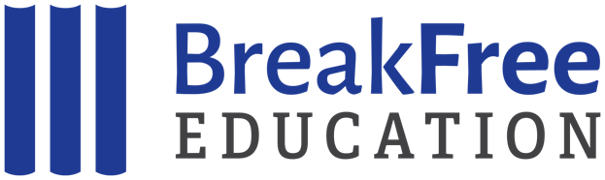
Mail-In Donation Form

Name Address City, State, ZIP
E-mail Address (we will not share your email address)
Phone
Enclosed is my check for $ .
(Please make checks payable to BreakFree Education)

Please mail this form, along with your donation, to:

BreakFree Education
9375 Gerwig Lane, Suite E
Columbia, MD, 21046

THANK YOU!

Your gift will make a difference in our work to bring high quality, engaging, and meaningful education to youth in confinement.

BreakFree Education is a 501(c)(3) tax-exempt organization. Gifts to BreakFree are tax-deductible as permitted by law. No goods or services are sent in exchange for gifts. Our Federal Identification Number (EIN) is 46-0757820

