Week 4
Community

Day 5

NAME:______________________

Day 5 Agenda

Topic | Activity
Warm-Up!
English Language Arts | - Read and respond to a quote about Community.  - Brainstorm needs and expectations of belonging to community  - Creating a guide for success in a chosen community
Science | - Read about How the Census Impacts Communities  - Answer questions about what you read  - Reflect
Mindfulness Moment!
Math | - Real World Math: Math and COVID-19: Health and Community impacts--what communities are most at-risk during the pandemic  - Practice Problems
Health | - Make an impact speech to support your community’s health
Mindfulness Moment!
Civics/Social Studies | - My Community: Complete a project to share about your community

Warm-up Activity: Write a journal entry around the daily quote on identity.
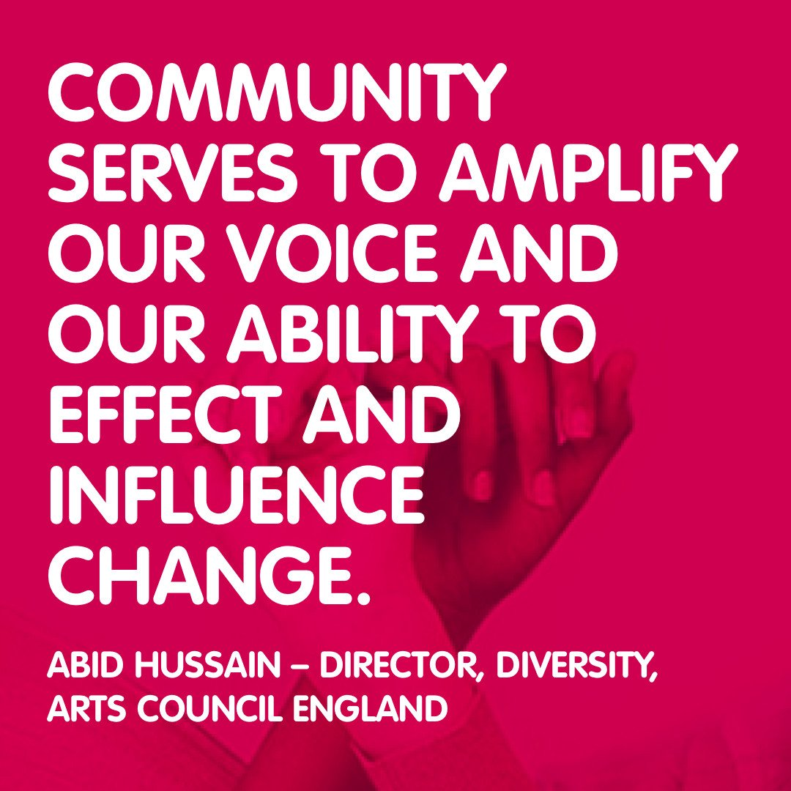

Day 5: What do I need from my community and what can I give to my community?
English Language Arts

What is this lesson about? Community is a give and take. We all need things from a community in order to feel a sense of belonging. In turn, we have a responsibility to participate in a positive way in our community to help others feel a sense of belonging too. Today, you will pick a community you are a member of and think about what you need from them in order to feel like you belong and what you can contribute to the community as well. You will create a mock guide for others who join your community, on what they should know and how they can contribute in order to keep your community strong and united.

Step 1: Read, Think, Write
Read the following quotes. Pick one and respond. Your response should include the following:
1. Explain the quote. What does it mean?
2. Do you agree or disagree with the quote? Why or why not?
3. Give an example from your own experience of what the author of the quote is saying.

“One of the most important things you can do on this earth is to let people know they are not alone.” ― Shannon L. Alder, Author.

I definitely feel like you have an influence. I'm 21 years old, and I'm thinking about the kids that are from my neighborhood, from my community, that are looking up to me and seeing me handle myself a certain way, so I do feel a responsibility in that sense to handle myself a certain way in front of those guys. --Jaylen Brown, NBA Player.
The role we can play every day, if we try, is to take the whole experience of every day and shape it to involve American man. It is our job to interest him in his community and to give his ideas the excitement they should have.-- John Hay Whitney, Publisher.

A community is like a ship; everyone ought to be prepared to take the helm. - –Henrik Ibsen, Author.

Beloved community is formed not by the eradication of difference but by its affirmation, by each of us claiming the identities and cultural legacies that shape who we are how we live in the world. –Bell Hooks, author.

Write your response below:

Step 2: Brainstorm

Belonging to a community requires give and take. Each member of a community gets something from the community that makes them feel a sense of belonging. Think about Sam in Seedfolks—he liked that he could help others connect and he liked connecting with people who were different from him. It also requires that one contribute to the community in some way. Think about how Jose Andres was able to contribute his talent in cooking and his many connections in the culinary world in order to help his community.

Think of a community that has been positive for you. (It doesn’t have to be perfect, sometimes even a challenging community is positive because it helps us grow.). Brainstorm and share what you need to feel a part of a community. (To create friendships? To feel like you are learning? To feel loyalty?) Include at least 4 things you need to make you feel like you belong in a community in a positive way. On the other side of the graphic organizer, include a minimum of 4 contributions that you can make to help others in the community or to make the community stronger.

What I need from my community | What I can contribute to my community

Step 3: Creating a Guide for Community Membership

Create a guide for success for someone who wants to be part of a community of which you are a member. (Example: family, friend group, religious community, class, team, work group, etc..). Give this person information on what they can get from the group (a sense of discipline? new skills? friendships?) and what they can contribute to the community to make it stronger and better community.

Your guide should include:
- A short description of the community and at least three qualities or interests that the community has in common,
- At least three of the benefits a new member might get from being a part of this community.
- At least three of the expectations of what they should contribute to the community.
Be positive, be thoughtful, and be persuasive.
A sample design has been provided but you can be creative as long as you include the required information.

Sample:

Our group is made up of people interested in reading, listening, analyzing and creating poetry in the form of raps, spoken word, performance and written poetry, We all have something that we want to say and enjoy finding creative ways to say it.

So you want to join our poetry writers’ community?

Create yours here:

Step 4: Share out
Share your guide with someone in your group or with the whole group. After everyone shares, look for benefits and expectations that you had in common. Are there any expectations that could be considered “universal” (that every kind of group would expect)?

Student Feedback:
Circle the emojis that best represents how this activity made you feel. | 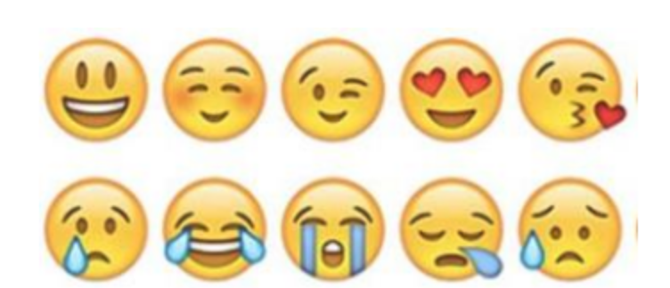  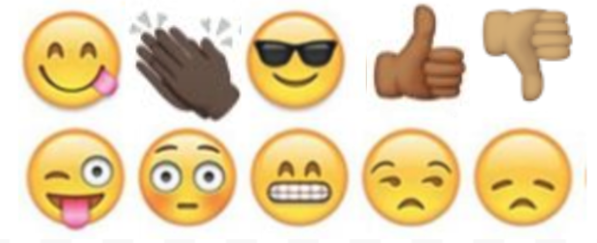

Day 5: Science
How will the 2020 Census impact your community?
What is this lesson about?: Today you will read through the How will the 2020 Census impact your community? passage. You will answer a few questions about what you read. You will reflect on this week’s readings.

Step 1: Read the passage

How will the 2020 Census impact your community
census.gov

What Is the 2020 Census?

The 2020 Census counts every person living in the United States and five U.S. territories.
The count is mandated by the Constitution and conducted by the U.S. Census Bureau, a nonpartisan government agency. The 2020 Census counts the population in the United States and five U.S. territories (Puerto Rico, American Samoa, the Commonwealth of the Northern Mariana Islands, Guam, and the U.S. Virgin Islands). Each home will receive an invitation to respond to a short questionnaire—online, by phone, or by mail—between March 12-20.

Why We Conduct This Count
The census provides critical data that lawmakers, business owners, teachers, and many others use to provide daily services, products, and support for you and your community. Every year, billions of dollars in federal funding go to hospitals, fire departments, schools, roads, and other resources based on census data.

The results of the census also determine the number of seats each state will have in the U.S. House of Representatives, and they are used to draw congressional and state legislative districts.
It's also in the Constitution: Article 1, Section 2, mandates that the country conduct a count of its population once every 10 years. The 2020 Census will mark the 24th time that the country has counted its population since 1790.

Impact in Your Community

School lunches. Plans for highways. Support for firefighters and families in need. Census results affect your community every day.

Shaping Your Future
The results of the 2020 Census will help determine how hundreds of billions of dollars in federal funding flow into communities every year for the next decade. That funding shapes many different aspects of every community, no matter the size, no matter the location.

Think of your morning commute: Census results influence highway planning and construction, as well as grants for buses, subways, and other public transit systems.

Or think of your local schools: Census results help determine how money is allocated for the Head Start program and for grants that support teachers and special education.

The list goes on, including programs to support rural areas, to restore wildlife, to prevent child abuse, to prepare for wildfires, and to provide housing assistance for older adults.

Importance of the Data

The 2020 Census will determine congressional representation, inform hundreds of billions in federal funding every year, and provide data that will impact communities for the next decade.

The 2020 Census will provide a snapshot of our nation—who we are, where we live, and so much more.

The results of this once-a-decade count determine the number of seats each state has in the House of Representatives. They are also used to draw congressional and state legislative districts.

Over the next decade, lawmakers, business owners, and many others will use 2020 Census data to make critical decisions. The results will show where communities need new schools, new clinics, new roads, and more services for families, older adults, and children.

The results will also inform how hundreds of billions of dollars in federal funding are allocated to more than 100 programs, including Medicaid, Head Start, block grants for community mental health services, and the Supplemental Nutrition Assistance Program, also known as SNAP.
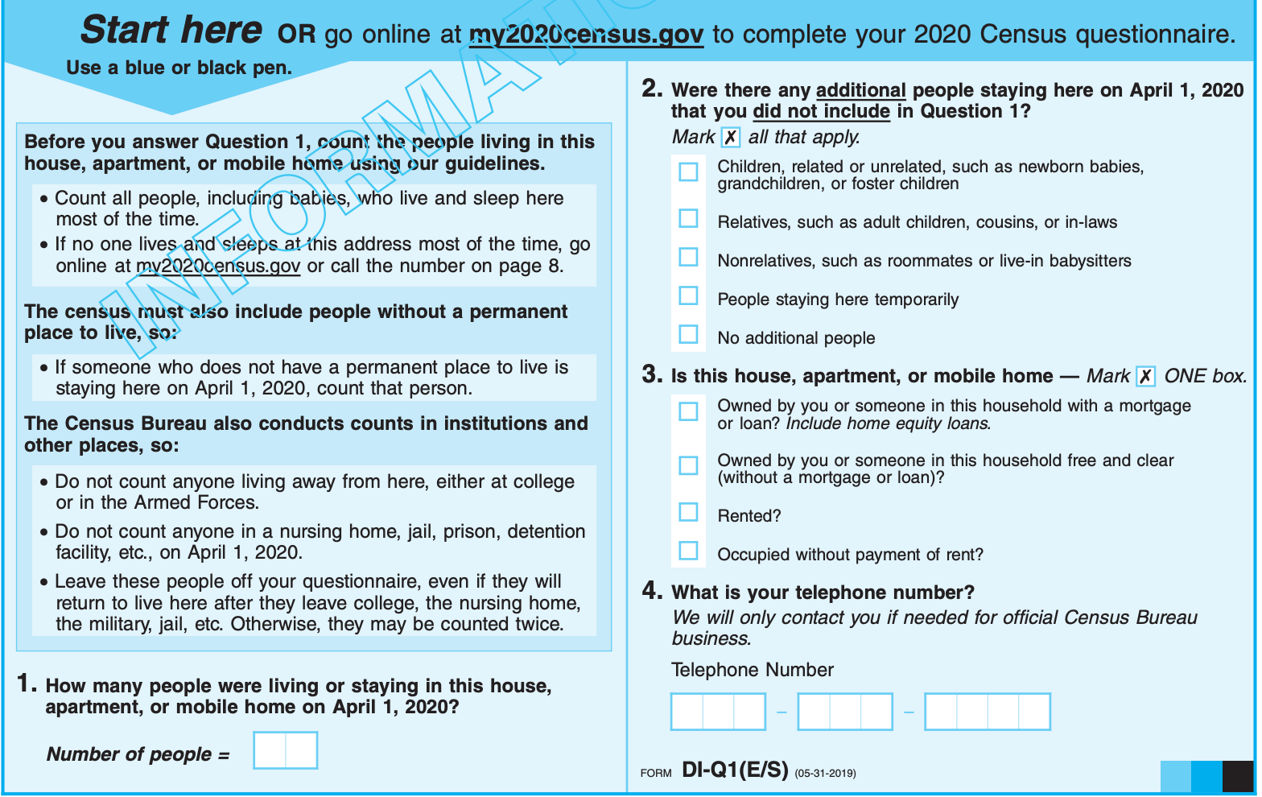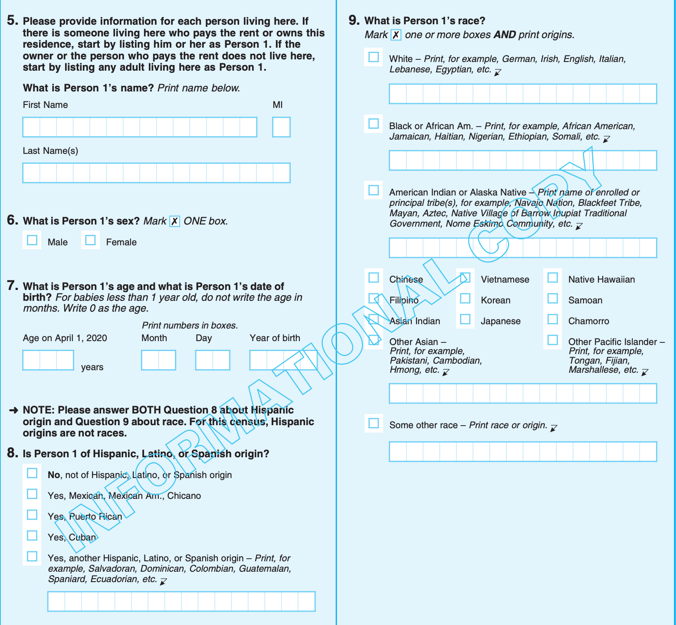
Step 2: Answer the questions
- Do you think the census is important? Why or why not?

- What are 2-3 pieces of information that are collected on the census?

- What additional information do you believe should be collected on the census?

Step 3: Reflect

As you reflect on this week’s science lessons on community, what stands out most to you? What is one thing you want to change or make better?

Student Feedback:

Circle the emojis that best represents how this activity made you feel. | 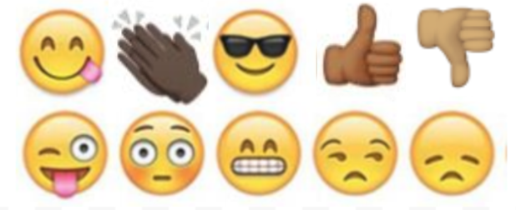  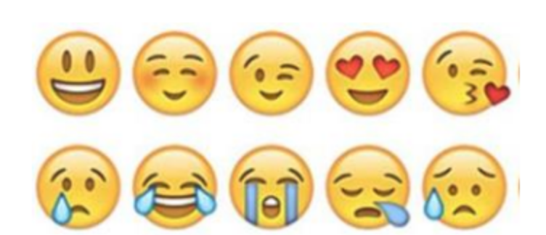

Mindfulness Moment!

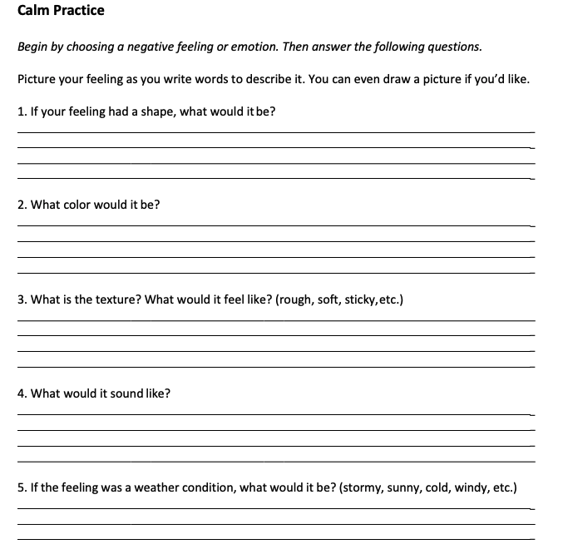

Day 5: COVID-19 and Community Impact
Math

What is this lesson about?: In this lesson, we will look at how COVID-19 is impacting different communities across the country. This lesson is not meant to create any anxiety or worry on your part. Rather, it is meant to help you see how this crisis can both impact communities and create stronger ties among communities.

But first: Today’s Warm-Up
Yesterday you did some work on taxes and our shared responsibility to support basic public functions. For today’s warm-up, we have a few follow-up questions.

Marcus is 45 years old. He is single and he earns $40,000 per year, or approximately $20.00 per hour. He pays approximately 25% in taxes. 25% is the same as ¼. At the end of a year, how much does he pay in taxes? How much is he left with.

His friend Kenny earns the same amount. Kenny has 2 children. Kenny gets an $8,000 credit for his two children. So he only pays taxes on $32,000. He pays 25% on this amount. How much does he pay in taxes (what is 25% or ¼ of $32,000)? After he pays that amount, how much will he have left over from his $40,000?

Is it fair that Kenny pays less in taxes than than Marcus? Yes/No.

- Why does the government think that Kenny should pay less in taxes than Marcus?

Step 1/Activity 1: In this activity we will analyze how the City of New York has come together to around its daily tribute to all of the health care workers there.

This chart shows the average number of hours worked by an emergency room nurse per week at a hospital in New York City over the last 6 weeks.

 | Week of March 9 | Week of March 16 | Week of March 23 | Week of March 30 | Week of April 6
Hours worked per week
Emergency Room Nurse | 40 | 48 | 60 | 72 | 72

How many hours per week was the average Emergency Room nurse working during the week of March 9th?

What had this gone up to by March 23rd? How about about by April 6th?

What is the percentage increase between March 9th and April 6th?

Use the formula below: (the hours worked the week of March 9th is the Original amount; the Amount of change is the hours worked the week of April 6th - hours worked the week of March 9th)-:

Percentage Change=$\frac{Amount of change}{Original amount}$-→ then convert the decimal to a % by moving the decimal 2 units to the right

This chart shows the number of emergency room nurses available to work at that same hospital in New York City over the last 6 weeks.

 | Week of March 9 | Week of March 16 | Week of March 23 | Week of March 30 | Week of April 6
Number of Available Nurses | 60 | 60 | 54 | 46 | 42

How many nurses were available to work the week of March 9th?

What had this gone down to by the week of March 23rd? How about about by April 6th?

What is the percentage decrease between March 9th and April 6th?

Use the formula below (the hours worked the week of March 9th is the Original amount; the Amount of change is the hours worked the week of April 6th - hours worked the week of March 9th)-:

Percentage Change=$\frac{Amount of change}{Original amount}$-→ then convert the decimal to a % by moving the decimal 2 units to the right

What do you think is the reason for this decline in the nurses available to work over this time?

Step 2/Activity 2: Providing a hot lunch or dinner to the nurses working extra hours

After reading an article about all of the nurses working overtime, a nearby restaurant decides that it will make and deliver hot meals to them each day for a week. This also ends up being a good way for the restaurant to stay open and help get a few people some hours working in the kitchen. In this activity, we are going to calculate how much it will cost the restaurant to make and deliver sandwiches each day for seven days.

Use the information below to calculate how much this kind act will cost the restaurant owner.

Food costs for a Turkey Club Sandwich $3.00 per sandwich
Delivery Cost $15.00 fixed
- Note: this is a fixed cost; the delivery costs the same amount no matter how many sandwiches she delivers
Salary and Benefits for Sandwich Maker $22.00 per hour
- The sandwich maker can make 30 sandwiches in 2 hour and up to 60 sandwiches in 4 hours. In fairness to the sandwich maker, the restaurant owner pays her for either a full 2 or a full 4 hours.

How much will it cost the restaurant to provide 30 sandwiches to the hospital (food, delivery and salary) - Remember, this is the cost of 30 sandwiches, the delivery and the salary and benefits all together.

How much will it cost the restaurant to provide 45 sandwiches to the hospital?

If the restaurant provides 30 sandwiches for the weekdays (Monday thru Friday), and 60 sandwiches on Saturday and Sunday, how much will it cost all together to pitch in and support the nurses for one week.

Step 3/Activity 3: Who is coronavirus affecting more?

As you may have read the coronavirus has impacted different communities in different ways. One thing we do know is that people with underlying medical conditions are more likely to die or become seriously ill. Those conditions include diabetes, heart disease, obesity, and past respiratory illnesses. It also is more dangerous in the elderly (although people of all ages can die from it).

One result of these studies shows that in many cities in the US, African Americans are contracting coronavirus and dying at a greater rate than white Americans. The chart below shows some of this troubling data.

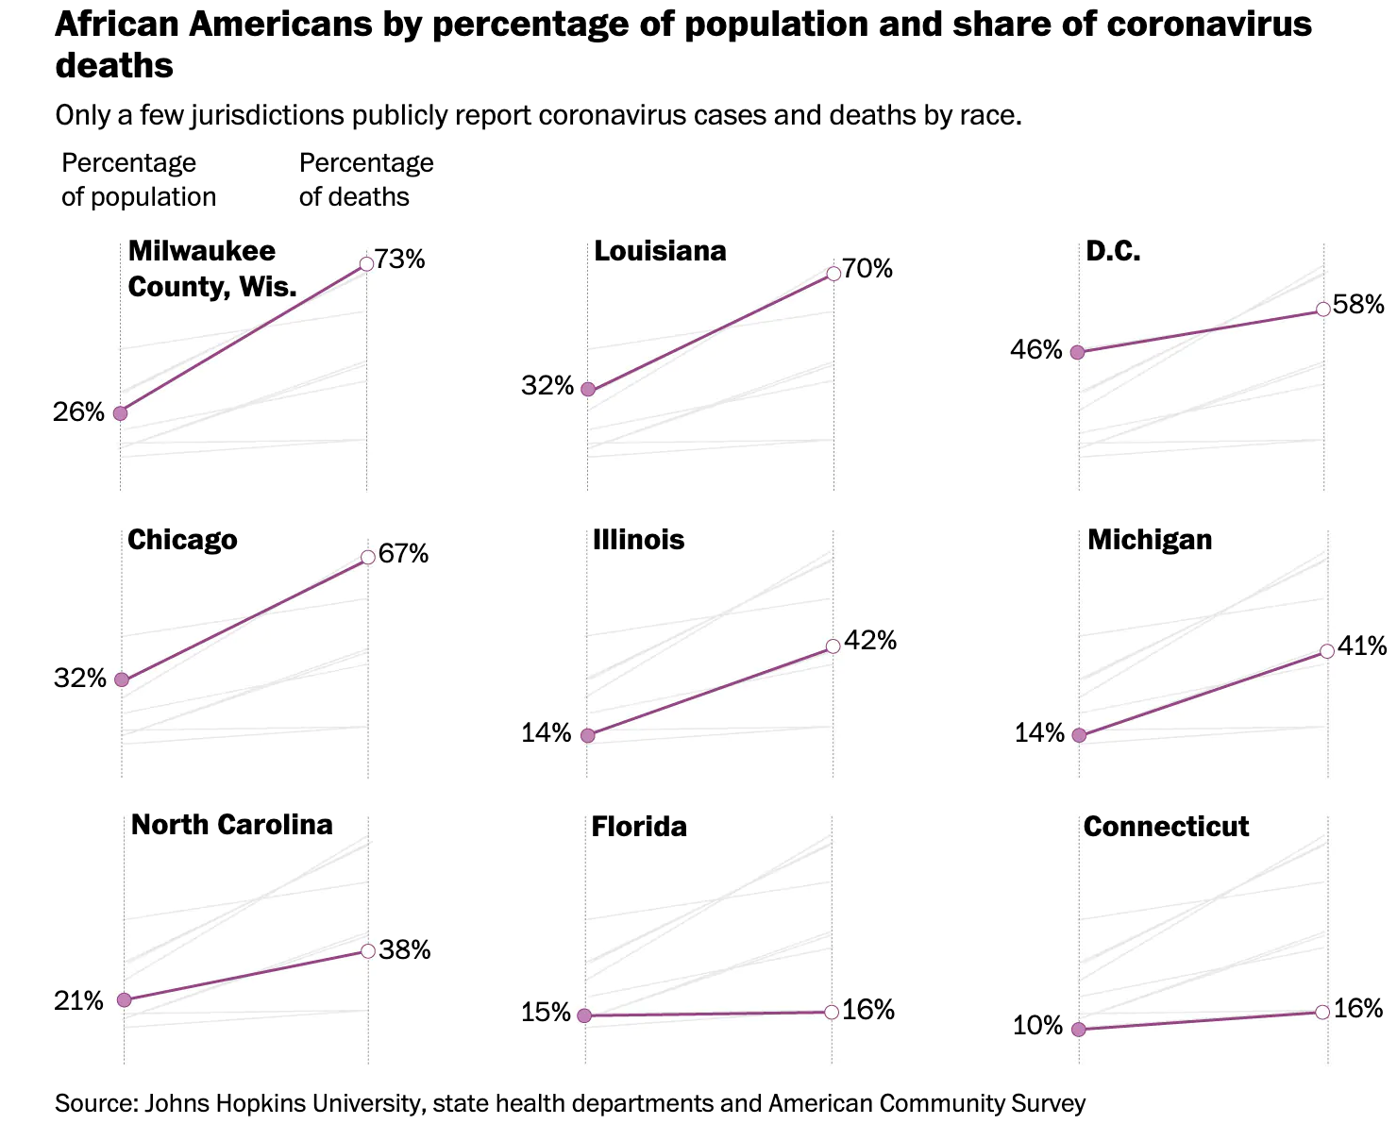

This chart shows the % of adults with diabetes in each of the states above, as well.
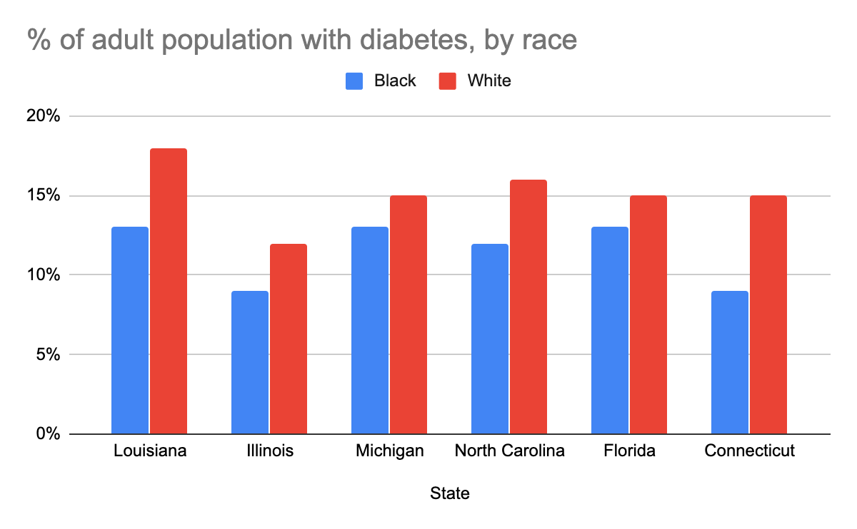
Based on these charts answer the following questions:

- What percentage of the population in Illinois is African American? What % of the coronavirus cases are from African Americans?
- What percentage of African Americans living in Illinois have diabetes? How does that compare to the % of whites with diabetes?

- What percentage of the population in Michigan is African American? What % of the coronavirus cases are from African Americans?
- What percentage of African Americans living in Michigan have diabetes? How does that compare to the % of whites with diabetes?

- What percentage of the population in Louisiana is African American? What % of the coronavirus cases are from African Americans?
- What percentage of African Americans living in Louisiana have diabetes? How does that compare to the % of whites with diabetes?

- What percentage of the population in Florida is African American? What % of the coronavirus cases are from African Americans?
- What percentage of African Americans living in Florida have diabetes? How does that compare to the % of whites with diabetes?

We don’t have all of the facts here (we just have a sampling of two data points).

- Based on this data, what questions would you want to ask about the relationship between someone being susceptible to the coronavirus and diabetes?

- Is there a direct correlation between increased rates of diabetes and contraction of coronavirus?

- Look carefully at the Florida charts. What is different about Florida than the other states’ data?

- What might be going on in Florida that is different than in the other states?
Step 4/Activity 4: Is coronavirus impacting immigration?

In our last activity for today, we will finish up looking at how the coronavirus is impacting larger issues related to creating a shared community. Around the world, countries have been closing their borders in order to prevent people from coming into the country and possibly bringing the virus with them. Many people think this is a good, safe policy for now. But it could be used to keep people out, for the wrong reason, if it stayed in place after the crisis.

Hypothetical Immigration flows into the US, March 2019 vs March 2020

 | March 2019 | March 2020
Mexico/Central America | 18,000 | 2,000
Western Europe | 16,000 | 4,000
Middle East | 5,000 | 1,000
Sub Saharan Africa | 9,000 | 1,500

Use the chart above to create a double line graph comparing the immigration flows to into the US over the two years. We have completed the first double bar for you.
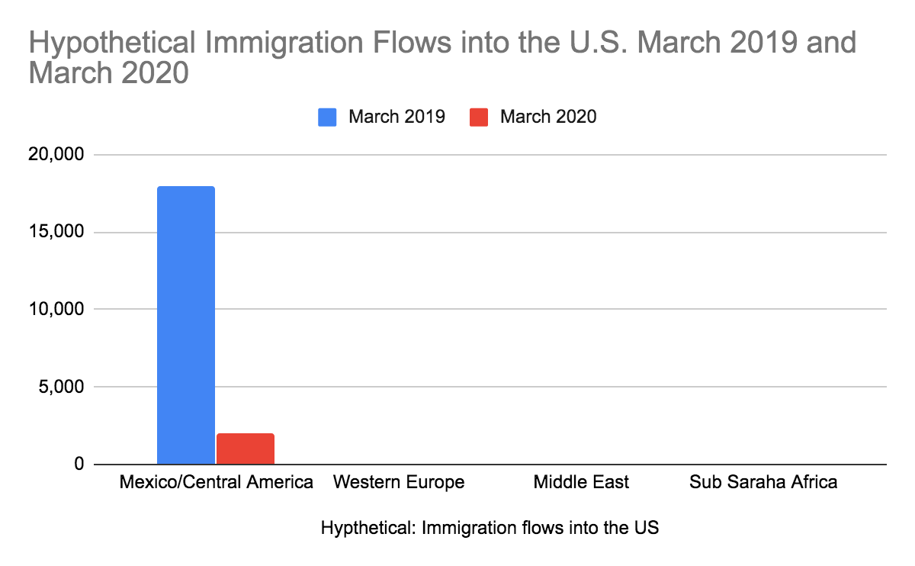
- Based on this hypothetical chart, how many fewer individuals all total entered the country in March of 2020 vs March of 2019?

- Which region of the world had the greatest decrease in the number of individuals permitted to enter the country?
- How many fewer individuals from Sub Saharan Africa entered in March of 2020 compared to March of 2019?

- If the table stayed the same for the next 6 months (be careful), how many fewer individuals from Mexico/Central America would come between March-August 2020 compared to March-August 2019?

- If the table stayed the same for the next 6 months, how many fewer individuals from the Middle East would come between March and August 2020 compared to March and August 2019?

To consider/discuss: Based on your understanding of where different racial and ethnic groups come from, what would happen over time if the pattern of the hypothetical immigration pattern of March 2020 stayed in place for a number of years?

Skill Builders and Review Problems
- See separate document-

Student Feedback:

Circle the emojis that best represents how this activity made you feel.

Day 5: Make an Impact Speech
Health

What is this lesson about?: In today’s lesson you will focus on the community health issue you chose on day 3, and you will prepare a speech to share your ideas on what your plan is to improve that issue.

Step 1: Follow the steps to write your own TED talk.

What is a TED talk?
A TED Talk is a showcase for speakers presenting great, well-formed ideas in under 18 minutes.

Why under 18 minutes?
This short talk model works, since it only demands the audience's attention for a short period of time, decreasing the chance of minds wandering or daydreaming about lunch. In fact, some of our greatest TED Talks have been as short as 5 minutes long!

What is a great, well-formed idea?
It can actually be one of two things:
- Something that’s new and surprising; an idea or invention that your audience has never heard about.
- A great basic idea (that your audience has maybe already heard) with a compelling new argument behind it that challenges beliefs and perspectives.

In other words, an idea isn’t just a story or a list of facts. A good idea takes certain evidence or observations and draws a larger conclusion.
Step 2: Writing your Ted Talk

Think back to your last lesson on community impact. How will you make an impact on your community? Share it in your TED talk.

Hook―How do you establish a connection with your audience so you can get them to “buy into” the idea?
Write your hook here:

Explain the Current Problem―What exactly is the current environmental challenge, what do your peers need to understand about it, and how does it impact present and future ecosystems.

Share the Current Solutions―What solutions are currently available, how do they work, and what kind of difference can they make?

Closing―Reconnect with the audience and close with a passionate call to action.
Students are encouraged to think about the following when they are preparing:
· Who is in your audience?
· How can you use humor in your speech?
· What visual will help get your point across?

You wrote your first TED talk!!

Mindfulness Moment!
Peaceful reflection.
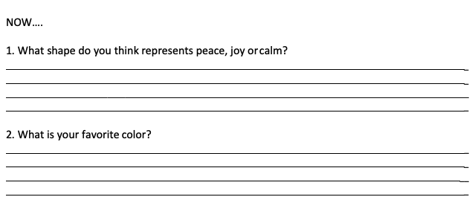
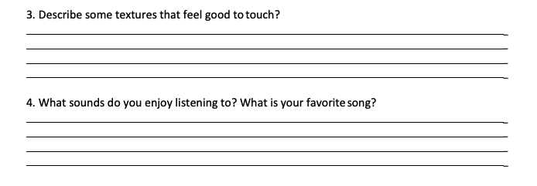

Day 5: Communities of the World: Your Own!
Social Studies

What is this lesson about?: This week you have explored communities and countries from all over the world. You’ve learned how communities can be different, but maybe you’ve also learned how they can be the same! For example, communities have styles of clothing, religion, languages, home styles and architecture, and food. All of these things help to define a community. Today you will create a final project to share about your community.

Step 1: Brainstorm about your community

First, you need to decide what community you want to share about. You can choose from your home country (the USA or another country), your state, or your local community (your city or neighborhood).

What community will you focus on? __________________________________________
What is the history of your community?
When or how was is founded/created? ________________________________________________
What are some significant historical events of your community? ____________________________ _______________________________________________________________________________
What is the nature of geography of your community?
What does it look like? ____________________________________________________________
Where is it located? _______________________________________
Food
What type of food is typical in your community? _________________________________________
What is your favorite food or recipe? _________________________________________________
Homes
What do homes look like in your community? ___________________________________________
_______________________________________________________________________________

Step 2: Prepare your report!
You can use the template below or be super creative and use a blank paper to complete your report:

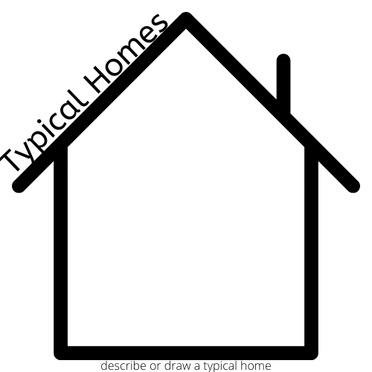

Step 3: Reflection

What do you like about your community?

What would you want to change about your community?

How do you think people from outside your community view your community?

Why is your community important to you?

How does your community impact your identity or who you are?

Student Feedback:
Circle the emojis that best represents how this activity made you feel.

