Week 1
Strength

Day 3

NAME:______________________

Day 3 Agenda

Topic | Activity
Warm-Up!
English Language Arts | - Read an article about Victoria Woodhull and respond to questions about the reading  - Write a short essay/paragraph about how people respond to challenging times and use evidence from your readings to support your claim
Science | - Check your understanding of bridge designs  - Solve problems around bridge design
Mindfulness Moment!
Math | - Understanding the power and strength of exponential growth--both for good and bad
Mindfulness Moment!
Civics/Social Studies | - Review key vocabulary  - Create a sketchnote about WWI and it’s main themes, key players, and key terms  - Make a meme using images from WWI
Warm-up Activity: Write a journal entry around the daily quote on strength.
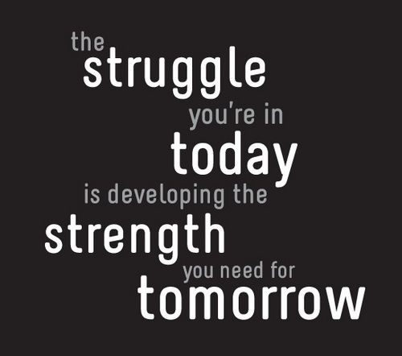

Day 3: English Language Arts
Strong Women

What is this lesson about?: Today you will finish our series on strong women for Women’s History Month. You will learn about Victoria Woodhull, the first woman to run for president in the U.S.

Step 1: Read the following text.
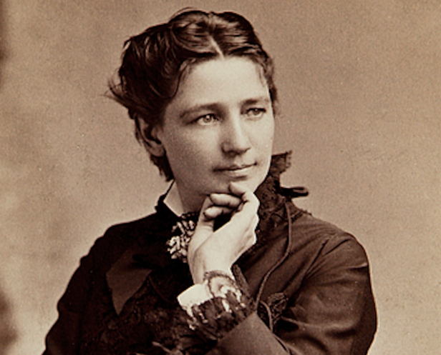
In 2016, Hillary Clinton made history. She became the first woman to be the presidential nominee of a major political party. But she was not the first woman to run as a presidential candidate. That honor belongs to Victoria Claflin Woodhull.
In 1872, Woodhull became a third-party candidate, running against the Republican president, General Ulysses S. Grant, and his Democratic challenger, Horace Greeley. At the time, women in the United States did not even have the right to vote. They wouldn't have that right for another 50 years. But that did not stop Woodhull from making a historic bid for change.

"Women Are The Equals Of Men"
Woodhull was an early feminist and supporter of women's rights. She first received national attention in 1871, when she was invited to Washington to speak before the house judiciary committee. Woodhull made a bold statement before the committee: "Women are the equals of men before the law, and are equal in all their rights."
Woodhull argued that women already had the right to vote. The 14th Amendment to the Constitution granted that right to all citizens born in the United States, she said. She also claimed that the 15th Amendment applied to women as well. The 15th Amendment had ended slavery in 1870. Women, Woodhull said, had long been treated in a similar way to enslaved people. Women needed to be freed from having to act as servants to their husbands and families.
If women were not given their political rights, Woodhull promised, they would have no choice but to revolt. They would rise up and govern themselves.
Not surprisingly, the committee did not agree with any of her positions.

A New Political Party Emerged
For 25 years, suffragists had tried to get the leaders of the two major political parties to listen. Suffragists were people who fought for women's right to vote. Repeatedly, they were ignored. Asking for their rights was getting them nowhere. Now, suffragist leaders decided it was time to act. On May 9, 1872, the National Woman Suffrage Association formed a new political party, The Equal Rights Party. Woodhull was selected to run as its candidate for the presidency of the United States.
Woodhull was far ahead of her time. She pushed for female suffrage, of course. But she also demanded equal pay for men and women. She believed in universal health care and changes had to be made to American prison systems.
Woodhull never had any real chance of being elected, and she was too young to be the president. However, her candidacy helped bring attention to issues that were otherwise ignored.

Political Downfall
Along with her sister, Woodhull ran her own newspaper, Woodhull and Claflin's Weekly. The paper helped bring attention to Woodhull's views. In the end, though, the paper was her downfall. On November 2, 1872, three days before Election Day, Woodhull published two articles about two major critics of her campaign. One of the pieces accused New York preacher Henry Ward Beecher of having an affair with a married woman. The other claimed Wall Street trader Luther Challis had assaulted two girls.
Because the two articles discussed sexual matters, they were considered inappropriate, and against the law. Woodhull and her sister were quickly arrested and jailed.
Even though she was now in jail, Woodhull remained on the ballot. We will never know how many votes she received. This is partly because some polling stations probably threw away her votes. However, we do know she did not win any states. Grant easily won a second term.

Death And Legacy
Woodhull and her sister were later cleared of charges and freed from jail. She continued to give public speeches and to publish her weekly paper, but her political career was over. She suffered from constant poor health and was always short of money. Woodhull eventually moved to England. There she started another newspaper, The Humanitarian, and threw her support behind the British suffragist movement. Woodhull died in 1927. A year later, British women won the right to vote.
Today, Woodhull has mostly been forgotten. When she is remembered, she is usually treated as an odd fact about U.S. history. But Woodhull deserves to be considered an important pioneer in the fight for women's rights.
Following Woodhull's presidential run, suffragists continued fighting for political change. The Equal Rights Party continued to nominate women for the presidency. Each voting day, it sent members to polling stations to insist on women's right to vote.
Progress was slow, but by 1918, women had won the right to vote in 40 states. In 1920, the Constitution was changed to give all women in the United States the right to vote. Since Woodhull's campaign, third parties have nominated 21 more female presidential candidates. Jill Stein ran in 2016 for the Green Party. That same year, Hillary Clinton won the Democrat nomination, 136 years after Woodhull was arrested.
Back in 1872, Woodhull closed her campaign with a letter to the editor of the New York Herald. Woodhull's letter was written from her prison cell. It showed she knew very well what she had begun: "The public may succeed in crushing me, even to the loss of my life. But let me warn them and you that from the ashes of my body a thousand Victoria Woodhulls will spring. They will seize the work laid down by me and carry it forward to victory."

Step 2: Answer the following questions.

Circle what you think is the central idea to the text.
- Suffragettes worked very hard to win the right to vote for women.
- Victoria Woodhull was a strong leader in fighting for women’s equality and other social justices.
- Sometimes we have to fail in order to be successful and Victoria Woodhull did just that.
- Women are equals to men and should, therefore, have the same freedoms and rights as men.

Explain why you chose your answer above. What in the text makes you think that is the central idea?

After reading about Victoria Woodhull, provide three examples from the text that show she was a strong, courageous, and/or brave woman.

Step 3: Write a short essay.

Over the past three days, you have read about women who have had to overcome societal challenges beyond their control. Reflect on the methods that these women used to find strength within to overcome these challenges.

Choose and circle one of the following statements about how individuals handle societal challenges beyond their control. You will then brainstorm and write a paragraph expanding on the statement.

Statements | When faced with opposition, individuals can dig deep to find strength within to do what is right.
 | Individuals who show strength in times of difficulty, inspire others to be strong as well.
 | When we cannot control what is happening, our strength comes from controlling how we respond.

For your paragraph, you will need to support your statement of choice with clear reasons and relevant evidence from your readings on Harriet Tubman, Frances Harper, and Victoria Woodhull. Complete the graphic organizer below to help you brainstorm before writing your paragraph. You must provide 3 pieces of evidence from your readings to support the statement. (the example provided is for statement 2 above)

Evidence | Citation | Explanation of how this evidence supports your statement/argument
The people that Harriet Tubman helped to freedom gave her hugs and told her “God bless you” | Letter to Tubman | Harriet Tubman’s bravery and strength inspired the people she helped to be brave in the face of danger and they showed appreciation to her. (supports statement 2 above)
Now that you have examples to help support your statement of choice, write your paragraph and argue that the statement you chose is true.

Student Feedback:

Circle the emojis that best represents how this activity made you feel.

Day 3: Science
Bridges

What is this lesson about?: Today you will use your knowledge about bridges and designs to solve challenges involving picking the best bridge for a situation.

Step 1: Consider the following quote

“A bridge has no allegiance to either side.”
What do you think is the meaning of this quote?

Step 2: Check your understanding
arch beam cable-stayed cantilever suspension truss

Match the above names with the below pictures:

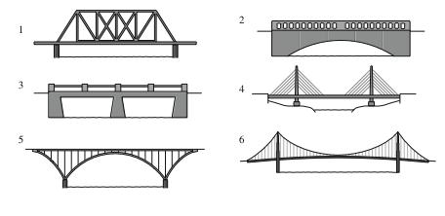
Write your answers here:

- __________________________________
- __________________________________
- __________________________________
- __________________________________
- __________________________________
- __________________________________

Step 3: Solves the following challenges.

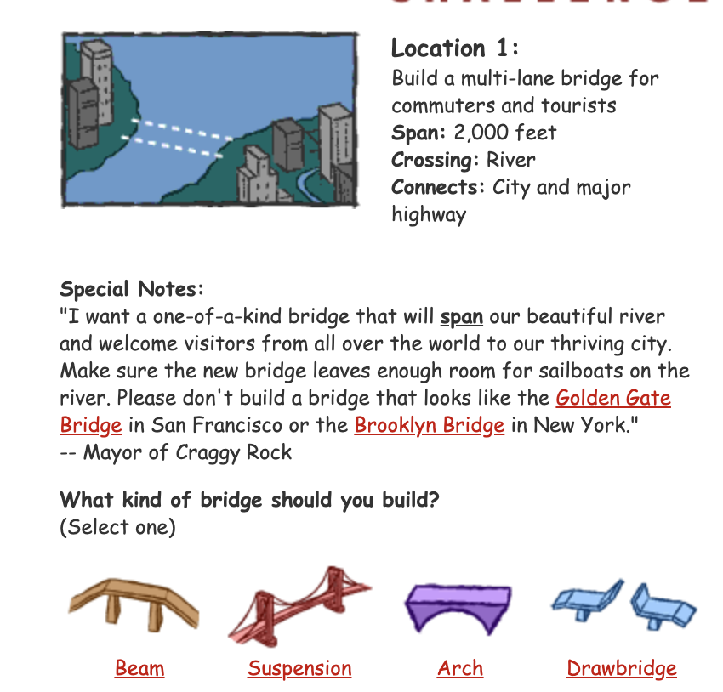

Why:

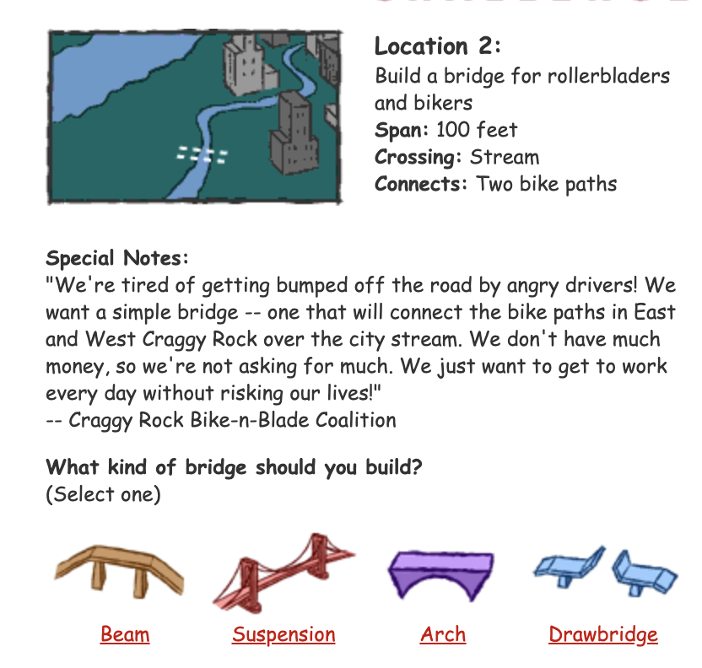

Why?

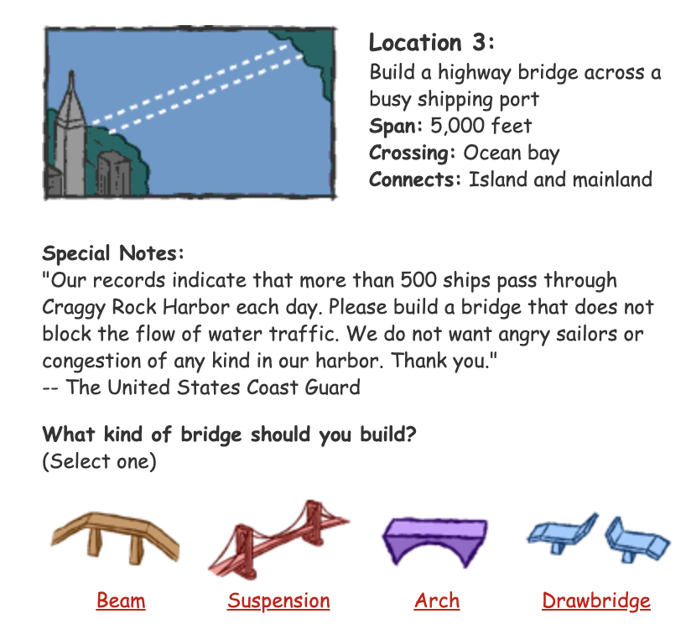

Why?

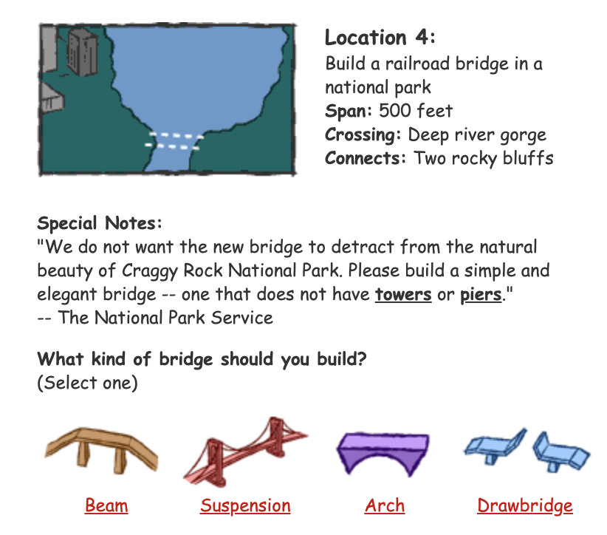

Why?

Step 4: Reflection

What was the most interesting thing you learned about bridges?

What is something you think you would be able to teach someone else about bridges?

Student Feedback:

Circle the emojis that best represents how this activity made you feel.

Mindfulness Moment!
Mantras: Choose one below and say it over and over all day.

I can do more than I believe.
My dreams will come true.
I am great today, and I will be even greater tomorrow.
My heart is full of kindness and courage.
I am what I am.
Life is a daring adventure or nothing at all.
Yesterday is not today.
OR
Create your own mantra:

Day 3: Math
Exponential Growth

What is this lesson about?: There has been a lot of discussion lately about exponential growth. Today we will compare different types of growth -- linear, and exponential -- and look at a couple examples of them.

First, take a few minutes for today’s warm up:
Take a few minutes to answer questions below.

Which would you choose?
A friend of yours goes to work for Nike. After she has worked there for a couple of years, she tells you some pretty amazing news--that some Nike shoes are made in the exact same factory using the exact same supplies and the exact same machines as shoes that are sold at Target under the Champion brand.

- So you check out a pair of Nikes at Foot Locker. They cost $110. You go to Target and look carefully at the shoes--and you are pretty sure that you have found the ‘same’ shoe, but it’s a Champion brand. It costs $45.

Discuss: Which pair of shoes would you buy? Why?

Step 1: Understanding Linear Growth.

Complete each of the problems below. Use the information provided to answer the questions.

Complete the chart below:
Assume that every year a mysterious new, cuddly Teddy Bear reproduces exactly one time and makes a baby all by itself. Each Teddy Bear only makes 1 baby, 1 time. The Teddy Bears do NOT die, ever.

Question: After 6 years how many Teddy Bears will there be? Fill in the table below to help you answer the question-

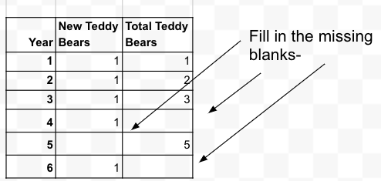
Now, we converted this table to a graph. .
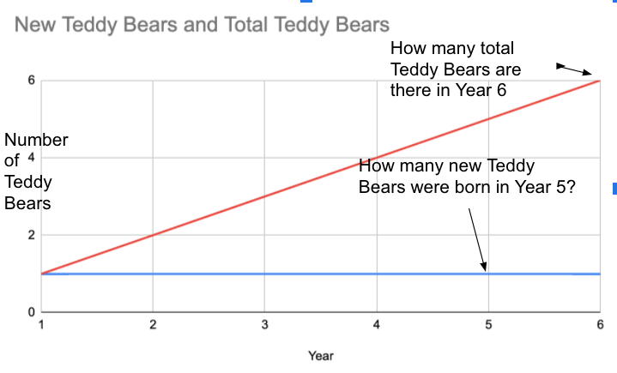Looking at the graph, how many total Teddy Bears are there after 6 years? How many new babies were born in year 5?

Step 2: Understanding Exponential Growth, Round 1
Complete each of the problems below. Use the information provided to answer the questions.

Complete the chart below:

Assume that every year a mysterious new cuddly Teddy Bear reproduces exactly one time and makes two babies all by itself. Each Teddy Bear only makes 2 babies, 1 time. But the creatures do NOT die, ever.

Questions:
How many new Teddy Bears are born in year 4? After 6 years how many Teddy Bears will there be all total? Fill in the table below.
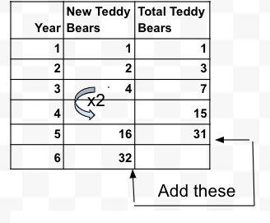
Below we converted this table to a graph.
- Looking at the graph, how many new Teddy Bears are born between year 5 and year 6?
- How many Teddy Bears are there after 6 years?
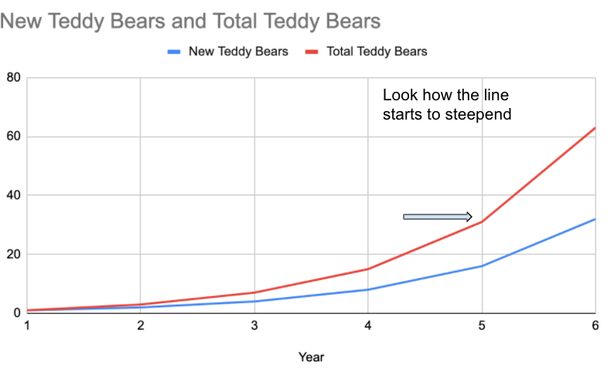
Step 3: Understanding Exponential Growth, Round 2

Complete each of the problems below. Use the information provided to answer the questions.
Complete the chart below:
Assume that every year a mysterious new cuddly Teddy Bear reproduces exactly one time and makes three babies all by itself. Each Teddy Bear only makes 3 babies, 1 time. But the Babies do NOT die, ever.
Questions:
- How many new Teddy Bears will be born in year 5?
- How many total Teddy Bears will there be in year 6?
Fill in the table below.
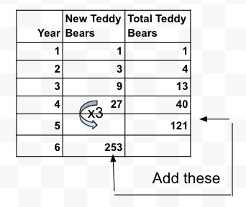
Below we have converted this chart to a graph.
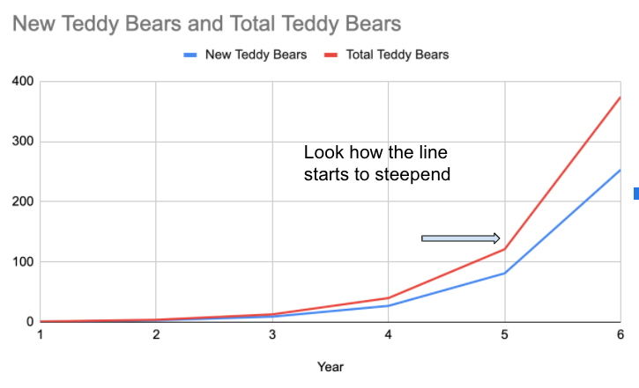
Looking at the graph:
- How many mystery Teddy Bears are there after 6 years?
- What will this graph start to look like by year 8 or 9? Will it flatten out or get steeper?
Step 4: Understanding Exponential Growth, Discussion Questions

What would be something positive that could come from really strong, exponential growth? What is something that you wish would grow faster and faster, really quickly?
- Say every act of kindness resulted in two more acts of kindness and that went on and on?
- Or say that for every flower that blooms, bees can pollinate two more flowers during the spring, making the outdoors beautiful and fresh?
- What would you like to grow exponentially?

What would be something negative that could come from really strong exponential growth?
- Say every time an adult said something negative to a child, that child grew up and said two negative things to their child?
- What would you like to make sure does not grow exponentially?

Student Feedback:

Circle the emojis that best represents how this activity made you feel.
Mindfulness Moment!

A common mindfulness activity is a ‘body-scan’. This involves focusing on different parts of your body, one at a time, and thinking about how they feel. We like to add another dimension to this idea by drawing them. For example, start drawing your hand and fix your attention on how it looks and what sensations you are feeling. It doesn’t have to be perfect because the finished product doesn’t matter – mindfulness drawing is all about the process!
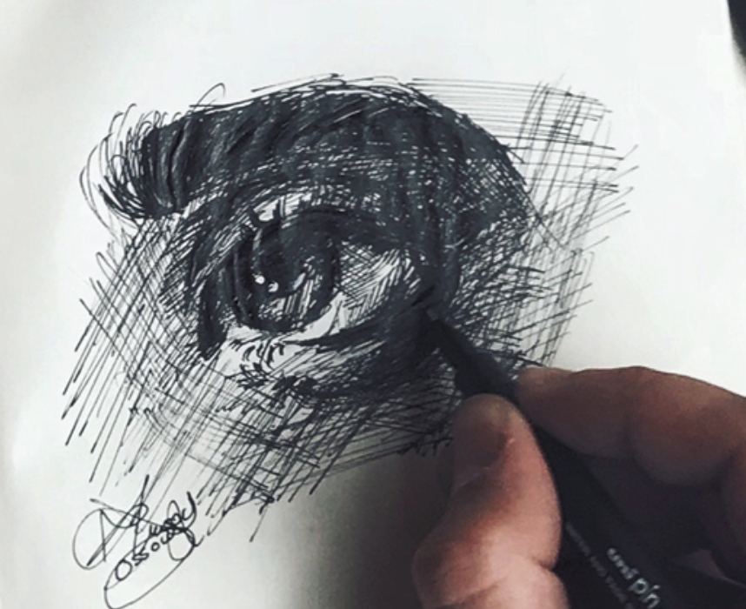
Day 3: Civis/Social Studies
World War I

What is this lesson about?: Today you will review what you have learned about WWI during the past couple days and create graphic notes on the key themes and issues of WWI. You will also use your creativity to make a meme with WWI images.

Step 1: Review of key vocabulary
Match the correct definition with each key term (refer to your readings from Day 1 and 2, if necessary)

- Nationalism _____________
- Imperialism _____________
- Alliance _____________
- Militarism _____________

- Forming friendships with other countries for protection
- To build up and use one’s army
- Love for one’s country and support for its interests, sometimes to the detriment of others
- Spreading a country’s influence by conquering

Step 2: What is a sketchnote?
Look at the image of the sketchnote below. What do you think a sketchnote is?
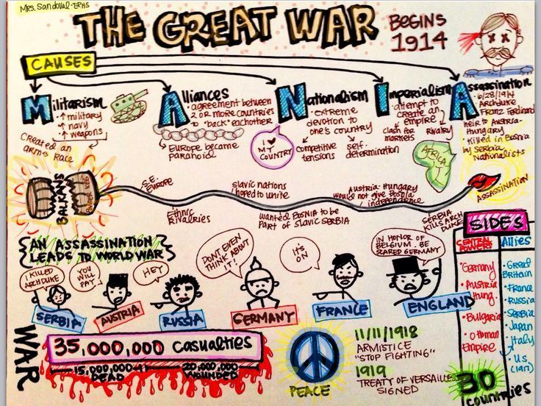

Sketchnoting is a form of note-taking, hence the “noting” part of it, but as you might guess it involves bringing more visuals into the process compared to typical note-taking, hence the “sketch” part. The whole idea behind adding sketches to your notes is that it taps into parts of your brain that would lie dormant if you only use words to explore ideas. It’s the combination of the two that’s most powerful – using both words and visuals while taking notes!

Step 3: Your turn! Create a Sketchnote on WWI

You’ve spent the last two days learning about WWI, and now it’s time to take note of all you have learned. Your assignment is to create a sketchnote titled “World War I.” Here’s what you need to include in your sketchnote:
- Causes of WWI
- Key countries that were involved
- Key vocabulary (nationalism, alliance, imperialism, militarism)
- Who won the war, who lost the war
- The results of the war

Have fun with this assignment! Get started in whatever way works best for you (start drawing images that capture themes of WWI or begin by writing words). You can use arrows and equation signs to help with the slow of your sketchnote, too.

Use this page for your sketchnote

Step 4: Create a WWI meme

Take a look at the example memes below.
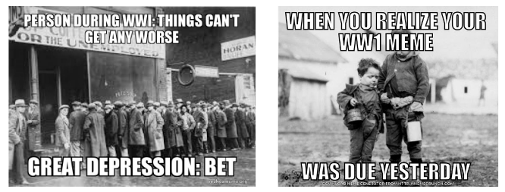

Now, using the below templates, create your own memes with the WWI images.
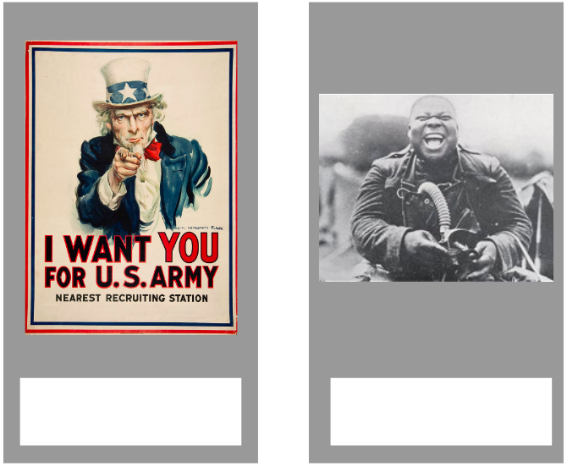

Step 4: Share with a partner.

Review your sketchnote and memes with a classmate.
- Did you include any of the same drawings in your sketchnote?
- What do you like about your classmates Sketchnote that you want to add to yours?
- Do you have any feedback on your classmate’s memes? How might you make your meme stronger after seeing your classmates?

Student Feedback:

Circle the emojis that best represents how this activity made you feel.

Creative Activities: Can you invent a new sport?
List of Supplies
- 2 tennis balls
- a plastic bat
- one goal
- 10 players
Design a game that could use the above supplies.
Rules:

Describe or draw what it looks like:

