Week 2
Environment

Day 1

NAME:______________________

Day 1 Agenda

Topic | Activity
Warm-Up!
English Language Arts | - Discover what this week’s theme means  - Learn about setting in fictional stories  - Read passages and respond to questions about setting
Science | - Read the article, Coronavirus shutdowns have unintended climate benefits: cleaner air, clearer water  - Make recommendations to continue the cleaner air and clearer water  - Draw a picture of something within your environment that most concerns you and make suggestions to bring about change
Mindfulness Moment!
Math | - Real world Problem: Making smart choices about cell phones and cell phone plans-  - Practice: Multiplication & Division, Quick Hits
Health | - Sleep Journal  - Sleep Survey
Civics/Social Studies | Environmental Activism: Wangari Maathai  - Read an article  - Answer questions about the article  - Summarize the article

Warm-up Activity: You will determine the conditions of the story by filling in the blank and writing the rest of the story.
Lori did not want to leave town, but when Ashleigh did ________________, she felt she had no choice.

Day 1: Settings in Fictional Stories
English Language Arts

What is this lesson about?: In this lesson, you will consider the theme for the week, which is “Environment.” You will explore what “environment” is in fictional story-telling by learning about story settings. In the next two classes, we will continue exploring settings of stories and how the setting informs a story’s theme, mood, and plot.

Step 1: Reflect on this week’s theme

This week, your lessons are organized around the theme of “Environment.” Write a definition for “environment” below.

Circle the words below that you think are synonyms to “environment.” (Reminder: A synonym is a word or phrase that means exactly or nearly the same as another word)

Habitat Life Surroundings America Theory Place
Farm Structure Setting Neighborhood

Look at the definition of environment on the next page. Was your definition close?
After looking at the definition of Environment, list 5 environments in which you could find a bird?

Question to consider: Does our environment affect how we act? How we think? How we feel? Write down a short answer:

Definition
Environment: 1. the surroundings or conditions in which a person, animal, or plant lives or operates; 2. the natural world, as a whole or in a particular geographical area, especially as affected by human activity.

Step 2: Learn about “settings” and environments in stories

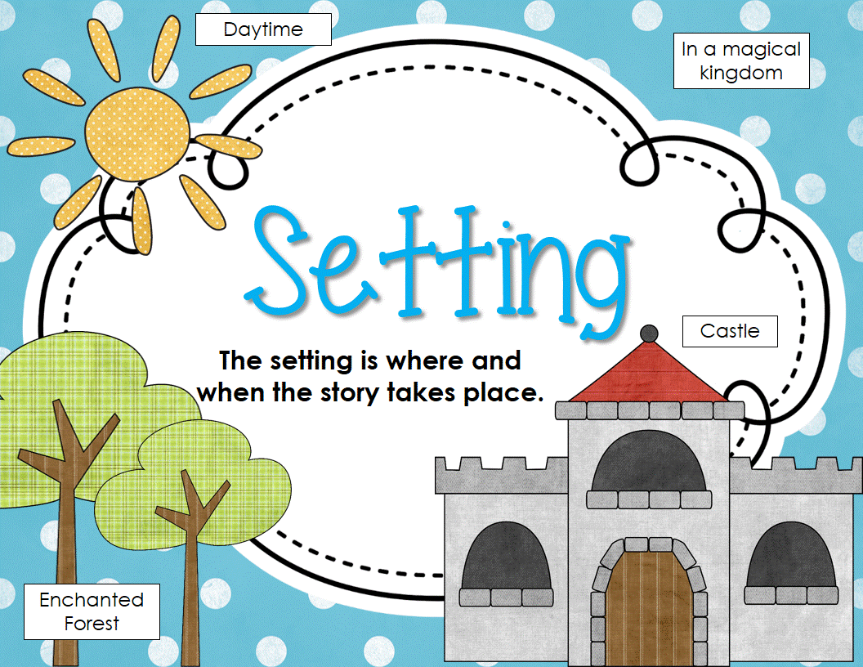
What is setting?
The definition for “setting” is time and place. The setting informs a story’s theme, mood, and plot, and provides context. Setting isn’t only in the background of a story! Setting can play an important role in the stories we read and the movies we watch. Setting can establish the mood and reveal the characters and conflict. It can even give clues to the theme—the universal message—of a story.

How do you know what the setting of a story is?
Sometimes, a narrator will tell you where and when the story occurs right away. Often, though, you’ll have to look for clues to determine the setting. Try to find words or phrases that tell you what it looks like or sounds like where the characters are. Characters can also give clues about the setting. Authors often describe the setting by relying on our senses and providing details about what the setting tastes, feels, sounds, smells, or looks like.

Think about the five senses. Act as if you are an author writing a story, write short phrases or words to brainstorm what your character might sense in the location of a jungle.

See
Feel
Hear
Smell
Taste

Now, using your brainstorm above, write a short intro paragraph to your story. You can give details about your main character to help describe what they are sensing. Do not use the word “jungle” in your paragraph, let the reader figure out the setting on their own.

Step 3: Read and answer the questions.

Read the passage and answer the following questions.

As Maribelle hurried down the street, the wind swept the snow along the sidewalk and hid her footsteps, so that it looked as if no one had passed. Above her, the cold, silent skyscrapers of the city loomed. The whole block was eerily silent in the snowstorm, and she pulled her coat tightly around her. Maribelle had only moved here a few months before. She came because she wanted to be a singer. But right now, she was frightened.

Question 1: Where do you think Maribelle is?

Question 2: What quote helped you to determine where Maribelle is?

A “Above her, the cold, silent skyscrapers of the city loomed.”
B “Maribelle had only moved here a few months before.”
C “But right now, she was frightened.”
D “She came because she wanted to be a singer.”
___________

Setting can symbolize, or stand for, other elements of a story. For example, when setting changes, a character might change. Setting can also symbolize what a character is feeling in a particular scene. Setting can also help us understand the choices that characters make.

Read the following passage and answer the question.

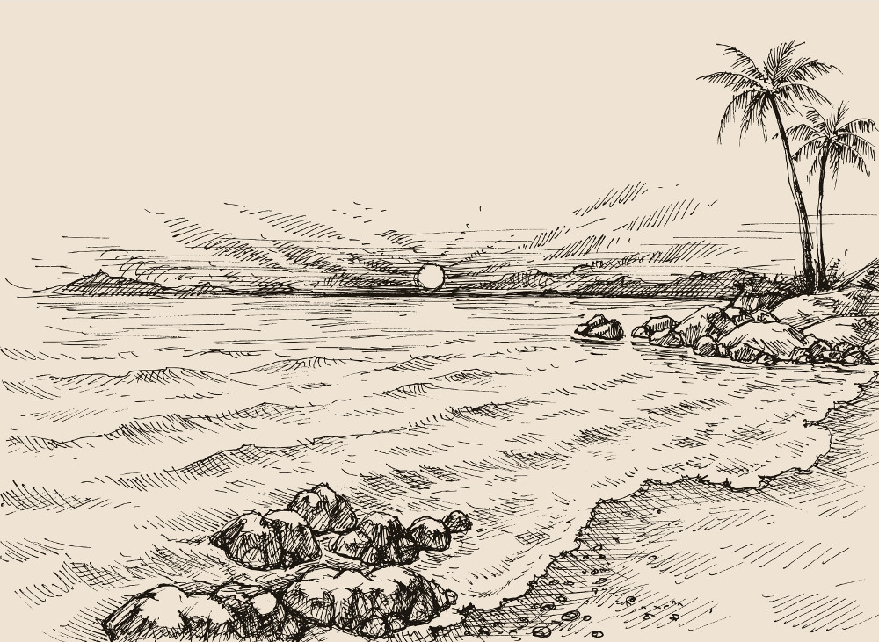
Gilberto had been excited to go to the beach but when he got there and saw how crowded it was, he became annoyed. The sun twinkled in the sky, a warm yellow globe. The sound of the ocean drummed in his ears and the sand itched his ankles and feet. Beside him, his sister slurped loudly on an ice cream cone. “Could you not?” Gilberto asked.

Question 1: What quote about the setting helps you to understand how Gilberto is feeling?

A “The sound of the ocean drummed in his ears and the sand itched his ankles and feet.”
B “The sun twinkled in the sky, a warm yellow globe.”
C “Beside him, his sister slurped loudly on an ice cream cone.”
D “Gilberto had been excited to go to the beach...”

Question 2: Explain why you chose your answer:

Step 4: Practice developing the setting of a story

Read the following sentences describing a situation or character. Develop a setting that would give context to the sentence and make the sentence more understandable.

Example: Jeremy was standing, waiting. His jaw was clenched and he was sweating.

What setting could this happen in?

In this example, the mood is tense and nervous. A setting that would fit this might be a sporting event, say Jeremy is at a racetrack and is about to race in the 100-meter sprint.

Sentence 1: Chills drew down Maria’s spine and she sprang to her feet.

What setting could this happen in?

Sentence 2: Peter’s grandma was looking at him and smiling, she was proud of her grandson.

What setting could this happen in?

Sentence 3: Marcus stared into the eyes of Kevin, there was no way he was going to let Kevin win this time.

What setting could this happen in?

Sentence 4: The wind blew in Jackie’s hair as the sun warmed her skin. She could hear the birds chirping in the distance.

What setting could this happen in?

Step 4: Closing Reflection

Complete the graphic organizer and answer the question below about today’s lesson on setting.

What I learned | What I have questions about

Now that you have learned about the importance of story settings, how will you change the way you consider the setting or environment of a story as you read in the future. (Will you pay more attention to the setting? Why?)

Student Feedback:

Circle the emojis that best represents how this activity made you feel.

Day 1: Science
Environment

What is this lesson about?: Today you will read through the article, Coronavirus shutdowns have unintended climate benefits: cleaner air, clearer water
You will take on the role of an environmentalist. An environmentalist is someone who is concerned with or advocates the protection of the environment. After you read the article, please answer the questions.

Step 1: Read through the article, Coronavirus shutdowns have unintended climate benefits: cleaner air, clearer water

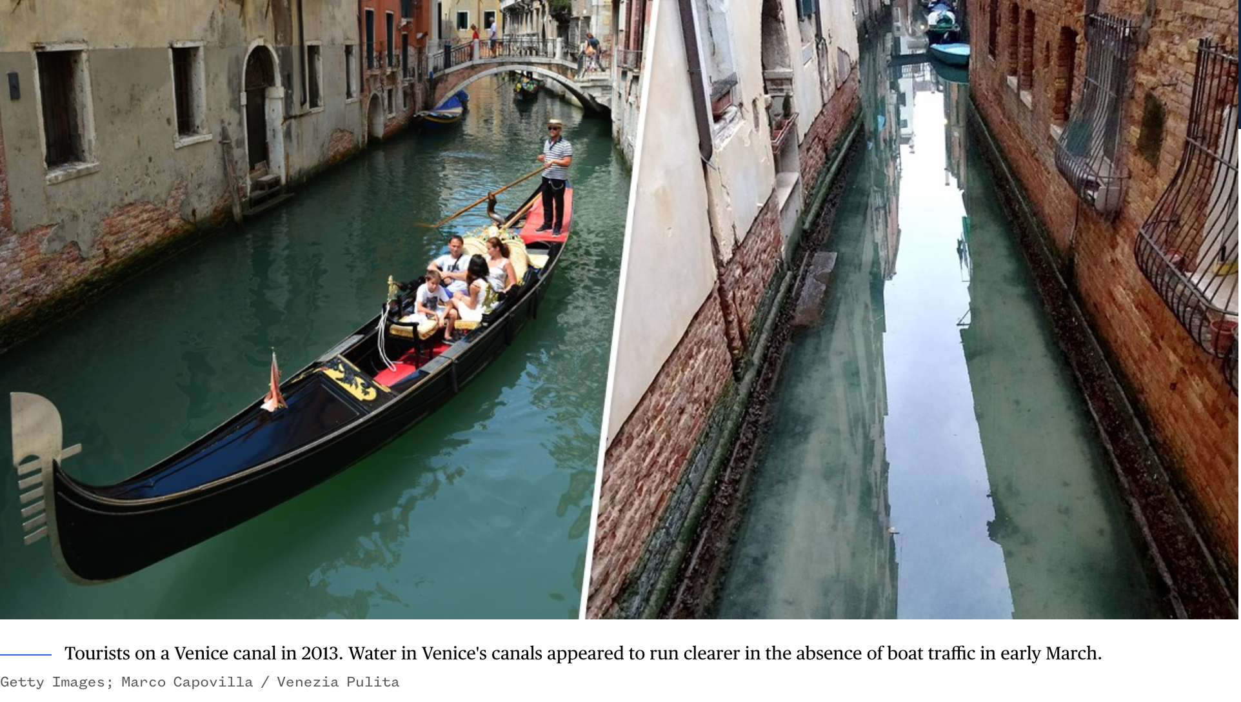
By Denise Chow (NBC Science News)

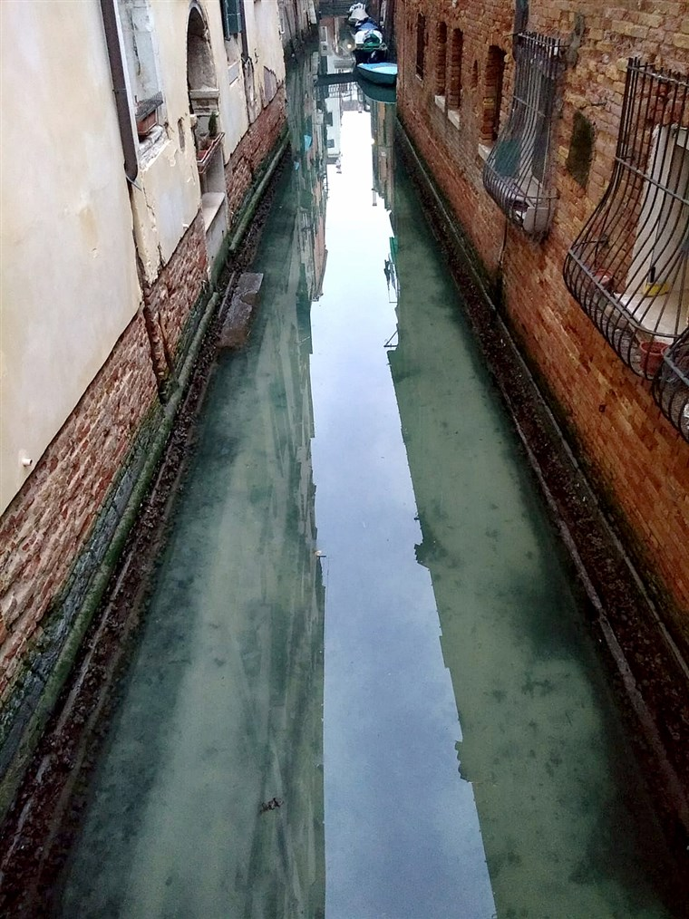
In Venice, the often murky canals recently began to get clearer, with fish visible in the water below. Italy's efforts to limit the coronavirus meant an absence of boat traffic on the city's famous waterways. And the changes happened quickly.
Countries that have been under stringent lockdowns to stop the spread of the coronavirus have experienced an unintended benefit. The outbreak has, at least in part, contributed to a noticeable drop in pollution and greenhouse gas emissions in some countries.
Although grim, it's something scientists said could offer tough lessons for how to prepare — and ideally avoid — the most destructive impacts of climate change.
"If we can think about how to prepare for climate change like a pandemic, maybe there will be a positive outcome to all of this," said Christopher Jones, lead developer of the CoolClimate Network, an applied research consortium at the University of California, Berkeley. "We can help prevent crises in the future if we are prepared. I think there are some big-picture lessons here that could be very useful."
The coronavirus pandemic has sickened more than 180,000 people and killed more than 7,100 worldwide since early January. Some countries, most notably China and Italy, have been forced to seal their borders and restrict residents' movements to control the rates of infection.
Satellite observations have shown that the temporary measures have also driven significant decreases in harmful emissions.
"Carbon dioxide is tied to industrial activity, electricity production and transportation, so anything that affects those sectors will impact greenhouse gases, as well," Jones said.
Nitrogen dioxide over #China has dropped with the coronavirus quarantine, Chinese New Year, and a related economic slowdown.
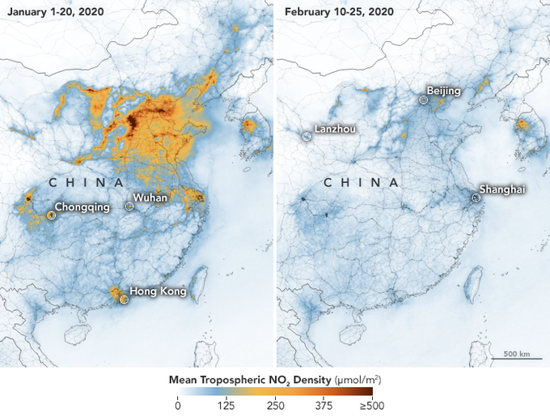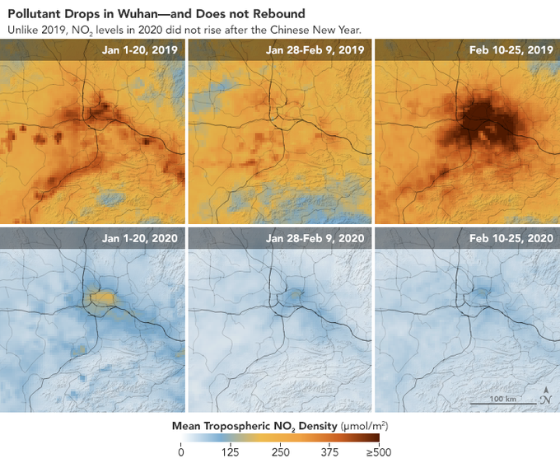
The coronavirus first emerged in late December in Wuhan, China. As it rapidly spilled into neighboring regions, the Chinese government locked down the city, quarantining 11 million people in Wuhan. Eventually, the lockdown would include almost 60 million people in the province of Hubei.
Industrial operations in the coronavirus hot spot ground to a halt, and travel restrictions within China meant that air, rail and road traffic were paused or scaled back across some regions.
According to Lauri Myllyvirta, an analyst at the Centre for Research on Energy and Clean Air in Finland, the restrictions contributed to a 25 percent drop in China's carbon dioxide emissions over four weeks beginning in late January, compared to the same time last year.
Myllyvirta's analysis also found that industrial operations were reduced by 15 percent to 40 percent in some sectors and that coal consumption at power plants fell by 36 percent.
Pollution-monitoring satellites operated by NASA and the European Space Agency observed drastic decreases in air pollution over China over two weeks in February when the quarantine was in effect. The satellites measured concentrations of nitrogen dioxide, which is released by cars, power plants and industrial facilities, from Jan. 1 to Jan. 20 and again from Feb. 10 to Feb. 25. The difference was unmistakable.
Clearer waters in Venice in early March were an unintended climate benefit of the coronavirus lockdowns in Italy.Marco Capovilla / Venezia Pulita
The cloud of nitrogen dioxide that was parked over China in January seemed to evaporate in February. NASA scientists said that similar emissions reductions have been observed in other countries during economic disruptions but that the sharp decrease in air pollution in China during the quarantine period was especially rapid.
"This is the first time I have seen such a dramatic dropoff over such a wide area for a specific event," Fei Liu, an air quality researcher at NASA's Goddard Space Flight Center, said in a statement this month.
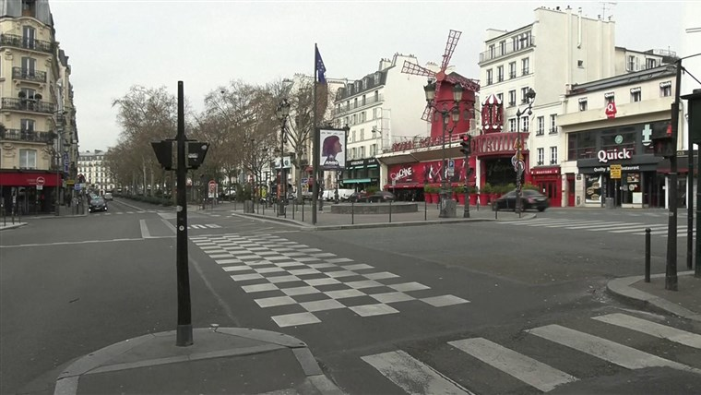
Pollution levels have similarly decreased over Italy, which has become the center of the coronavirus pandemic outside China. On March 8, as cases spiked, Italy locked down its northern Lombardy region. Two days later, the prime minister expanded the quarantine to include the entire country.
Concentrations of nitrogen dioxide in the atmosphere over Italy also fell precipitously, as they did in China. An analysis by The Washington Post found that the most dramatic drop was observed over northern Italy.
Nitrogen dioxide can irritate the lungs, and inhaling the pollutant can increase the risk of asthma and inflammation of the lungs. Although the noxious gas isn't thought to be a major contributor to climate change, studying its concentration in the atmosphere can help scientists understand other heat-trapping greenhouse gases that do drive global warming.
Jacqueline Klopp, co-director of the Center for Sustainable Urban Development at Columbia University in New York City, said she expects to see greenhouse gas emissions plummet across the board because of the
"People were in their homes and really stopped a lot of the activities that lead to greenhouse gas emissions and other pollution," she said.
Early observations have shown that extreme social-distancing measures are likely also having an effect on air pollution at the city level in the U.S.
Jordan Wildish, a project director at Earth Economics, an environmental non-profit organization based in Tacoma, Washington, developed an online dashboard to track air quality in San Francisco, New York City and the Seattle area, comparing the measurements with figures from the same time last year.
In San Francisco, which is under shelter-in-place orders to control the spread of the coronavirus, the average concentration of fine particulate matter — tiny particles in the air that are dangerous because they can be breathed deeply into the lungs — over the past five days was almost 40 percent lower than the previous year.
In New York City, there was a 28 percent drop over the same period of time, and the Seattle-Tacoma-Bellevue saw a 32 percent decrease.
But experts warned that observed reductions are temporary and that as cities, countries and economies bounce back, so, too, will emissions — unless major infrastructure or societal changes are adopted.
Klopp said the pandemic could make companies and governments realize that other threats to humanity, including climate change, could be just as devastating and that it's imperative to develop protective measures.
"As we move to restart these economies, we need to use this moment to think about what we value," she said. "Do we want to go back to the status quo, or do we want to tackle these big structural problems and restructure our economy and reduce emissions and pollution?"

Step 2: Answer the following question

An environmentalist is someone who is concerned with or advocates the protection of the environment. If you were an environmentalist, based on what you are noticing with Italy’s waters and China’s skies from this article, what recommendations would you make so the cleaner air and clearer waters continue?

Step 3: Draw a picture

Draw a picture of something within your environment that most concerns you.

As an environmentalist, what suggestions will you make to bring about the change that is needed? Please write your response on the lines below:

Student Feedback:

Circle the emojis that best represents how this activity made you feel.

Mindfulness Moment! Respond to your Mindfulness card in the box below.
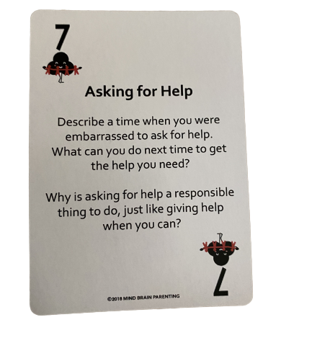

Day 1: Cell Phones
Math
What is this lesson about?:
Today’s lesson is about Cell Phone purchasing plans. Every day you are bombarded with advertisements about different cell phone purchase options. In this environment it’s easy to make poor decisions or get confused. Hopefully, today’s project will help on this.

But first: Today’s Warm-Up
It’s spring. You plant a small tree outside. It is 6 inches tall when you plant it.

- If it grows 6 inches every month for 5 months, how tall will it be in 5 months (In inches? In feet and inches)?

- If it doubles in size every month for 5 months, how tall will it be in 5 months? (In inches? In feet and inches)?

- If it doubles in size for 3 months and then grows 6 inches for the last 3 months, how tall will it be in 5 months?

Step 1: Let’s consider these different phone/coverage plans, just to make sure we understand the options.
A | The  Phone/Plan | What’s included | Money At Purchase | Monthly Cost | # of Months
B | IPhone 10 only, pay at purchase | Phone only | $700 | $0 | 0
C | IPhone 10 only, pay monthly | Phone only | $200 | $20 | 3 years/36 months
D | IPhone 10, plus max coverage, pay monthly | Phone, plus coverage | $200 | $50 | 3 years/36 months
E | IPhone 7 only, pay at purchase | Phone only | $350 | $0 | 0
F | IPhone 7, plus max coverage, pay monthly | Phone, plus coverage | $50 | $20 | 3 years/36 months
G | Coverage only: AT&T | Unlimited | $75 (first 3 months) | $25 (after the first 3) | Requires you to sign up minimum of 12 months
H | Coverage only: COX | Unlimited | $60 (first 2 months) | $30 (after the first 2) | Requires you to sign up minimum of 12 months
I | Coverage only: Straight talk | Unlimited | $35 | $35 | Pay monthly

Step 2: Answer the questions below, using the information in the chart above. Be careful!!!

If you buy the IPhone 10 on the monthly plan (Row C), how much will you pay for the phone after 3 years (36 months)?

How much more is that than if you buy the same IPhone 10 all cash up front (Row B)?

- Why would you choose the monthly plan (Row C) instead of the all cash up front plan (Row B)?

How much more is an IPhone 10 than and IPhone 7, all cash up front?

- Is that difference worth it? Yes/No. Why?

If you buy the IPhone 10, plus max coverage, on the monthly plan (Row D) how much will you pay for your phone and coverage after 3 years?

How much more, over three years is that than a similar plan, but with the IPhone 7 (Row F)?

- Is that difference worth it? Yes/No. Why?

Now, let’s take a look at the coverage plans, only.

What is the primary reason to purchase Straight Talk, if it costs more per month than ATT or Verizon?

- Over 1 year (12 months) how much will you pay for
  - ATT?
  - Verizon?
  - Straight Talk?

What is one good reason to go with AT&T?

What is one reason not to go with AT&T?

Step 3: Make Your Own Plan
Based on the information above, design an advertisement for a cell phone plan below. You are trying to appeal to teenagers. What sort of plan works best for you and other teenagers you know.

- Do you want to have a high or low cost to acquire the phone? Do you want to bundle the phone plus the service? Do you want this to be month to month or longer?

Write out or draw your cell phone plan below!

Name:

My plan to not get ripped off buying a cell phone:
RIPPED OFF BY CELL PHONE DEALERS - NO WAY!!!

Discuss: share your plan with others, if permissible.

Step 4: Understanding the environmental costs of discarded cell phones.

Each year millions of phones are traded in, thrown away and discarded. They have plastic and metals in them that can cause health and environmental problems. These problems can be mostly solved if the phone is taken apart and certain pieces recycled.

There are estimates that each phone that is discarded and not disposed of properly costs society up to $10 in pollution.

Do you have any ideas on what could be done to encourage people to turn in their cell phones to a cell phone store/dealer so that it will be properly taken apart and recycled?

What about some sort of plan where if you turn in an old phone you will get a certain amount of $.

Design a pop-up add below designed to get people to turn in all of their old phones…
󠀠
Make Your Pop Up Ad HERE

Cash $ for turning in used cell phones!!!

Skill Builders and Review Problems-
If you have time, complete the “skill builder” problems in the separate handout packet for Day 1.
- Divisibility
- Multiplication in 1 minute
- Multiplication Table

Student Feedback:

Circle the emojis that best represents how this activity made you feel.

Day 1: Sleep
Health

Step 1: Sleep Journal
Describe your sleep last night...light, heavy, too much, too little, snoring?

Step 2: Read the article

Teens are getting less sleep than ever before, and experts are calling it a national health crisis. Read on to learn the shocking consequences—and real strategies for getting the rest you so desperately need.

Generation Zzzzzzzz
It was the last class of the day, and George Sinclair’s eyelids felt like bricks. He tried to pay attention to his teacher, but his chin kept dropping toward his chest. George was operating on an hour of sleep after staying up to rehearse a history presentation and study for finals, so this one last period was feeling like an eternity.
Finally, the bell rang, and George headed to his pickup truck to make the 25-minute drive to his home in El Cajon, California. He blasted music to try to stay alert, but as he turned onto his street, no sound was strong enough. George nodded off.
When he jerked awake, his truck was veering across the road. It flipped on its side and slammed into a fence; a post crashed through the windshield, missing him by inches. “The two-by-four was under my armpit,” George recalls. “The car alarm went off, and I had to step on the board to climb out. I am so lucky to be alive.”
You know drinking or using drugs is dangerous, but the latest research shows that not getting enough sleep—like 85 percent of teens—can be just as hazardous. Missing just two hours of shut-eye quadruples your risk of a car accident and affects your decision-making—like George’s choice to get behind the wheel.
What’s more, experts say the teen sleep crisis is fueling a rise in mental-health issues and suicide. “Teens are getting less sleep now than ever before,” says Dr. Nathaniel Watson, a sleep specialist at the University of Washington. “This is a public health epidemic.”
Step 2: Sleep Survey
Thinking about a typical night in the last month . . .

1. How long does it take you to fall asleep?
0–15 min. 4 points
16–30 min. 3 points
31–45 min. 2 points
46–60 min. 1 point
>60 min. 0 points

2. If you then wake up one or more times during the night, how long are you awake in total? (Add up all the time you are awake.)
0–15 min. 4 points
16–30 min. 3 points
31–45 min. 2 points
46–60 min. 1 point
>60 min. 0 points

3. If your final wake-up time occurs before you intend to wake up, how much earlier is this?
I don’t wake up too early/Up to 15 min. early 4 points
16–30 min. early 3 points
31–45 min. early 2 points
46–60 min. early 1 point
>60 min. early 0 points

4. How many nights a week do you have a problem with your sleep?
0–1 4 points
2 3 points
3 2 points
4 1 point
5–7 0 points

5. How would you rate your sleep quality?
Very good 4 points
Good 3 points
Average 2 points
Poor 1 point
Very poor 0 points

Thinking about the past month, to what extent has poor sleep . . .
6. affected your mood, energy, or relationships?
Not at all 4 points
A little 3 points
Somewhat 2 points
Much 1 point
Very much 0 points

7. affected your concentration, productivity, or ability to stay awake?
Not at all 4 points
A little 3 points
Somewhat 2 points
Much 1 point
Very much 0 points

8. troubled you in general?
Not at all 4 points
A little 3 points
Somewhat 2 points
Much 1 point
Very much 0 points

Finally . . .
9. How long have you had a problem with your sleep?
I don’t have a problem/<1 month 4 points
1–2 months 3 points
3–6 months 2 points
7–12 months 1 point
>1 year 0 points

Now add up your total score and enter it here: _____________________

Use the following as a guide:

0–9 Your sleep problems seem to be severe. You should definitely try to get some help.

10–18 You have some sleep problems. It’s important to examine your sleep habits and see how you can make changes.

19–27 Your sleep is in good shape, but there are still many steps you can take to make it even better.
28–36 Your sleep is in great shape. Keep doing what you’re doing and spread the word!
Share
Share your results. Do you agree with them?

Student Feedback:

Circle the emojis that best represents how this activity made you feel.

Day 1: Environmental Activism
Social Studies

What is this lesson about?
In this lesson, you will read and respond to questions about Wangari Maathai, a social, environmental and political activist and the first African woman to win the Nobel Prize. Then, you will paraphrase and summarize the main ideas in a closing activity.
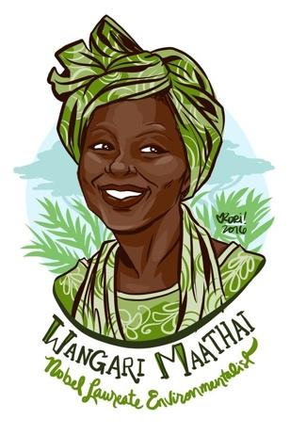
Step 1: Read the following short biography.
Wangari Maathai
In poor countries it is women who most often are sustained by the forests around them. From forests they fetch their wood for fuel, animal fodder, healing herbs, fresh spring water and nutritious fruits and nuts to eat and sell. When forests are cut for timber or large-scale agriculture, women’s livelihood and the health of their families suffer. In Kenya, a modern “Johnny Appleseed” has initiated a successful program to counteract the alarming destruction of Africa’s forests. Her Green Belt Movement seeks not to preserve wildernesses, but to conserve places that have been home to people through the centuries.
Political activist and environmentalist Wangari Maathai was trained to be a leader. When she was growing up, her father, a truck driver, made sure she was brought into family discussions and valued her opinions. This was a rare occurrence in her male-dominated society. At school she was taught that her generation had to accept responsibilities for the development of their young country. Sent to the United States and Germany for her formal education, Maathai took degrees in biology, becoming Kenya’s first female Ph.D. recipient. She then became the first woman to teach and chair a department at the University of Nairobi’s Department of Veterinary Anatomy. At age 25, she was ready to look for “new challenges so that I could play my part as a leader. … I felt ready to play my role in the development of my country.”
When Maathai’s husband was elected to parliament in 1993, she formed Envirocare, a program that hired the poor to help clean up their districts. Envirocare was once given over 6,000 tree seedlings to distribute. This event started Maathai on her future course: to introduce community tree planting as a way to improve human settlements and avert desertification.
In 1977 Maathai joined the National Council of Women in Kenya, a powerful organization which represents scores of national women’s organizations, both urban and rural. She became head of its Environment and Habitat Committee, which gave her a platform to expand her ideas. On Earth Day in 1977, she mounted a rally that resulted in the planting of seven trees in honor of legendary women and men who had made contributions to their communities. With that act, Maathai’s organization, the Green Belt Movement, was born.
Green Belt’s campaign started by planting protective “green belts” to help preserve the land. They initiated tree-planting activities at schools, in national parks and in communities. Farmers, 70 percent of whom were women, were also targeted. Maathai says that “It was important to be simple and practical. … Planting trees and food crops was easy and practical as agroforestry had always been our people’s way of farming.”
The hunger for free seedlings, which were distributed to those wanting them, was there. The next step was to ensure that the green belts would generate income for the women, thus ensuring their participation as stewards of the environment. One strategy was to have women own the trees they planted, and the products from them. Wangari wanted to develop a positive change for women since they were not usually given ownership of the land they farmed.
Maathai taught women how to rear the seedlings, plant, and market them. She helped develop environmental education classes which taught professional forestry techniques. The graduates took jobs as tree nursery managers, teachers in environmental programs for children, Green Belt promoters and rangers. The Green Belt Movement also encouraged training of the handicapped and school dropouts, hoping to curb the rural migration to urban centers for better prospects.
In 1981, Maathai tried to enter politics by becoming a candidate for parliament. To do so she resigned her position at the University of Nairobi. In the end, the ruling party refused to accept her as a candidate. By then, Maathai had lost not only her university position, but also the government-sponsored housing that went with it.
Being jobless and homeless did not stop Maathai. In 1990 her activism became well known when she opposed the ruling party’s plan to use the only green space in downtown Nairobi, Uhuru Park, for a skyscraper and shopping mall. Maathai sued to stop the project, but lost the suit in court. The Green Belt Movement was thrown out of its state-owned building with the government threatening to make the group illegal. Nonetheless, foreign investors behind the skyscraper project got the word; the proposed multistory complex was halted. Even though Maathai lost the suit, she won the struggle in the real world of international economics. Maathai’s name now became a rallying point for people around the nation and the world.
In 1992 Maathai returned to the same spot where plans to build the complex had been fought. This time it was as the head of mothers of political prisoners, some of whom were prisoners of conscience. Maathai and the mothers, most of whom were between 60 and 82 years old, camped and began a hunger strike. Riot police with tear gas moved against them. One canister hit Maathai, knocking her unconscious. The mothers returned, however, and kept up the protest for a year until 52 political prisoners were released. Today the area is known as Freedom Corner. Maathai regularly returns to it to plant and water trees in memory of those who died in the struggle for freedom, justice and democracy in Kenya.
Following her support of victims of violent ethnic clashes in Western Kenya, Maathai went into hiding in 1993 in fear for her life. Because of pressure by Amnesty International, she surfaced within a month. Most recently she has been trying to get opposition parties united behind one candidate. She entered the last race herself, but was too late to mount a successful campaign.
Because of her active support for the environment and for victims of oppression, Maathai has been honored around the world. She has received the Right Livelihood Award, called “the alternative Nobel Peace Prize,” the U.N. Environmental Program (UNEP) Global 500 Award, and the 1991 Africa Prize for Leadership for the Sustainable End of Hunger, as well as other awards. One of the founders of the Women’s Environment and Development Organization (WEDO), Maathai co-chairs its international board of directors. The Green Belt Movement, which Maathai still coordinates, has gone international with branches in 13 countries, including the United States. Groups from other countries have come to Kenya to study the movement’s ideas, and Maathai travels to numerous international conferences as an honored speaker. In the years ahead, she is planning to expand her activism into three new areas which are becoming critically important in Kenya: food security, health and the welfare of children, particularly the increasing numbers of street children.
Over the decades, Green Belt members have planted millions of trees that have produced income for tens of thousands of families. Eighty percent of the 15 million seedlings first planted have matured, encouraging the Kenyan government to increase spending for more tree seedlings. The success of this grassroots attempt to combine community development and environmental protection has proven Maathai correct when she states that environmental degradation can be reversed. But protecting forests is not only the responsibility of governments and foresters, she says. “The responsibility is ours individually.”
Step 2: Answer the questions below.
Reread the first paragraph. What is the Green Belt Movement and why did it start?

Maathai was an accomplished scholar. Why did she return home to Kenya?

Reread the paragraph that begins, “The hunger for free seedlings.” What does it mean to ensure something happens?

Reread the paragraph that begins, “The hunger for free seedlings.” Why did Maathai think it effective to ensure the plantings led to money for the women?

Reread the paragraph that begins, “The hunger for free seedlings.” How did this idea differ from the women’s usual experience?

Step 3: Summarize

Step 2: Complete one of the following summarizing activities in the space below
- Dear Fam: Summarize the reading’s central ideas and most significant developments in a letter to one of your family members.
- Text Message: Summarize the reading’s central ideas and most significant developments in the form of a text message to a peer who didn’t read it.
- Draw it Out: Summarize the reading’s central ideas and most significant developments by sketching a comic strip with at least 3 panels to illustrate the beginning, middle and end of the narrative.

Student Feedback:
Circle the emojis that best represents how this activity made you feel.

