Week 2
Environment

Day 4

NAME:______________________

Day 4 Agenda

Topic | Activity
Warm-Up!
English Language Arts | - Learn about the debate around recycling  - Read an article  - Choose a position on the debate and organize your thoughts
Science | - Read the article, In just 10 years, warming has increased the odds of disasters  - Respond to questions about the text; make recommendations
Mindfulness Moment!
Math | - Apartment hunting. What to look for in a lease. Understanding the full cost of renting an apartment. How about a roommate?  - Practice: Fractions, Decimals and Percents
Health | - Sleep Journal  - Sleep Comic
Civics/Social Studies | - Do a close reading of an interview  - Annotate the text with thinking notes  - Develop interview questions

Warm-up Activity: You will determine the conditions of the story by filling in the blank and writing the rest of the story.
“I know you were expecting an asteroid to hit your house but on the bright side now you have ________________ to look forward to.”

Day 4: Recycling Debate - Persuasive Writing
English Language Arts

What is this lesson about?: For today’s lesson, you will explorethe debate around whether recycling programs are actually helping our environment. There are both pros and cons to recycling and you will read an article that explains both sides of this debate. You will then have the opportunity to choose a side and prepare for a debate speech in which you make your argument. You will finish your speech tomorrow (you will need today’s materials to finish your lesson tomorrow).

Step 1:
From an early age, kids are taught the three R's of protecting the planet: Reduce, Reuse and Recycle. But is recycling really the environmental fix it's made out to be?

What have you been taught about recycling?

Do you know people that recycle? What do they recycle and how?

Step 2: Read the text

*Before you begin reading, quickly turn to Step 3 and review the graphic organizer you will be filling out after reading. Now, keep in mind what information you will need to put into your graphic organizer as you read!

PRO/CON: Should we throw away the recycling program?

PRO: The costs of recycling outweigh the benefits
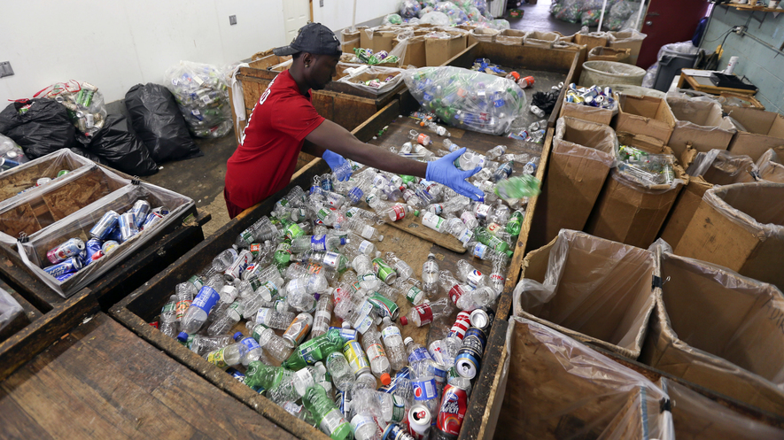
If you’re worried about the planet, please make sure your garbage is buried in a landfill. There is plenty of space available.
On the surface, the phrase “reduce, reuse, recycle” may seem like a realistic call to action. It makes particular sense to those who want to reduce the amount of oil and gas that are burned and halt climate change, and reduce the amount of garbage we will leave for future generations to deal with.
The truth, however, is that the cost of the recycling process almost always outweighs the benefits.
Even the U.S. Environmental Protection Agency (EPA) says it only makes sense economically and environmentally to recycle about 35 percent of our trash. Among those materials are paper and aluminum cans, according to the government department.

More Expensive And More Electricity
Recycling 1 ton of paper or aluminum cans, the agency says, can save about 3 tons of carbon dioxide emissions over producing new materials. Carbon dioxide, a gas, is produced during the recycling process and can lead to climate change. A ton equals 2,000 pounds.
Not so fast.
Paper mills pay for the trees they process. If it was cheap enough to recycle scrap paper, producers would be beating down your door to buy it. There is a good reason why they aren’t.
It’s more expensive and takes more electricity and water to recycle old paper than to cut down pine trees, turn them into paper, and then grow new trees.
Plastic, which is made from oil, is another problem. Recently the price of oil has gone way down. It has now become cheaper to make a new plastic container than to recycle an old one.
Also, the EPA says that recycling a ton of plastic saves only about a ton of carbon dioxide. However, that doesn’t take into account the water to rinse their plastic containers before people put them into a recycling bin.
John Tierney is a science writer for The New York Times newspaper. He pointed out that if people use hot water to wash plastic containers, they actually contribute to sending more carbon dioxide into the atmosphere. Coal or gas is burned to heat the water up in the first place.

Are We Pretending About Recycling?
Glass is even worse. To reduce emissions by 1 ton you have to recycle 3 tons of glass. Including the cost of collecting old glass from neighborhoods, and the pollution produced by the collection trucks and the recycling process itself, glass recycling creates more emissions. It is also more expensive than making glass from scratch. New glass is made mainly from sand, and we have plenty of cheap sand in the world.
Many cities pick up glass in recycling trucks only to dump it at the local landfill.
Why are they pretending? Because people feel emotional about the motto “reduce, reuse, recycle.” They learn it in school and hear it everywhere they go. Most Americans are blind to the evidence about recycling programs.
More environmentalists should consider the costs and benefits of recycling programs. They should get rid of those that waste money and harm the environment.
If recycling saved money, companies would be lined up at your doorstep to buy your trash. Don’t look now, because they’re not there.
The true recycling test is whether someone will pay you to sort and save your trash. If they’re not, what you’ve been told about recycling is probably just garbage.

CON: Recycling cuts down the amount we waste
We Americans use a lot and waste a lot. We dump far more trash than we need to into landfills. In fact, we make twice as much garbage per person as Western Europe.
The amount of trash produced annually in the United States has tripled since 1960. In 2013, it totaled 254 million tons, which comes to 4.4 pounds per person every day. A ton equals 2,000 pounds.
We’ve made a lot of progress over the years in handling garbage. People started recycling much more after the mid-1980s. On average, Americans today recycle or compost about one-third of their trash.

Seattle's Pay-As-You-Throw System
The U.S. Environmental Protection Agency (EPA) is a government department. It reports that we recycle about two-thirds of paper, and just over half of aluminum cans. Yet, we recycle only 4 out of 10 electronics items such as cellphones and computers, and only about one-third of glass containers and even slightly less of plastic bottles and jars.
We should be able to do much better than this. So why don’t we? Some people just don't want to bother recycling. A number of states say that people have to recycle, but they don’t enforce their laws. In most cases, they do not offer people much reason to recycle.
Some states and cities do much better because they take recycling seriously. Cities such as Seattle, Washington, encourage recycling. Seattle charges people money for throwing out their garbage. People call it a pay-as-you-throw system. Even if the cost is small, it encourages people to recycle, and they do.
In 2014, half the people in Seattle recycled their trash. This rate continues to improve. The city is trying to reduce as much garbage as possible. Few other cities have set such a high goal.

Critics Sending The Wrong Message
Some critics see matters differently. They argue that recycling costs too much and is not effective. Some states seem to agree with them. They do not want to contribute to the cost of city recycling programs and say the cities should end their programs or pay for the cost themselves.
Is this the right action to take? Recycle only if there are enough benefits? Doing that would send exactly the wrong message.
Some experts believe that we should start way before this point. We should prevent or reduce waste when things are made. Then we should reuse what is left over, and only then throw out what cannot be recycled.
No one argues that the cost of recycling is not important. Still, there are ways to deal with that cost rather than say it is too high and abandon recycling programs. We could follow the lead of cities like Seattle by putting a price on trash. If people have to pay more, they will find ways to reduce the amount of trash they throw out. Also, the fees can cover the cost of recycling programs.
We are in the early stages of an important change. It will reduce waste and pollution and get people to change what they use and what they throw out. That’s the way to go.

Step 3: Organize your thoughts

Tomorrow you will be asked to prepare a persuasive speech. The purpose of a persuasive speech is to convince your audience to agree with an idea or opinion that you present. First, you'll need to choose a side on a controversial topic, then you will write a speech to explain your position, and convince the audience to agree with you.

Today you will work on the first step. Use the graphic organizer below to outline your points for a debate.

The topic of this debate is: Should we stop recycling?

What is your position on this topic? Circle one: Yes No

Explain your position:

Argument to support your position | Evidence to support your argument  (provide quotes or facts taken from the text)
Step 4: Closing Thoughts

How can debates be positive for our society?

What is a current hot topic or debate that you feel strongly about?

Student Feedback:

Circle the emojis that best represents how this activity made you feel. | 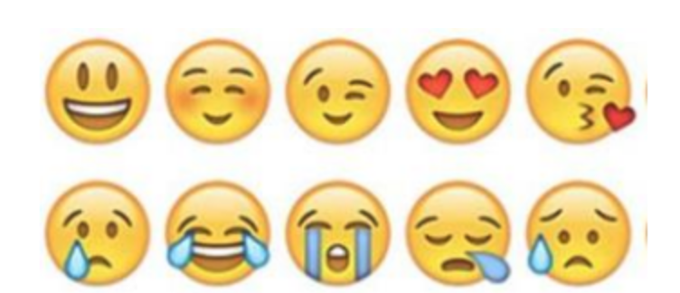  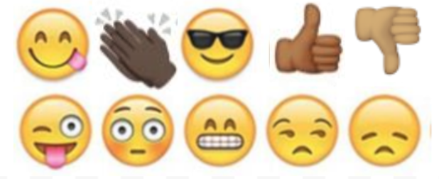

Day 4: Science
Environment

What is this lesson about?: Today you will read the article, In just 10 years, warming has increased the odds of disasters. You will respond to the questions at the end of the article.

Step 1: Read the article

In just 10 years, warming has increased the odds of disaster.
- By Chelsea Harvey, E&E News on March 20, 2020
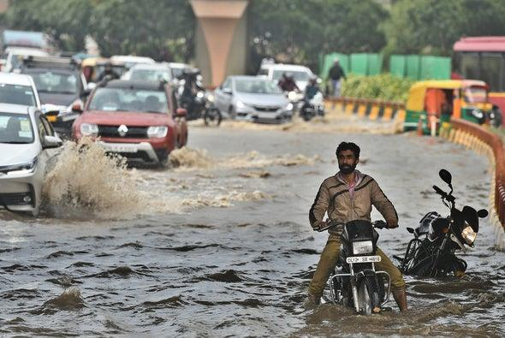
A motorcyclist tries to cross a waterlogged stretch amid slow moving traffic near AIIMS, on March 14, 2020 in New Delhi, India. Credit: Biplov Bhuyan Getty Images

Small levels of global warming can increase the likelihood of extreme events, new research warns. That’s prompting scientists to question how accurately disasters in the recent past can be used to predict extreme events today.

A study published Wednesday in Science Advances suggests that some research attributing climate change to individual disasters has underestimated the probability of certain extremes in the last decade. That’s especially true of unprecedented hot and wet events.

That’s because researchers were basing their analyses on a historical study period extending only up to the year 2005, said author Noah Diffenbaugh, a climate scientist at Stanford University. As it turns out, the warming that’s occurred since then has had a big impact on global extreme events.

“The global warming, even just in the 21st century, has created such a substantial increase in the frequency of extreme hot and extreme wet events over these regions that those frequencies fall well outside of the [previously] predicted probabilities,” Diffenbaugh told E&E News.

Studies investigating the influence of climate change on extreme events often use climate models to conduct their analyses. A common method is to run two series of simulations—one based on historical climate data reflecting the real-life progression of climate change over time, and one based on an imaginary world in which climate change does not exist.

The difference between the two simulations can reveal the way climate change affects the probability of extreme events occurring around the world.

One of the most commonly used model suites is an ensemble known as CMIP5—it was developed by an international team of scientists and has served as the basis for countless climate impact studies. The issue is that CMIP5’s historical simulations only reflect data up to 2005.

That’s not a flaw in the models’ design; it’s just the information that was available when they were first being developed. A new suite of climate models, known as CMIP6, is in development and will reflect an up-to-date historical climate period.
It means that analyses relying on CMIP5’s historical climate period don’t necessarily account for the warming that has occurred since 2005.

Diffenbaugh’s study presents a new method for checking predictions made in previous papers that relied on data from the past. These include some of his own past work, which used CMIP5 simulations to estimate the influence of climate change on extreme heat and precipitation events in the historical period and made predictions about future extremes.

Wednesday’s study suggests that predictions based on data from the past can substantially underestimate the probability of extremes in the present. This was the case for record-breaking hot and wet events in the Northern Hemisphere between 2006 and 2017, Diffenbaugh found.

“One implication of these results is the present probabilities are potentially closer to the period going forward ... than they are to the previous two decades,” he said.
Diffenbaugh added that the method outlined in his paper isn’t limited to checking studies based on CMIP5 simulations ending in 2005.

That was the main example used to illustrate the point in the new study. But the method could be used to evaluate other predictions based on data from earlier historical periods, just as long as the time window in which the predictions were made has already passed.
The study’s findings aren’t particularly surprising, other experts say.
“Of course the role of climate change is larger than originally estimated if you have another 10 years of warming in the data,” said Friederike Otto, an expert on climate change and extreme events at the University of Oxford, in an email.
But the size of the effect is worth pointing out, added Sebastian Sippel, a climate extremes expert at the Swiss Federal Institute of Technology in Zurich.
“The finding of this study, which in a sense is expected but in a sense is also kind of surprising, is how strong the change is,” he said.
According to Diffenbaugh, the paper could have practical applications for community planners working to address the impacts of climate change.
If people are designing infrastructure or making other decisions using recent climate data, instead of future climate projections, they could be significantly underestimating the consequences of global warming.
“That’s kind of the crucial point of this paper, is that climate change has to be taken into account, even on time scales of 10 years or so,” Sippel added.
The paper serves as yet another “wake-up call” about the speed at which climate change is progressing on Earth, he noted.
“The expectation that the next 10 years would be broadly the same as the last 20 or 30 years—this just cannot be expected anymore,” Sippel said.

Step 2: Answer the following questions

Do you believe global warming is impacting or drastically changing our Earth?

What data do you think is important to collect?

If you were an environmentalist, based on this article, what recommendations would make that you believe would lead to positive changes within the environment?

Student Feedback:
Circle the emojis that best represents how this activity made you feel.

Mindfulness Moment! Respond to your Mindfulness card in the box below.
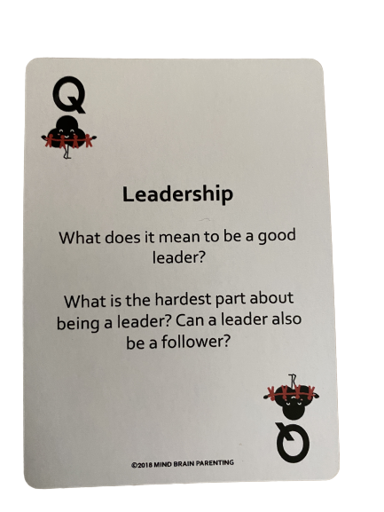

Day 4: Housing
Math

What is this lesson about?: Today we are going to look into the ways that your home environment impacts your financial status. Mostly, we are going to look at the cost of living on your own vs the cost of living with others and a more shared space.

Today’s Warm-Up
Back to those cell phones, and more…

You walk into a store and they offer you an IPhone 10 for free so long as you purchase a second IPhone 10 for $200 and sign onto a three year plan where you pay $150 per month. For that $150, you get both phones and unlimited call/data for three years

Answer these questions to help you consider this deal.

- After three years, how much money will you have paid all total, including the $200 you put down?
  - Down payment= _____________
  - $150 x _____________ months = _____________
  - Total cost for 2 phones and service for 3 years: _____________

  - Should you take the deal? Yes/No? Why?
.
Step 1: Compare the three rental options below

One Bedroom Apartment for Rent.
$800 per month.
Water included.
Tenant pays gas, electric, phone/cable
Estimated gas: $45/month
Estimated electric: $70
Phone/Cable/other-no estimate
1 month security deposit due with application

Two Bedroom Apartment for Rent.
$1200 per month.
Water included.
Tenant pays gas, electric, phone/cable
Estimated gas: $70/month
Estimated electric: $100
Phone/Cable/other-no estimate
1 month security deposit due with application

Three Bedroom House for Rent.
$1800 per month.
Tenant pays water, gas, electric, phone/cable
Estimated water: $60/month
Estimated gas: $90/month
Estimated electric: $120
Phone/Cable/other-no estimate
1 month security deposit due with application

Step 2: Answer the questions below to help figure out which of these options might be best for you

Living on your own: Assuming the estimates are correct,
- How much will it cost you per month for rent and related costs on your own, in a 1 Bedroom Apartment?

- How much will this be over 1 year?

Sharing a 2 bedroom: Assume you find a good roommate and you decide to rent the 2 bedroom apartment.
- How much will your total monthly cost be --- for you and your roommate?

- How much will it cost you per month?

- How much will this be over 1 year?

Renting a 3 bedroom house: Assume you find 2 good roommates and you decide to rent the 3 bedroom house…
- How much will your total monthly cost be --- for you and your two roommates?

- How much will it cost you per month?

- How much will this be over 1 year?

Step 3: Considering these options and making a decision.

What is one good thing about living alone?

What is one of the not so good things about living alone?

How much money would you save over 1 year if you lived in a 3 bedroom house with roommates instead of in a 1 bedroom apartment?

Is that savings worth it to you? Yes/No.

Step 4: Getting Real…

Ok, assume you are 19 and you are working part-time and going to college part-time. Your mom and dad tell you you can stay with them for the next couple of years to save money. They would like you to contribute $100 per month for rent.
- How much will that cost over 1 year?

- What would be one benefit of living with your parents for another year?

- What would be the downside of living with your parents for another year?

- Discuss: Would you accept this offer? Why/Why not?

Assume that at your job you earn $550 per week. After taxes, you take home $400 per week (we will learn about taxes this next week).

- How much money will you take home each month after taxes?

- Discuss: Now, with that amount of pay each month, what housing options look like they could work for you?

Skill Builders and Review Problems-
If you have more time, take a few minutes to complete the “skill builder” problems in the separate handout packet.
- Decimals - rounding
- Decimals - converting

Student Feedback:

Circle the emojis that best represents how this activity made you feel.

Day 4: Sleep
Health

Step 1: Sleep Journal
How did the tip that you used from yesterday help you sleep?

Step 2: Read the Text

Let’s say you’re taking a Spanish test when an answer just won’t come to you, even though you nailed it on last night’s practice quiz (10 sleepless hours ago). Or maybe you miss every free throw during your basketball game—and to top it off, you snap at your teammate on the way to the locker room.
These may seem like unrelated events, but here’s the surprising truth: Each may be a direct consequence of your lack of snooze time. In one study, just an hour less of sleep each night made sixth-graders perform like fourth-graders on mental tests. Other research shows that sleep loss makes you run slower and miss more shots in sports, while doubling your odds of injury.
Some experts even argue that teens would be less likely to take risks or suffer from anxiety and depression if they could just get enough sleep.
“When you’re sleep-deprived and you run into a stressful situation, whether it’s with your friends or something else, you’re going to get angry and upset,” explains Dr. Kathleen Berchelmann, a pediatrician in St. Louis, Missouri. “I see a lot of depression, anxiety, and even suicide attempts in teens who aren’t getting enough sleep.”
It’s stunning to think that by spending more time in bed, you could potentially lift your GPA, get along with your loved ones, excel on the field, and just plain feel happier. But scientists say it’s true—many teens are walking around like zombies without even realizing it.
We get it: With so much on your plate, sleep seems like the easiest thing to sacrifice. But that’s a mistake. “You cannot hack your sleep,” Watson says. “If you want to be your best version of yourself, sleep is crucial.” And the only way to get it is to go totally lights-out for at least eight hours.
George, for his part, says that since his crash, he takes his shut-eye seriously. But it can be tricky now that he’s living with a roommate in a college dorm.
“Sometimes I just go to sleep while people are hanging out in the room,” he says. “My friends say, ‘Hey, why are you going to bed so early?’ I tell them, ‘I need my sleep—and you guys should go to bed too.’”
Sound impossible? It’s not—
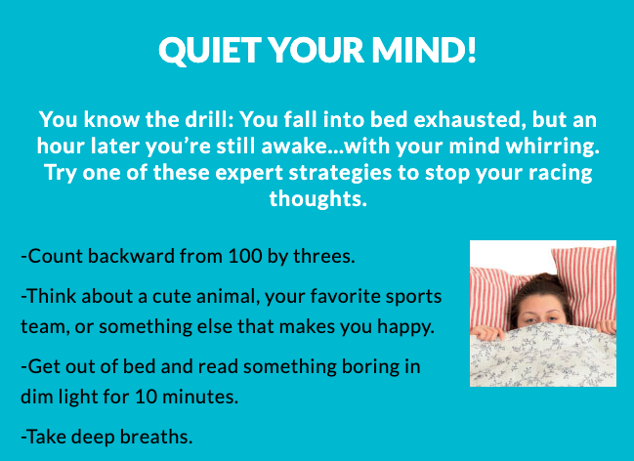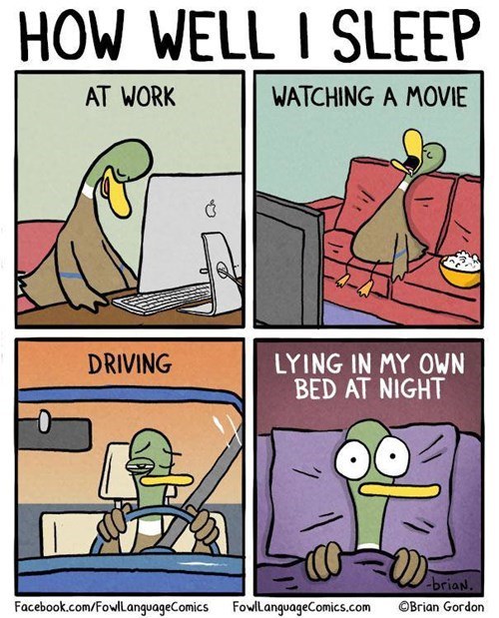
Step 2: Design a comic strip!

Design a Comic Strip that shows teens tips to developing better sleep skills. (look at the example above!)

Day 4: DJ D-Nice’s Club Quarantine
Social Studies

What is this lesson about? In this lesson you will read about how culture and the arts can bring people comfort during times of distress and how a sense of community can exist even when folks don’t share the same physical environment.

Step 1: “First Read”
Read the article one time through, independently or out loud with a peer or adult.

How DJ D-Nice’s Club Quarantine Became an Isolation Sensation
Rihanna, Oprah, Michelle Obama, Drake and Democratic candidates Joe Biden and Bernie Sanders were among the 100,000-plus who tuned in.
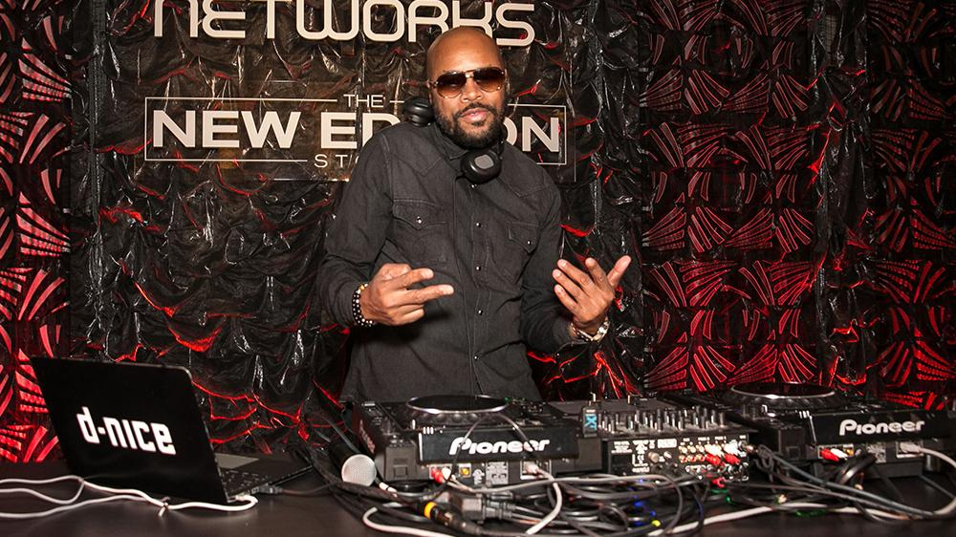
CREDIT: BRIAN TO/SHUTTERSTOCK
DJ D-Nice’s Instagram Live virtual dance parties have been the sensation of isolation, drawing upwards of 150,000 viewers — among them, both Democratic candidates, Joe Biden and Bernie Sanders, former first lady Michelle Obama, Drake, Oprah Winfrey, Will Smith and even Facebook CEO Mark Zuckerberg — and helping relieve anxiety during this time of stress and uncertainty. The Bronx native, whose real name is Derrick Jones, currently lives in Los Angeles and is, like all of the city’s residents, under a “safer at home” mandate calling for a weeks-long quarantine.
So last Friday, he took to the turntables — DJ-ing and mixing for some eight hours straight with barely a bathroom break. Under the banner “Home School at Club Quarantine,” his sets featured an abundant mix of genres — from disco to funk to soul and hip-hop.
Jones got his start at age 15 with rap group Boogie Down Productions alongside KRS-One and DJ Scott La Rock. After selling millions of records, putting out two successful solo albums and helping Kid Rock get a deal and working on his first album, Jones decided to leave the music industry in 1993, telling Variety, “I just felt burnt out.”
Fast forward to 2020, and his audience has never been bigger or his presence more impactful. Just yesterday, legendary rapper Scarface, who tested positive for COVID-19, credited D-Nice’s IG Live for “saving” him. Currently counting 1.7 million followers on Instagram, the outpouring of support and feedback has commended the DJ’s cheerful spirit, positivity and talents on the turntables. D-Nice spoke with Variety and revealed the one song he played twice: for Rihanna.
Where did the idea to host a virtual dance party originate and how did you get it going?
I live in L.A. now so when the quarantine happened, I felt stuck. I started going through withdrawals. I miss being in front of a crowd. All my life, whether I was rapping or DJ-ing, there’s always a crowd involved. To be isolated and not have that as an option, it threw me off. I decided to jump on IG Live and create a fun small party. I didn’t have any turntables hooked up, I was pressing buttons on my computer directly into my iPhone. My friends were joining in, we’re all having a great time. It was people in the music industry or in fashion. There were roughly 200 of us, all cool people I’ve known throughout years.
We’re in there pretending we’re in a club. I was playing music and telling stories about certain songs I produced back in the day. Just a fun time. I did it the next day. The third day, I could tell there was something different about it. More people were coming, so I decided to go out and buy new turntables and really DJ, Not just play music, to really get in there and spin records. That particular day — last Friday — Jennifer Lopez happened to stop in, and so did Drake. I couldn’t believe so many people were in this chat room. Michelle Obama to Oprah to Ellen Degeneres, it ended up being amazing. They weren’t just popping in, they’re in there listening to the music and interacting with people in the comment section. Gayle King, Lionel Richie, Jimmy Jam and Terry Lewis, The Rock, Rihanna came in.
Then as it was building, and we got to 95,000 people, I felt like we’re about to get cut off [after an hour if IG]. All of a sudden, Mark Zuckerberg signed in. We’re all tripping, like. “Wait, Mark Zuckerberg is in here!” I’m begging him, “Mark, please don’t shut it off! We need to reach at least 100K.” As soon as we hit 100K, everyone’s going crazy. Everyone erupted — happy in being a part of something so monumental. The number 100K doesn’t truly reflect the amount of people who actually heard everything, because people were in and out of the chat room. Knowing we did something so iconic is a great feeling.
What was the purpose of it, in your view?
To provide enjoyment for my friends. I figured, I’m sitting here isolated, I knew that feeling wasn’t unique. Other people were in the same predicament. If we can connect in this chat room while I’m playing music, then we’d all have a good time. Pretend that we’re together. Even though we weren’t physically there, we’re connected. We’re still communicating with one another via text. So many people felt that way because it started to take off, and it wasn’t celebrity-driven. … It grew organically. People caught on.
What was the greater cultural significance?
Oh man, this is a weird time. We’re all dealing with the coronavirus. To have a few hours of not worrying about a thing and hearing music, celebrating with each other and allowing that to relieve some stress is important. Music relieves all stress. No matter what type of music you listen to, it literally changes and touches your spirit. I play more of an uplifting set. Disco music always had a feeling of love and celebration so I tend to find records that feel that way. Whether I’m playing Stevie Wonder “All I Do” or First Choice’s old disco record “Doctor Love,” it feels like love. You want to dance, get up and celebrate. For music to have the ability to take the focus off what’s going on in the world, for an hour or two or however long you’re in that chat room, it’s extremely important finding a way to be happy right now.
How are you feeling in isolation and what were you hoping to provide for others?
Sometimes, I forget I’m here alone. Once I have on headphones and I’m playing music, I actually feel connected as well. It hasn’t really bothered me to be honest, I’m much happier now that I’m doing this. I hope other people feel the same way. We’re caught up in this virtual world of hanging out in Club Quarantine — that doesn’t really exist but for some reason, it’s the biggest club in the world right now.
What do you think drew so many there?
The music, it came from an honest place. I didn’t do this to have all the fanfare that’s going on, I did it because we love music. That’s why I ended up doing a playlist on Spotify. Even after I finished DJ-ing, I wanted the music that I played to actually have a home. [Those who] may not have heard a certain song, they could go back and play that song. Now they’re being introduced to new artists.
What’s the significance of having Biden and Sanders in the room?
With the internet chat room, everyone’s on a level playing field. No one’s really a celebrity. Biden came in and lifted people’s spirits. In their mind, they never imagined being in a text or chat room with Joe Biden. It’s important for [Biden and Sanders] to be there because we’re all going through this together. And for Biden or Bernie supporters, everyone felt good seeing them in there. They felt like they could touch them.
How long did you intend on spinning? Was it to break a record?
It wasn’t really about breaking a record. I was so caught up with enjoying the moment and the music. I play what I love, the music happens to feel good to me. Even though I was getting tired by hour seven, I watched Rihanna come in and I was happy to play even more music. Even though I’ve DJ’d for her in the past, the feeling that I had was… imagine this: most of the parties I DJ, I’m going into someone else’s world. I have to cater my set to what they want. In this case, they’re coming into my world. They’re coming to D-Nice’s Instagram Live. I played what I wanted to hear and wanted to expose them to, and they had a great time.
You said several times “we made history,” how do you mean?
There’s never been 100,000 people in one IG Live.
Describe how you felt when it reached 100,000?
Man, I was definitely emotional. To start something out of being lonely and doing it with 200 friends, to build that so quickly — it was less than a week. Five days. To build something that impacted people on such a large scale, that provided them with happiness and joy, to take their minds off what’s going on. Some people may have a hard time paying their bills they’re losing jobs; doctors and nurses on the front line dealing with this — and for one or two hours to allow them to escape that reality? It makes me emotional when I think about it. I had the ability to do that from my kitchen counter.
Of the hundreds of celebrities that popped in, who blew your mind the most?
Well, I’ve met Mrs. Obama before. I’ve met Joe Biden before. I was extremely happy they’re there but the one person who surprised me was The Rock. The Rock being in my IG live leaving comments, like, “Hey D, great job brother,” that meant a lot to me. I’m a big fan.
Did you have any communication with Zuckerberg?
We interacted one time, just one line each. When we’re about to reach that 100K mark, I yelled out “Zuck, yo Mark, please don’t cut us off!” His response was, “You got this.” That’s what made it all exciting; We were all rooting to get to that number.
To confirm, no songs were repeated throughout?
One song was repeated: Burna Boy’s “Ye” record. I played that earlier, then when Rihanna was there. I know that’s one of her favorite songs, so I decided to play it again.
Who are your top artists in rotation?
I play a lot of Stevie Wonder and Prince.
How did you get into DJ-ing?
I love creativity, so I started a creative services agency developing websites for iconic artists like Luther Vandross, Aaliyah and Alicia Keys. I was doing online marketing for Reebok, Violator Records, 50 Cent’s G-Unit sneaker and in 2003, I was invited to a party by a friend, Q Tip from A Tribe Called Quest. He was spinning with Mark Ronson and being there, I fell in love with music again. I fell in love with DJ-ing.
I started from the bottom. I was one of those guys who’d DJ for six hours in New York City clubs. Even though they weren’t paying a lot, it was gratifying to me. I had my first residency at Serena At the iconic Chelsea Hotel. Similar to the story I’m having right now, it started with 10 people, then it grew to a real party. I was able to play the set I play currently: a mix of everything. I went on to do a lot of clubs — residencies in Cane and Canal Room in NYC. One day, Kid Rock asked me to DJ a Sports Illustrated event he was hosting ahead of the Super Bowl. After that, I became more of a private event DJ. I did tons of huge events all the way until I played the inaugural ball for President Obama’s second term. I became one of the DJs the Obamas would frequently use.
Are you planning to keep Club Quarantine going on a regular schedule?
We’re determining that now. I don’t want to burn it out. It’s been such a great party for people to keep their spirits lifted, but I know I can’t physically do that every day. I’m going to see as far as we can take it. When this is over, I want to take it on the road. Allow people to have that experience of Club Quarantine in person.
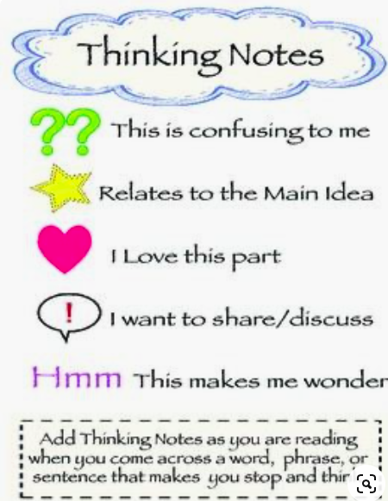
Step 2: “Second Read”

Read the article again, this time marking your paper with “Thinking Notes” in the text and margins. Thinking notes are your way of interacting with and “talking back to” the author and people in the story. Underline, circle or make a note next to things that excite you, touch your heart, make you sad, make you laugh, make you wonder, remind you of something, or even things that make you want to holler! Here are some ideas for symbols to help get you started.

Step 3: Your Turn

D-Nice answers over a dozen questions in this interview.
Are there things you still want to know that didn't get addressed? What are they? Are there follow up questions you think should be asked? Jot down 3 additional questions YOU would ask DJ D-Nice if you were doing the interview:

1.

2.

3.

Student Feedback:
Circle the emojis that best represents how this activity made you feel. | 