Week 6
Change

Day 5

NAME:______________________

Day 5 Agenda

Topic | Activity
Warm-Up!
English Language Arts | - Read 2 articles from a choice of 4 articles about Young Activists  - Complete a graphic organizer comparing and contrasting the articles.  - Write a letter to inform others and call them to action about an issue that is important to them and that they want to change.
Science | - Read about Personality Changes  - Answer questions about  - Draw a picture  - Reflect
Mindfulness Moment!
Math | - Change and Youth Climate Change Leaders
Health | - How can you change the world?
Mindfulness Moment!
Civics/Social Studies | - Historiography and the American Revolution  - Read and respond to the text

Warm-up Activity: Write a journal entry around the daily quote on identity.
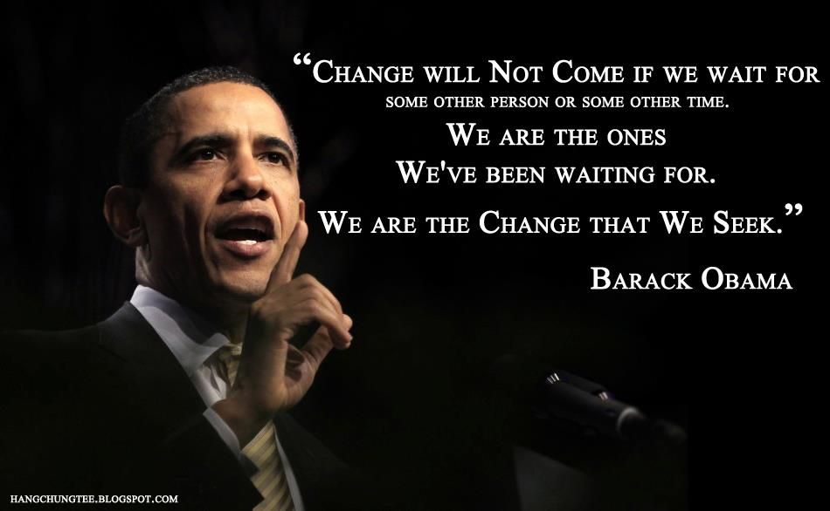

Day 5: Changing the World Around Us
English Language Arts

What is this lesson about?: Today you will read about young people who are working to change the world around them.

Step 1: Read the profiles

There are 4 profiles of young people who are activists for a cause that is very personal and important to them. Pick 2 profiles to read (1 short and 1 long) and as you read, think about the experience that changed this young person’s life and inspired him/her to become an activist.
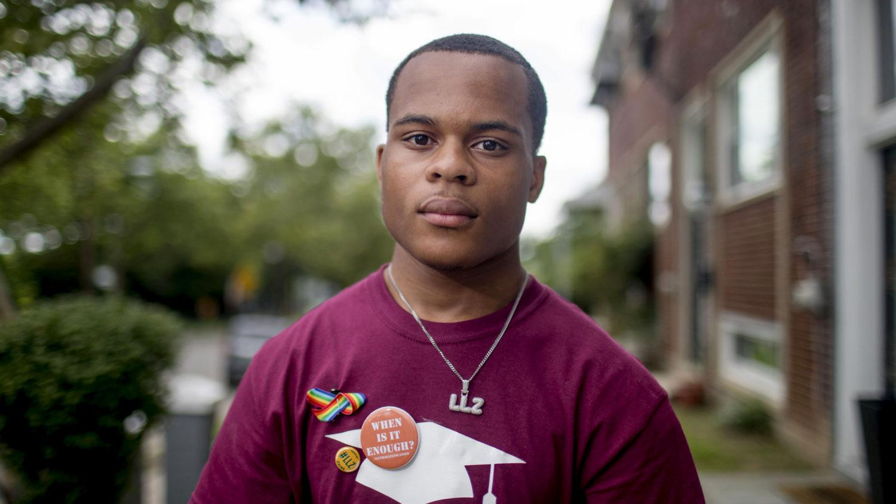
Zion Kelly
Gun control, 17 years old.
By Cheree Franco
Last September – a month before his 17th birthday – Zion Kelly was walking through the park near his home in Washington DC when a strange man asked him for his phone.
Unsettled, Zion bolted and later texted his twin, Zaire, to tell him about the encounter. What Zion couldn’t have known is that the same man – armed with a gun – would kill his brother just two hours later. Eight months on, Zion remembers Zaire as “goofy and always cracking a joke. He was the centre of our friend group.”
A shy kid, Zion often relied on Zaire to make friends for both of them. Growing up in the inner city, gun violence was always in the background. A month before Zaire’s death, the twins attended a vigil for a girl killed close to their house.
“We just accepted it,” says Zion. “Like, we have to be careful. There are guns, but what can we do?”
In February, 17 students from Marjory Stoneman Douglas High School were killed by a gunman in Parkland, Florida, and 17 others were shot but survived. A few weeks later, a woman named Mary Beth Tinker spoke at Zion’s school about the power of students to change policy.
In 1965, Mary Beth fought her middle school all the way to the US Supreme Court, after she was suspended for wearing an armband to protest the Vietnam War.
Zion felt inspired. He invited Parkland survivors to speak at his school. On 24 March, Zion joined these survivors at March for Our Lives to demand legislative gun control in front of the US Capitol building.
Waiting to speak, Zion trembled. This was Zaire’s thing. His twin had been captain of the track team, a candidate for student council president, the kid who grabbed the mic at a political fair and asked a DC councilman about gentrification.
But when he was introduced, Zion suddenly became confident. “I feel like change can happen, especially with the movement going on,” he says. “I want to step up and honour my brother.”
“Stepping up” means giving up his free time to speak at rallies, at the mayor’s breakfast, in front of congressional representatives and news cameras. It means advocating for a city ordinance, named after his brother, that would expand gun-free zones to create safe passage for students travelling to and from school. It means making sure no one forgets that Zaire was a teenager and a twin, rather than a statistic.
Taken from: https://www.huckmag.com/perspectives/activism-2/teenage-activists-protest-worldwide-
agents-of-change/
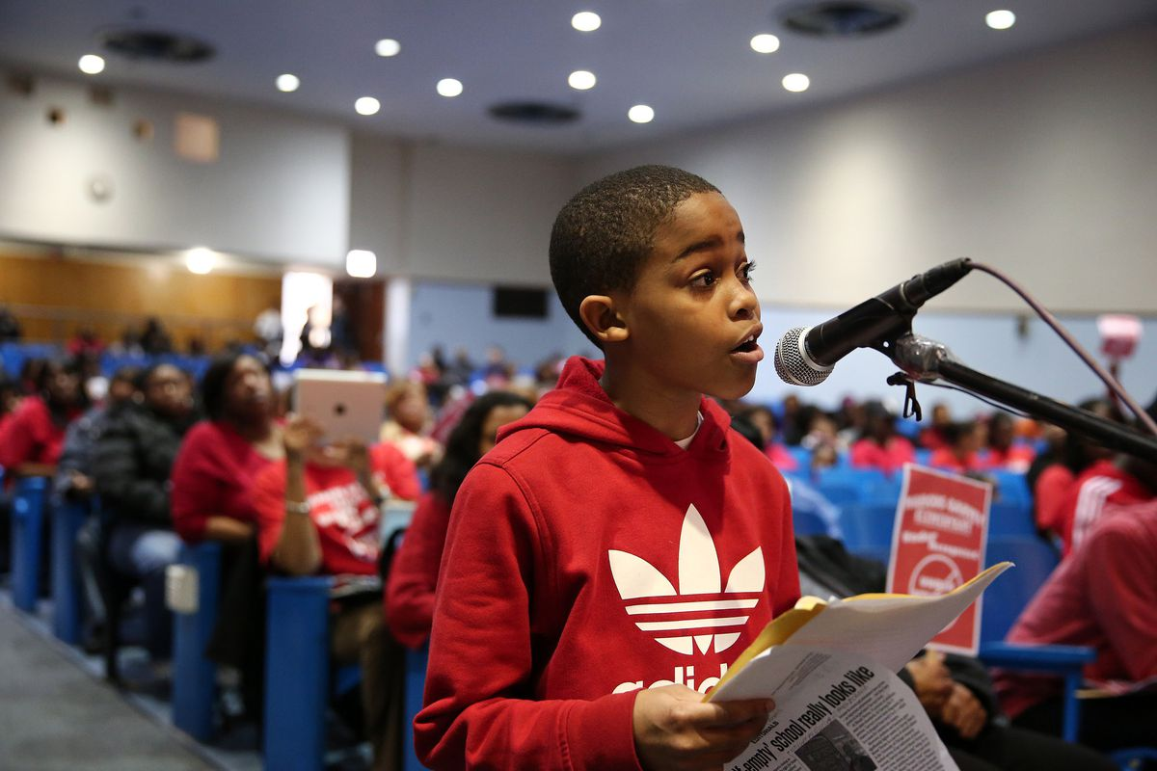

Asean Johnson
Public Education Reform, 9 years old.
By Jonathan P. Hicks

Since his appearance at the commemorative March on Washington last weekend, Asean Johnson has become an Internet sensation.
The 9-year-old Chicago student was the youngest speaker at the event in Washington, D.C., a distinction that fell 50 years ago to John Lewis. The young elementary school student spoke on the need for renewed funds and resources for the nation’s public schools.
“Every school deserves equal funding and resources,” he said to the crowd of thousands on Saturday. “I encourage all of you to keep Dr. Martin Luther King Jr.’s dream alive. Help us fight for freedom, racial equality, jobs and public education, because I have a dream that we shall overcome.”
While young Asean, a student at Marcus Garvey Elementary School in Chicago, has attracted the interest of the nation since he spoke on the steps of the Lincoln Memorial last weekend, he has been well known to residents of Chicago for his electrifying speeches in the face of planned school closures.
Since May, when the Chicago Board of Education voted to close nearly 50 schools, he has been widely followed. During the weeks that led to the vote, the young elementary school student offered a number of impassioned speeches criticizing the plan of the administration of Chicago Mayor Rahm Emanuel to close school buildings in an effort to reduce costs.
Asean said it was a special thrill to speak in front of the crowd at the Lincoln Memorial. “It was a very amazing experience,” Asean said, speaking with BET.com. “I was proud of myself. It was a great feeling to speak in front of all those people on the 50th anniversary of the March on Washington.”
The role of elementary school activist came almost by happenstance. His mother, who works for Chicago Public Schools, was on strike last year and her young son took extraordinary interest in the issues.
“I’m not an activist nor were we an activist family,” said Shoneice Reynolds, Asean’s mother, in an interview with BET.com. “When all the schools closed during the strike, he wanted to come to the picket line with me. He had a choice to stay with the babysitter, but he said he wanted to come with me and learn about the issues.”
Before long, he was walking along picket lines in the area closer to where his family lived, accompanied by his mother. His interest on the topic of school inequities grew to the point where he asked for permission to attend community forums called by elected officials in Chicago.
“At the first hearing, he wasn’t scheduled to speak,” Reynolds said. “They had a schedule of speakers, but they had a few minutes left at the end. And he said, ‘Mommy, I want to speak.’ And he did. And he has been speaking ever since. I've always said that he's a little old man," she said, laughing. "But he and his brother — my two boys — keep me grounded."
As far as his plans when he grows up, he has several paths he is considering. “I want to be a professional football player,” he said. “But, if that doesn’t work out, my backup plan is to be a politician — like president — or a lawyer or a scientist. We’ll see.”
Taken from : https://www.bet.com/news/national/2013/08/27/asean-johnson-a-nine-year-old-who-captivated-a-nation.html
Sophie Cruz
Immigration reform. 8 years old.
Sophie Cruz proves that you are never be too young to make a stand for what is right. Her first real feat of activism was weaseling her way through tight security to give Pope Francis a letter that said, in Spanish: “my friends and I love each other no matter our skin color.” She asked the Pope to speak with “the president and Congress” about immigration: she fears that her parents, who are undocumented immigrants living in America, could be deported from the U.S. at any day with the increasingly divisive and racist rhetoric towards immigrants in this country. When a six year old has to deal with things of that magnitude—and knows to ask for help—is when you know you know there’s a problem. Cruz isn’t just a one-hit wonder, though. She spoke at the Women’s March on Washington in January 2017, when she again advocated for immigrants’ rights. “We are here together making a chain of love to protect our families,” Cruz said. “Let us fight with love, faith, and courage so that our families will not be destroyed.” Cruz was also the recipient of the Define American Award for Activist of the Year in 2017.
https://www.complex.com/life/young-activists-who-are-changing-the-world/sophie-cruz

Sonita Alizadeh
Child Brides. 20 years old.
Sonita Alizadeh has taken a slightly less traditional but no less effective route to fighting against the patriarchal policies of forced marriages in her home country of Afghanistan: rap. Alizadeh was almost married twice, once at 10 years old and again at 16, before she rebelled by releasing a rap video titled “Brides For Sale” about the experience of women being sold into marriage by their families. It was a huge risk—for starters, it is illegal for women to sing publicly in Iran, where she was living by that time. However, it paid off: the song went viral, and she was able to get a scholarship to finish her studies at a U.S. high school. She continues to perform her powerful brand of rap and inspire a new generation of women to rebel against the outdated and cruel tradition of child brides in her home country.
https://www.complex.com/life/young-activists-who-are-changing-the-world/sonita-alizadeh
Step 2: Complete the Graphic Organizer

Complete the graphic organizer for each of the activists your chose to learn more about.

Activist 1: _________________________  Event that changed their life:  How he/she responded: | Activist 2: _________________________  Event that changed their life:  How he/she responded:
Notable achievement: What is something he/she accomplished? | Notable achievement: What is something he/she accomplished?

Step 3: Think and Write
Each of these young people has chosen to act on an issue that is important to them and try to change the world around them. Think about an issue that is important to you and that you believe should change.

Write a letter directed to your peers, or to the general public making them aware of the issue or problem, why it is important (who does it affect and how) and what they can do to help you bring awareness and change to this issue.

Use the template provided to write your letter.

____________________________ ← Date of Correspondence

Your Name
Address Line 1
Address Line 2

Recipient First Name Last Name, Title
Organization/Agency
Address Line 1
Address Line 2

Dear ____________________

My name is _________________ and I am _____________ (a resident of, a student, a community member of ) I am writing to ask for your support/help to _____________________________________________
__________________________________________________________ ← Use first paragraph to briefly identify yourself and your purpose for writing.

__________________________ (your issue and why it is a problem) Tell us who it affects too. ← Use second paragraph to explain why you think the action should be taken/should not be taken.

I am asking you/ I want for you to.. ← Use third paragraph to call recipient to action.

Sincerely,

Write your letter here:

Step 4: Share out.
Share your letter with a partner.

Student Feedback:
Circle the emojis that best represents how this activity made you feel.

Day 5: Personality Changes
Science

What is this lesson about?: Today you will read the Scientists say you can change your personality and Is it possible to change your personality? passages. You will respond to questions and complete a personality change activity.

Step 1: Read the Scientists say you can change your personality and Is it possible to change your personality? passages

Scientists say you can change your personality

But it Takes Persistent Intervention
Date: December 12, 2019
Source: University of California - Davis
Summary: A review of recent research in personality science points to the possibility that personality traits can change through persistent intervention and major life events.

It has long been believed that people can't change their personalities, which are largely stable and inherited. But a review of recent research in personality science points to the possibility that personality traits can change through persistent intervention and major life events.

Personality traits, identified as neuroticism (a neurotic character, condition, or trait), extraversion (outgoing), openness to experience, agreeableness and conscientiousness (doing work well and thorough), can predict a wide range of important outcomes such as health, happiness and income. Because of this, these traits might represent an important target for policy interventions designed to improve human welfare.
The research, scheduled to be published in the December issue of American Psychologist, is the product of the Personality Change Consortium, an international group of researchers committed to advancing understanding of personality change. The consortium was initiated by Wiebke Bleidorn and Christopher Hopwood, University of California, Davis, professors of psychology who are also co-authors of the latest paper, "The Policy Relevance of Personality Traits." The paper has 13 other co-authors.
Policy change could be more effective
"In this paper, we present the case that traits can serve both as relatively stable predictors of success and actionable targets for policy changes and interventions," Bleidorn said.
"Parents, teachers, employers and others have been trying to change personality forever because of their implicit awareness that it is good to make people better people," Hopwood added.
But now, he said, strong evidence suggests that personality traits are broad enough to account for a wide range of socially important behaviors at levels that surpass known predictors, and that they can change, especially if you catch people at the right age and exert sustained effort. However, these traits also remain relatively stable; thus while they can change, they are not easy to change.
Resources are often invested in costly interventions that are unlikely to work because they are not informed by evidence about personality traits. "For that reason, it would be helpful for public policymakers to think more explicitly about what it takes to change personality to improve personal and public welfare, the costs and benefits of such interventions, and the resources needed to achieve the best outcomes by both being informed by evidence about personality traits and investing more sustained resources and attention toward better understanding personality change," researchers said.
Why focus on personality traits?
Research has found that a relatively small number of personality traits can account for most of the ways in which people differ from one another. Thus, they are related to a wide range of important life outcomes. These traits are also relatively stable, but changeable with effort and good timing. This combination -- broad and enduring, yet changeable -- makes them particularly promising targets for large-scale interventions. Both neuroticism and conscientiousness, for example, may represent good intervention targets in young adulthood. And certain interventions -- especially those that require persistence and long-term commitment -- may be more effective among conscientious, emotionally stable people. It is also important to consider motivational factors, as success is more likely if people are motivated and think change is feasible, researchers said.
Bleidorn and Hopwood said examples of important questions that could be more informed by personality science include: What is the long-term impact of social media and video games? How do we get children to be kinder and work harder at school? How do we help people acculturate to new environments? And, what is the best way to help people age with grace and dignity?

Is It Possible to Change Your Personality?

New research says yes, but it depends on your follow-through.
Posted Sep 23, 2019 (Psychology Today)
If you've ever thought about how you might improve your personality, you're not alone. Research suggests that all of us, to a certain extent, possess an inherent desire to cultivate positive personality traits (such as being outgoing, optimism, and charisma) and to minimize negative traits (like pessimism and neuroticism). But is it even possible to change one's personality? Or, is personality better thought of as a fixed, unalterable entity?
New research appearing in the Journal of Personality and Social Psychology contends that personality change may be more attainable than we might think. Specifically, a group of researchers led by Nathan Hudson of Southern Methodist University found that people who actively worked to change aspects of their personality were, in many cases, successful in achieving the results they desired.
To arrive at this conclusion, the researchers recruited 377 undergraduates at the University of Illinois and Michigan State University to participate in a 15-week study. Participants were first asked to complete a short personality test that measured five core dimensions of personality: extraversion, agreeableness, emotional stability, conscientiousness, and openness to experiences. After completing the survey, participants were asked to choose which of these dimensions they would most like to change over the 15-week test period.
Depending on what they chose, participants received weekly "challenges," sent by the research team, that were meant to push people outside of their comfort zone on the personality dimensions they wanted to change. For example, someone who wanted to become more extraverted might be challenged to introduce themselves to someone new. Or, a person who wanted to improve their emotional stability might be asked to spend at least one hour doing something they enjoy.
The researchers requested that participants retake the personality test every week throughout the 15-week test period. They also sent new challenges every week of varying levels of difficulty. For example, for the trait of extraversion, an easy challenge asked participants to "Go to a public place where people mingle and say hello to someone new" while a difficult challenge required participants to "Introduce yourself to someone new and ask them at least two questions about themselves."
Through this design, the researchers tested whether participants were able to change their personalities by engaging in the challenges. Interestingly, they found that it worked. Participants who desired to change the traits of extraversion, conscientiousness, agreeableness, and emotional stability all showed improvement in these personality dimensions over the 15-week test period. Openness to experiences was the only personality dimension for which the exercise did not work (in fact, people who attempted to become more open to experiences actually ended up less open than when they started out).
The researchers also found that personality change did not have much to do with the difficulty of the challenges people accepted. What mattered more was consistently completing challenges, regardless of their level of difficulty.
The researchers conclude, "Our study provides evidence that actively making behavioral changes that pull one’s behaviors in alignment with desired traits is a viable strategy for volitionally (willingly) changing one’s own personality. Although this appears to be a promising prognosis for those who might seek out programs designed to help them change their traits, our findings emphasize a major caveat: Merely desiring change and formulating plans is not enough; it is necessary to follow through."

Step 2: Answer the following questions

- What words would you use to describe your personality:

- What do you like about your personality?

- What do other people like about your personality?

- What, if anything, do you dislike about your personality?

- What, if anything, do other people dislike about your personality?

- According to the articles you read, how can someone change their personality?

- Is there anything you would like to change about your personality?

- Using an example from one of the articles, what will you try to do to improve or change part of your personality?

Step 3: Draw a picture

Draw a picture of yourself that shows you with your improved personality.

Step 4: Reflect

As you think about this week’s science lessons, what’s one thing you will remember about change?

Student Feedback:
Circle the emojis that best represents how this activity made you feel.

Mindfulness Moment!
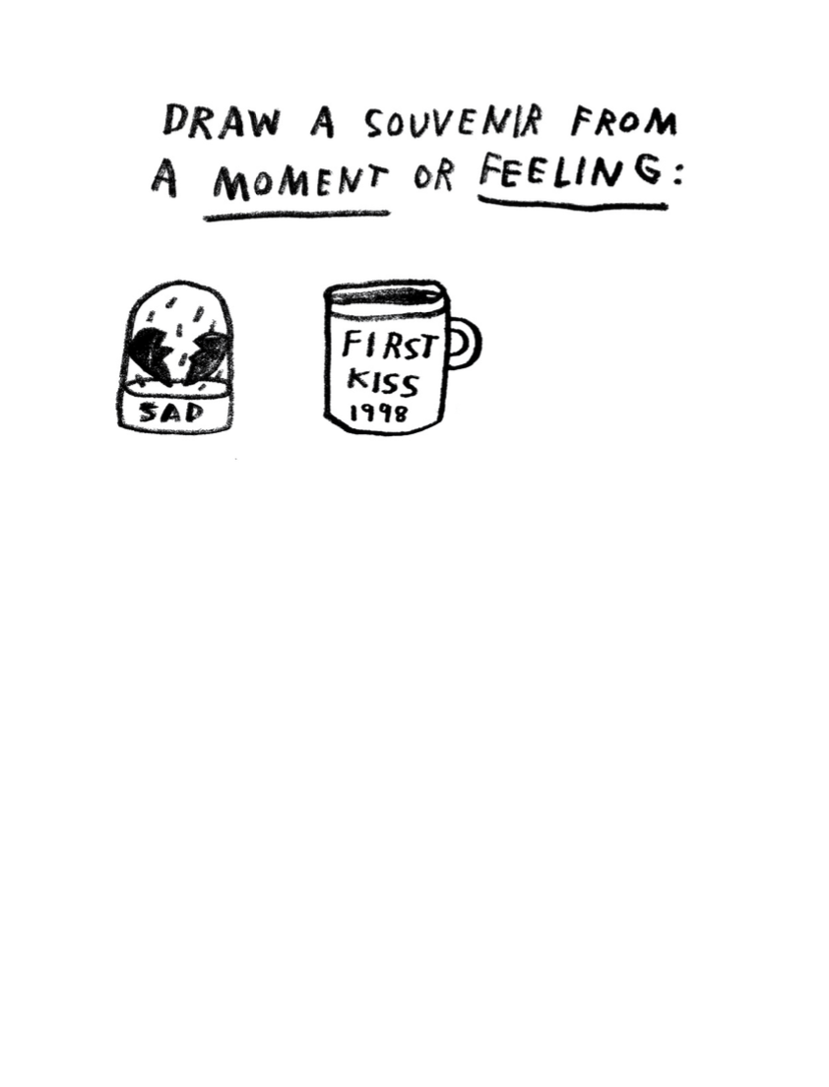

Day 5: Change/Youth Change Makers (Climate)
Math

What is this lesson about? Today’s lesson will look into how young people and each of us can help slow climate change and reduce pollution.

Today’s Warm-Up Problem
In many of the largest cities in the world, and in many small, rural communities in India and Africa, large portions of the population, earn their living by selling items each day, and using that money to enable them to purchase food for dinner in the evening.

The recent COVID-19 outbreak is making this nearly impossible for them to survive day to day. Estimates suggest that up to 265 million people in the world could be pushed to the brink of starvation this year.

- The entire population of the USA is 326 million people.

- Approximately what percentage of the US population is 265 million?

Step 1: Background

“We do not inherit the Earth from our ancestors. We borrow it from our children,” an oft-quoted saying from the Oglala-Sioux Native American nation.

- What does this quote mean, do you think?

“We will be known as the solution to the climate crisis,” 17-year-old Nadia Nazar, co-founder of the youth-led climate activist organization Zero Hour, said this September in Washington, D.C.

Later that week, 16-year-old Greta Thunberg addressed the United Nations General Assembly. "You have stolen my dreams and my childhood with your empty words. And yet I'm one of the lucky ones. People are suffering. People are dying. Entire ecosystems are collapsing. We are in the beginning of a mass extinction, and all you can talk about is money and fairy tales of eternal economic growth. How dare you!

"For more than 30 years, the science has been crystal clear. How dare you continue to look away and come here saying that you're doing enough.

What are some of her main points, do you think?

Greta Thunberg has gained prominence as a leading activist for changes to policies that might slow the rate of climate change and reduce the harm of pollution and greenhouse gasses.

She has highlighted the cost of air travel in terms of pollution, and has tried to avoid air travel and travel by boat, for example.
- What are some simple things that could be done to reduce air travel and pollution produced by airplanes?

Step 2 and 3: Greenhouse gas in the U.S. data and analysis

The chart below shows the major contributors to Greenhouse Gas Emissions in the US (in 2018).

Total Emissions in 2018 = 6,677 Million Metric Tons of CO2 equivalent. Percentages may not add up to 100% due to independent rounding.

* Land Use, Land-Use Change, and Forestry in the United States is a net sink and offsets approximately 12 percent of these greenhouse gas emissions, this emissions offset is not included in total above. All emission estimates from the Inventory of U.S. Greenhouse Gas Emissions and Sinks: 1990–2018.

Answer the questions below, based on the pie graph. We will round off numbers so that you don’t spend too much time doing long division…

Researchers have estimated that if we stopped eating all red meat (beef and pork), greenhouse gasses we would reduce overall output by almost 10%. The ‘agriculture’ slice of the pie chart is almost all a result of greenhouse gas emissions from raising livestock.
- If the US puts out 6,677 million metric tons of greenhouse gas in 1 year, how many metric tons of that is from agriculture?

The transportation ‘slice’ is primarily emissions from trucks and automobiles, but it also includes air travel, etc. Researchers say that if we could replace 50% of our current gas powered cars with electric cars we could reduce the greenhouse gasses produced by the transportation sector by that same amount (50%).

- How many metric tons of greenhouse gas would we ‘save’ if we converted over ½ of the car and truck fleet to electricity

We also put out greenhouse gasses when we use coal plants (and others) to produce electricity. There are other ways to produce electricity, including wind, sun, and water (rivers, ocean currents). Right now this can’t work for all of our electric needs, but as we build better batteries, we will get closer.

- How many metric tons of greenhouse gas would we ‘save’ if we were able to cut the pollution we put out in generating electricity by approximately 30%?

Another way to reduce greenhouse gasses is to find ways to absorb the CO2 that we all put in the atmosphere. The best way to do this ‘naturally’ is to increase our forests, trees and plants, all of which ‘take in’ CO2. Right now, forests and woodlands in the US take in about 12% of the greenhouse gasses that we emit.

- How many metric tons of greenhouse gas do trees and forests take in?

Researchers do NOT believe that we could plant enough trees to offset all of the carbon emissions we currently put out into the atmosphere. But many believe that we could likely double the amount of this intake over time if we were really smart.

- If we did double the amount of carbon emissions we took in by forests and trees, how many metric tons would that be?

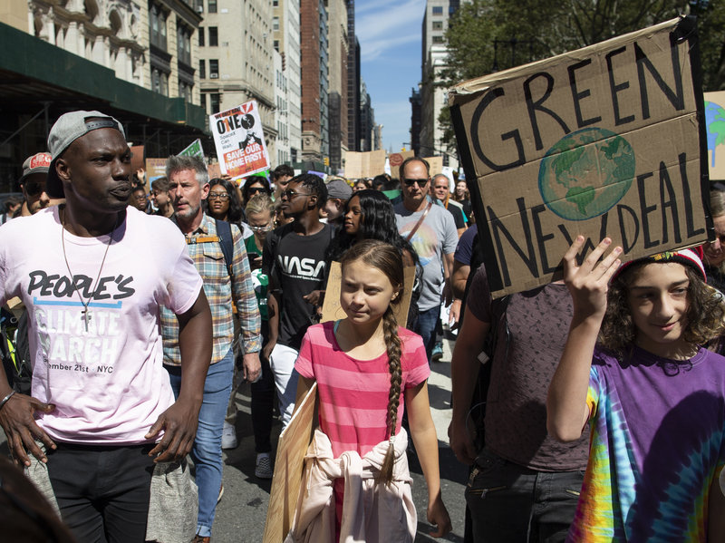
Step 4: How can you make a difference in your community--while detained or back at home

One of the hardest things about fighting climate change and working to reduce greenhouse gasses is that it is hard to see how small things matter. But it is important to know that a bunch of little things really add up.

- Example, if each person recycled their plastic water and soda bottles, well, wouldn’t all these plastic bottles that take hundreds of years to break down polluting the oceans. Similarly, if each person stopped using single-use plastic bags when they go to the grocery store or dollar store, we would nearly eliminate their use and the problems they create. Each person decides what car to buy and makes a decision to buy one that does or does not get good gas mileage or s or is not a hybrid or electric car...

- What are 1-2 things that you could be doing now and when you are released to reduce the pollution and carbon emissions you put out into the world?

Student Feedback:

Circle the emojis that best represents how this activity made you feel.

Day 5: How can you change the world?
Health

What is this lesson about?: In today’s lesson, you will focus on positive things that can change the world! Change doesn’t always have to be negative. Positive change can shape our future.

Step 1: Respond to the prompts below by using the scale.

Place a letter for each prompt below on the scale.

- How confident are you in identifying changes that can take place in adolescence?

- How confident are you in understanding the effect that change can have? (eg. on friendships, mood, routines, confidence, etc.)

- How confident are you in knowing strategies to manage change and where to seek support?

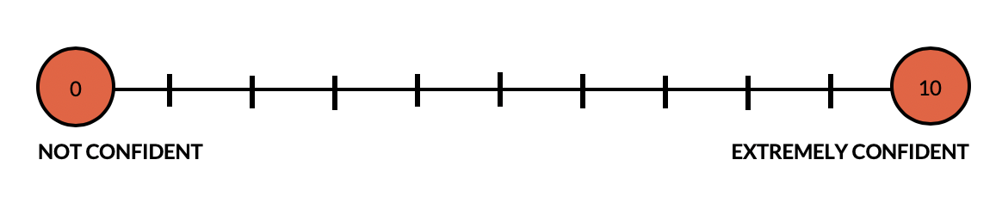

Reflect: Did your answers change from Wednesday?

Step 2: Reading about Change.

Shana Grant, 17, Washington, D.C.

Cause: Gun control and nonviolence
There were 116 homicides in the nation’s capital in 2017. It took just one to change Shana Grant’s life.
“I had always been interested in social justice and how I could improve my community,” the 17-year-old Washington native said. “But I wasn’t sure how to go about it.”

After September 20, 2017, she knew. That was the night that her 16-year-old friend, Zaire Kelly, was shot to death outside his home by a teenager trying to rob him.

Zaire was the first person Shana knew personally who had died from gun violence. And she wanted him to be the last. Police statistics showed that the percentage of gun-related deaths in the city was rising.
“It was time for it to be enough,” Shana said.

Believing strongly that youths can make a difference, she engaged in anti-violence activism. She was on Pennsylvania Avenue a few months later for the student-led March for Our Lives demonstration supporting gun-control measures. Other rallies and meetings followed. Last year, she was elected a D.C. youth “mayor” through a city-run program that develops future leaders.

“I have a unique perspective as an African American girl living in Ward 8 and seeing how gun violence and poverty affect families in my community,” Shana said.

Now she is working on a proposal to help students who are at risk of turning to a life of crime. She calls it “preventing the school-to-prison pipeline.”
At youth government meetings and town hall gatherings, she urges nonviolent solutions to problems. She calls it “practicing peace.”

Here are some of her suggestions for young people feeling angry or stressed: Breathe deeply, write down your feelings, talk to someone, try to see the other person’s point of view, and look for activities you enjoy, such as listening to music.

Shana expects to graduate in May from BASIS DC charter school. She wants to attend Spelman College in Atlanta, Georgia, in the fall and plans to become a doctor. She is not planning on giving up her activism, though.
“Things need to be changed,” she said. “I want to be part of that change.”
— Marylou Tousignant

Sidney Keys III, 14, Missouri

Cause: Improving literacy among boys
From a young age, Sidney Keys III loved to read. But finding characters he could relate to was a challenge, because most of the books at his school library featured white protagonists. “I’d never been exposed to African American literature in a fun way,” Sidney said.

That changed when Sidney’s mother, Winnie Caldwell, took him to EyeSeeMe, an African American children’s bookstore in University City, Missouri. Sidney, then 10 years old, picked up “Danny Dollar Millionaire Extraordinaire: The Lemonade Escapade,” by Ty Allan Jackson. “I couldn’t put that book down, because it was about a black boy who looked like me,” said Sidney, now 14.

Sidney wanted his peers to experience the same excitement in finding characters that resonated with them. In 2016, he created Books n Bros, a reading club for boys ages 7 to 13. The club, which now has 100 members, focuses on African American literature and meets each month to discuss a book; past topics have included history, sci-fi and fantasy genres.

Meetups take place in the Saint Louis area, but out-of-town “bros” can participate by Skype. Caldwell, who manages the club’s business and communications, said Books n Bros wants to eventually offer the program in schools.

The club is open to boys of all races and backgrounds and has an “Adopt a Bro” option enabling donors to sponsor memberships, which cost $25 a month.

People assume boys don’t enjoy reading, Sidney said. But he hasn’t found that to be true. “Now that kids are having fun while reading, boys don’t want to leave the meetups,” he said.

“Marvel’s Hero Project,” a new Disney Plus series recognizing kids who are making a positive impact, profiled Sidney in a documentary and comic book titled “The Spectacular Sidney.” The video premiered in January.
Getting to be in the documentary was “definitely pretty awesome,” Sidney said. But his favorite part of the Books n Bros experience has been helping boys like him improve their literacy skills and enjoy themselves at the same time.

“It really warms my heart knowing they’re having fun,” he said.
— Gina Rich

Step 3: How will you change the world?

What is something you want to change?

What ways would you cause others to make the change?

How would you know when a change has been made?

Step 4: Reflecting on change. Think back to the beginning of the week and summarize what you have learned about change.

Something I know now which I didn’t before is…

Something I now think/believe about change is…

Something I can do now as a result of this lesson is….

Mindfulness Moment!
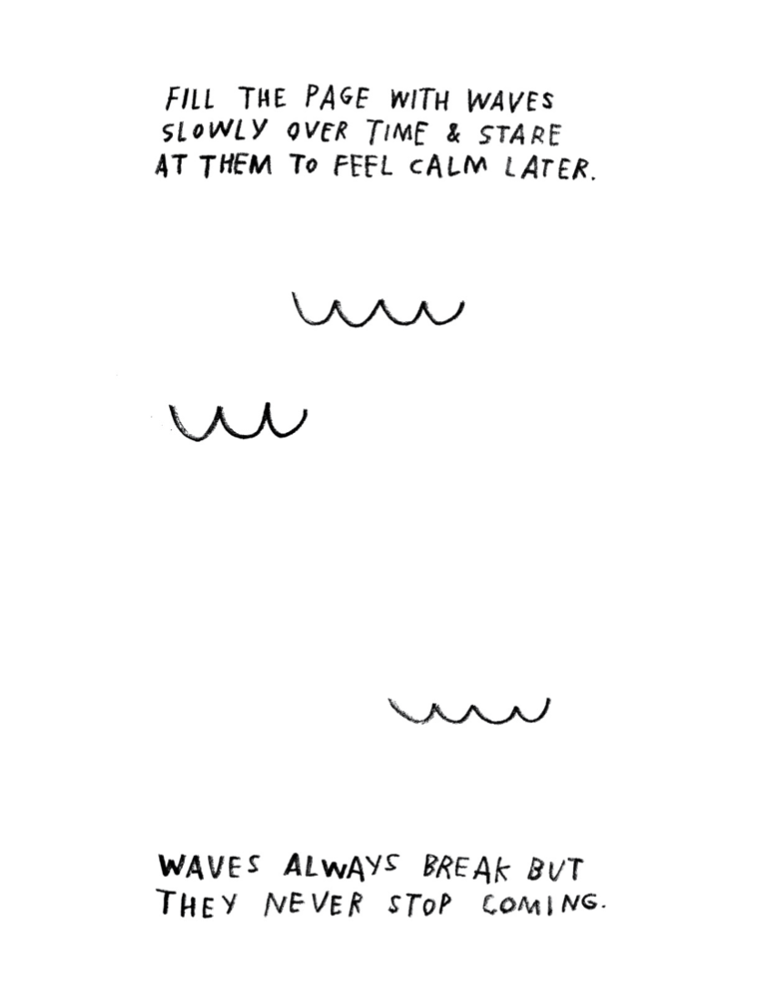

Day 5: Historiography and the American Revolution
Social Studies

What is this lesson about?: In today’s lesson we will briefly review what we’ve learned about history evolving or changing over time because of historians’ interpretations. We will take a look at one last example of this, perhaps the most important example in American history: The American Revolution. Then you will consider how the idea of history changing over time may affect your own life and personal history.

Warm-up: free-write

Take 5 minutes to read the quote below and reflect on it. Write what you think it means?
"The past does not influence me; I influence it." – William De Kooning

Step 1: Review

This week, you have learned that while the past itself never changes, history – in other words, our understanding and interpretations of the past – is always evolving. New historians explore and interpret the past through their own methods, priorities and values. They develop new theories and conclusions that may change the way we understand the past. We’ve seen how this has been true with examples of the Salem witch trials, Christopher Columbus, and the battle of the Alamo. What you have been learning about is called “historiography” (defined further, below).

Step 2: Before reading, some key terms

Continental Congress | Initially a convention of delegates from a number of British American colonies at the height of the American Revolution, who acted collectively for the people of the Thirteen Colonies that ultimately became the United States of America.
Loyalist | People who were loyal to Britain and did not want America to become its own nation
Tyranny | Cruel and oppressive government or rule
Whig | During the American Revolution, “whig” was a term to refer to patriots or those people who supported the revolution and wanted a free America

Step 3: Read the article

What is Historiography?
Historiography is, essentially, the history of history, or, more precisely, the history of history writing. It’s what we’ve been considering throughout this whole week as we’ve compared different interpretations of significant events in U.S. History. So, what’s the historiography of the most significant event in U.S. history, the American Revolution?

How have historians in different times and places interpreted the causes and character of the American Revolution differently? Perhaps no other topic in American history has been subject to so many differing interpretations as the American Revolution.

What follows is a summary of the different ways in which historians have interpreted the causes and character of the Revolution. It encompasses a debate that is as old as the Republic itself.

An understanding of the way historians have interpreted the Revolution differently can enrich the general reader’s own perspective and open up questions that promote critical and historical thinking on the part of the reader. Below is an explanation of different interpretations of the American Revolution.
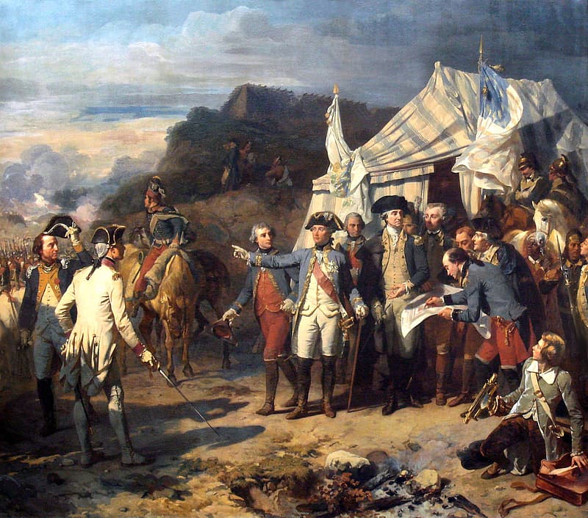

Historiography of the
American Revolution

1780-1820
Revolutionary Interpretation
Loyalist Interpretation

1820-1880
Whig Interpretation

1900-1940
Imperial Interpretation

1960-1980
New Left Interpretation

1980-Present
Neo-Progressive Interpretation
Revolutionary Interpretation:
The two major contemporary historians of the Revolution were David Ramsay of South Carolina and Mercy Otis Warren of Massachusetts. Ramsay, in 1789, told the story of how virtuous “husbandmen, merchants, mechanics, and fishermen” won independence from the corrupt British. He saw the Revolution as a constitutional crisis brought on by the conflict between Britain’s imperial interests and the colonists’ experience in self-government. The first female historian of the Revolution, Mercy Otis Warren, in her 1805 book, described the Revolution as a “boon of liberty.” [a “boon” is a blessing.] Being the sister of James Otis, Jr. and the wife of Dr. James Warren, she had been personally involved in the coming of the Revolution and saw the actions of the British in the 1760s and 1770s as attempts to establish tyranny over the colonies. Having been participants in the events of which they wrote, both saw their histories as a moral story and warned their readers against siding with the evil and corruption of the British.

Loyalist Interpretation:
Prominent Loyalists, too, wrote a number of contemporary histories of the Revolution, though some were only published after their death including Thomas Hutchinson, the former royal governor of Massachusetts, and Joseph Galloway, a former member of the Continental Congress. Unsurprisingly, these loyalist histories tended to focus on justifying British actions during the conflict and crisis. Hutchinson was an exception. He believed that party politics in Britain contributed to Britain’s confused and unorganized approach to governing the colonies. Galloway, however, believed that the disorganization came largely from politicians and officials’ unfamiliarity with the colonies, its governments, and its people. All the Loyalist historians tended to agree that the creation of popular anti-British sentiment in the 1760s and early 1770s was the product of a small number of ill-designing men who wanted to agitate things and create more conflict.

Whig Interpretation:
The Whig interpretation is best exemplified by a man whom Edmund Morgan called “the first great historian to deal with [the Revolution].” George Bancroft, like a number of historians of the pre-academic 19th century, used the leisure time his wealth afforded him to travel the country collecting and preserving primary source documents and to produce a massive multi-volume history of the United States. In the Whig interpretation, the underlying and unifying theme of American history was an effective march toward liberty and democracy away from the tyranny and absolutism of the Old World. In the Revolution, “the Americans seized as their peculiar inheritance the traditions of liberty.” This interpretation held sway through much of the nineteenth century.
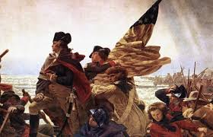

Imperial Interpretation:
In the early part of the twentieth century (early 1900s), a number of historians began looking at the colonial period from the British perspective. Unlike the Whigs, the imperial historians did not see a tyrannical ministry and British government bent on restraining the liberty of the colonists through harsh policies. Rather, historians such as George L. Beer, Charles Andrews, and Lawrence Gipson, studied British colonial policy and saw Britain’s attempts to manage trade and seek revenue from the colonies as reasonable policies, especially considering Britain’s war debt and colonists’ relatively light tax burden.

New Left Interpretation:
In the late 1960s and 1970s, “social history,” which focused on the lives of everyday persons, became predominant. At the same time, the Civil Rights movement and the feminist movement helped provide a spark for a new generation of historians to study the history of race and slavery in early America, as well as women’s history. Around the same time, young historians engaged in this “history from the bottom up” in an effort to recover the agency of common class colonists. Similarly, Mary Beth Norton and Linda Kerber both published books in 1980 about the impact of the Revolution on women.In the 1980s and 1990s, there was a resurgence of interest in class conflict and economic aspects of the Revolution. New-Leftists have argued that ordinary Americans during the Revolution were radical and eager to fight for their own interests, thereby bringing in the ordinary Americans into the historical conversation of the Revolution.

As we can see, the way historians have interpreted the Revolution has been influenced by the times in which they lived. The English historian, E. H. Carr, wrote, “Before you study the history, study the historian” and their own “historical and social environment.” This is true in all fields of history. Nevertheless, each of these interpretations made unique contributions to the ways in which we understand the Revolution today.

Step 4: Reflect and answer questions

Match the following explanations with the proper interpretation from above.

A. Britain acted fairly in raising taxes in the colonies and managing trade when considering the debt they had created through earlier wars. The argument that the British government was tyrannical is not accurate.
B. The American Revolution was about establishing a fair democracy and was a push towards liberty for the New World.
D. It was the ordinary American and their desire to fight for their own interests and rights that led to the revolution against Britain.

E. The revolution was justified because the Americans were rebelling against unfair treatment by the British government.

C. The revolution was caused by a small group of men in America who wanted to create trouble. Britain was not to blame for the revolution.
Loyalist
Whig
Revolutionary
Imperial
New Left

Create a timeline of the different interpretations using the graphic organizer below, or make your own on a separate piece of paper.

Name:______________
Dates:
Key aspects of interpretation: ______________________
_____________________________________________________________________
Name:______________
Dates:
Key aspects of interpretation: _______________________
_____________________________________________________________________
Name:______________
Dates:
Key aspects of interpretation: _______________________
_____________________________________________________________________
Name:______________
Dates:
Key aspects of interpretation: _______________________
_____________________________________________________________________
Name:______________
Dates:
Key aspects of interpretation: ______________________
_____________________________________________________________________
1700
2000

Step 5: Your personal history

You have explored how many historical events in U.S. history have been interpreted in different ways throughout time. As interpretations change (based on interests, morals, and values of the times, as well as historians personal perspective), our understanding of history also changes. With this in mind, answer the following questions about your own personal history.

Think about your life so far. Think back to a time when you felt your actions were misunderstood. Write what your actions were below.

How did people interpret your actions? How did they respond to what you did and why?

If history can change over time, why can’t your personal history change too? Reflect below on how you might get people to interpret your actions in another way. In other words, if a historian was writing your biography, what information would you want to make sure they had so that they would understand your actions better?

Student Feedback:

Circle the emojis that best represents how this activity made you feel.

